

**FLEETPRO**

**OPERATIONS MANUAL**

Version: 0.5

Fleetpro Operations Manual 

2021-07-02

**DISCLAIMER**

Senvion India Pvt Ltd

Unit No.2, 2nd floor-Victor,

International Tech Park (ITPB), Whitefield Road,

Bengaluru – 560066, India.

[www.senvion.com](http://www.senvion.com)

All rights reserved.

Protection Notice DIN ISO 16016: The reproduction, distribution and use of this document as well as the communication of its contents to others without explicit authorization in writing by Senvion is strictly prohibited. Offenders will be held liable for the payment of damages. Furthermore, all rights reserved in the event of the grant of a patent or industrial design.

Please ensure the latest versions of the applicable specifications are used. Images do not necessarily reflect the exact scope of supply, specifications, size or materials and are subject to technical alterations at any time. Please note that this document may not correspond with project-specific requirements.

Possible work procedures described in this product description comply with German, and Senvion’s, safety provisions and regulations. The laws of other countries may provide for additional safety specifications.

It is essential that all safety measures, both project and country-specific, be strictly complied with. It is the duty of each customer to inform itself, implement and comply with these measures. The applicability and validity of relevant legal and/or contractual provisions, technical guidelines, DIN standards and other comparable regulations are not excluded by the content or examples contained in this product description. Moreover, such contractual provisions and regulations shall continue to apply without any limitation.

All information contained in this product description is subject to change at any time without notice to, or approval by, the customer.

Senvion and/or its affiliates assume no liability for any errors or omissions in the content of this product description. Legal claims against Senvion and/or its affiliates based on damage or injury caused by the use or non-use of the information included herein or the use of erroneous or incomplete information are excluded.

Although Senvion strives to provide information which is accurate and makes this information available to customers in good faith, no representation or warranty is made, or guarantee given as to its accuracy or completeness. The sole applicable warranties in respect of the products described herein shall be those provided in a contract executed by an authorized representative of Senvion. EXCEPT AS PROVIDED IN SUCH EXECUTED CONTRACT, Senvion MAKES NO WARRANTIES, EXPRESS OR IMPLIED, AS TO THE PRODUCT SPECIFICATIONS, PRODUCT DESCRIPTIONS OR THE PRODUCTS

HEREIN DESCRIBED. TO THE EXTENT PERMITTED BY LAW, Senvion EXPRESSLY DISCLAIMS ALL IMPLIED WARRANTIES, INCLUDING THE IMPLIED WARRANTIES OF MERCHANTABILITY, FITNESS FOR A PARTICULAR PURPOSE, TITLE AND NONINFRINGEMENT.

All brands, trade-marks or product names mentioned in this document are the exclusive property of their respective owner

**Table of Contents**

1. Introduction & brief description 7

1.1 Overview: range of functions 7

1.2 Fleet Pro Application Release History 7

2. Dashboard 8

2.1 Cockpit 8

3. Control Centre 9

3.1 Data Monitor 9

3.2 Fleet Scan 10

3.3 Error Monitor 11

3.4 Error Log 12

3.5 Counter Monitor 13

3.6 Error Count 14

4. Insights 15

4.1 Farm 15

4.1.1 Overview 15

4.1.2 Availability 16

4.1.3 Capacity factor 17

4.1.4 Gen. Metrics 18

4.1.5 Service Metrics 19

4.1.6 Error Monitor 20

4.1.7 Cohort 21

4.1.8 Wind Rose 22

4.1.9 Power Curve 22

4.1.10 Downtime 23

4.1.11 Heatmap 25

4.1.12 Params 26

4.2 Turbine 27

4.2.1 Availability 27

4.2.2 Capacity Factor 28

4.2.3 Gen. Metrics 28

4.2.4 Health 30

4.2.5 Error Monitor 30

4.2.6 Cohort 31

4.2.7 Peer View 32

4.2.8 Key Metrics 33

4.2.9 Counters 38

4.2.10 Real Time 39

4.2.11 Wind Rose 39

4.2.12 PC Sector 42

4.2.13 Events 42

4.2.14 Params 43

5. Ticketing System 45

5.1 Overview 48

5.2 Tickets 49

5.3 Assigned tickets 50

5.4 Approvals 52

5.5 Ticket History 53

5.6 Bulk Upload 53

6. Data Flow 55

6.1 Network Trends 55

6.2 Network intra day 56

6.3 Data Sync 57

6.4 Data Sync Intraday 57

6.5 Time Status 58

6.6 Ingestion Log 59

7. Report 60

7.1 Engineering Report 60

7.2 Status Report 61

7.3 Performance report: 62

7.4 Monthly Fleet report: 63

7.5 Monthly Farm report: 64

7.6 Root Fault Downtime report 64

7.7 Daily Error Summary Report 65

7.8 DTR Report 66

7.9 DGR Report 67

7.10 LPF Report 68

7.11 Error Log Report 69

7.12 Params Report 70

7.13 Command Log Report 71

7.14 Counter report: 72

7.15 Component Anomaly report 73

7.16 Power Curve Performance Report 74

7.17 IO Report 75

7.18 Weekly Anomaly Report 76

7.19 Turbine Report 77

7.20 Production report 77

7.21 Derating Report 78

7.22 Day wise PC Performance report: 78

7.23 Weather Forecast report 79

7.24 IO Monitor Report 79

7.25 Error Duration Report 80

7.26 Snap Shot Report 80

8. Weather: 81

9. Financial KPI 81

10. Tech Center 82

11. Map 83

12. Email ID Change 84

13. Password Reset 85

# Introduction & brief description

Senvion SCADA FleetPro System is a full solution with a cascade of possibilities in monitoring, remote control, and data integration. It is a human-machine interface in the wind turbine process data acquisition i.e. processing data that has been measured for various analysis, reports. This web-based product function does not require any installation or administration of additional hardware.

## 1.1 Overview: range of functions

* Monitoring
* Control center
* Ticketing
* Weather
* Reporting
* Data flow
* Digital Twin
* Tech Centre

The functionalities are described in more detail in the following chapters.

## 1.2 Fleet Pro Application Release History

|  |  |  |
| --- | --- | --- |
| **S. No** | **Release Date** | **Semantic Version** |
| **1** | **20-Jun-20** | **Alpha 0.01** |
| **2** | **10-Jul-20** | **Alpha 0.02** |
| **3** | **17-Aug-20** | **0.1** |
| **4** | **14-Sep-20** | **0.2** |
| **5** | **26-Oct-20** | **0.3** |
| **6** | **15-March-21** | **0.4** |
| **7** | **30-June-21** | **0.5** |

# Dashboard

## Cockpit

Cockpit displays overall summary of the application for all machines which are integrated with Fleet Pro. This gives a general overview of analytics, turbine performance of entire fleet. We have options to choose the period to be displayed (Full Life, Today, Yesterday,7 Days,90Days,180Days,360Days).

* Availability: Displays fleet availability in percentage for selected time frame.
* Availability (production): Displays fleet produced energy in percentage for selected time frame.
* LPF: Displays Loss production factor for entire fleet.
* Downtime: Graphical representation of the total downtime in hours for the entire fleet
* Advanced monitoring: Displays count of total number of alerts, windfarms and turbines.
* Key Metrics: Displays count of active errors, average fleet availability, downtime in hrs, generation of fleet in MWh, MTTR and MTBF in hrs.
* Generation: Graphical representation of generation of entire fleet in MWh.
* Asset Overview: Displays total number of turbines which are in operational, shut down and in repair state.
* Top performers: Gives list of top performing turbines w.r.t turbine availability. CSV file of the same can be downloaded. Farm and turbine wise availability is displayed.
* Worst performers: Gives list of worst performing turbines w.r.t turbine availability. CSV file of the same can be downloaded. Farm and turbine wise availability is displayed.

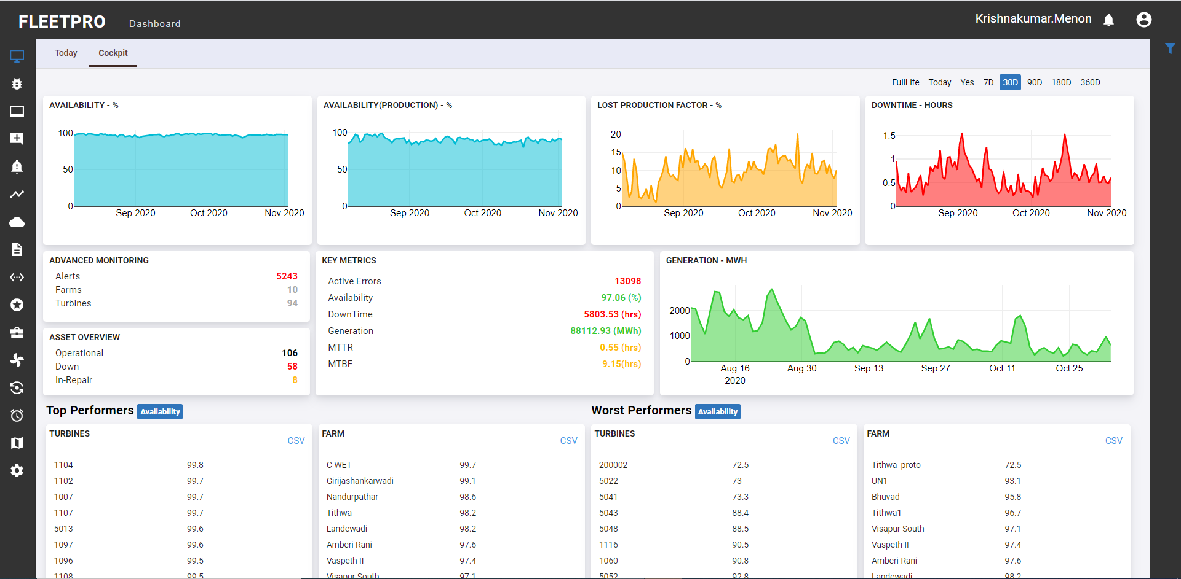

# Control Centre

This functionality is used to scan the entire fleet to check the status of the turbines. It is used to monitor the WTG status, alarms, counters, error count. The sub modules in control centER are described further

## Data Monitor

This sub module is used to monitor the real time status of the turbine measured values (Data Points). The network connectivity status is also displayed in column 1N1. This screen helps the users to understand the status of WTGs in one single screen. Based on this status the turbines are analysed further.

* IEI – Denotes the Standard Error and 1D1 –turbine operating state
* All, offline and online indicates the status of the turbines.

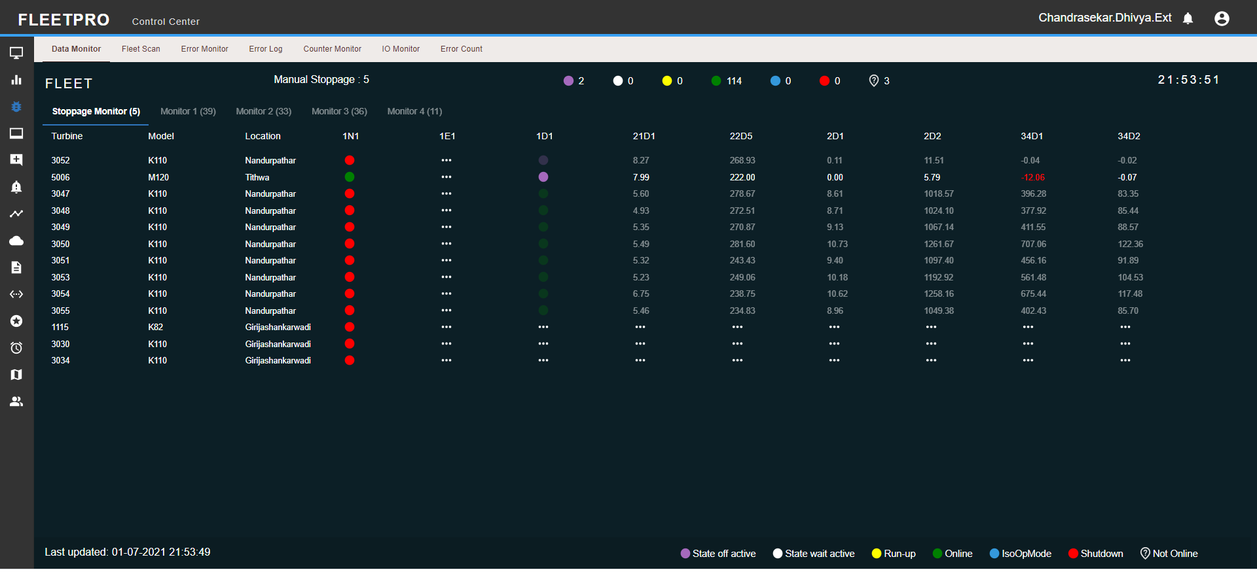

Fig 3.1a: The sensors to be monitored can be selected from filter “select sensor”

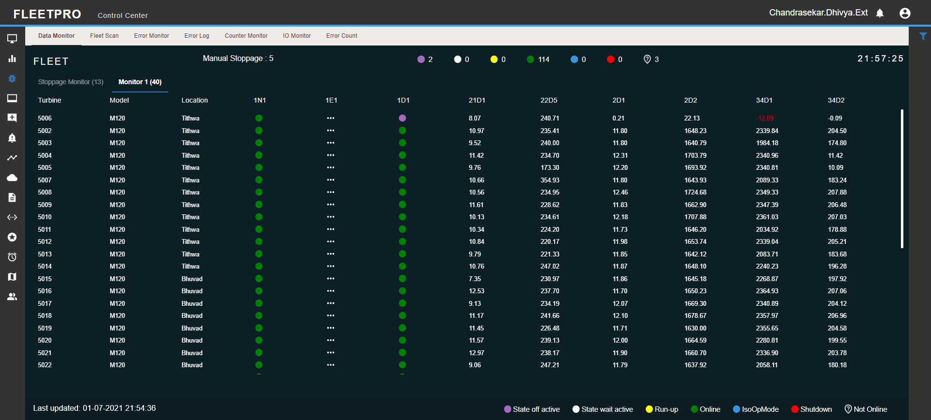

Fig 3.1b: Fleet

## Fleet Scan

This functionality is derived based on the number of open error counts in the entire fleet. The CSV report can be downloaded. This helps in fetching the active errors based on the view mode selected(fleet/farm/turbine). On clicking the Count option, the error details are displayed in the error monitor tab. The user can have a detailed view of the errors in the error monitor tab.On click of the count option it navigates to the error monitor tab (can be added)

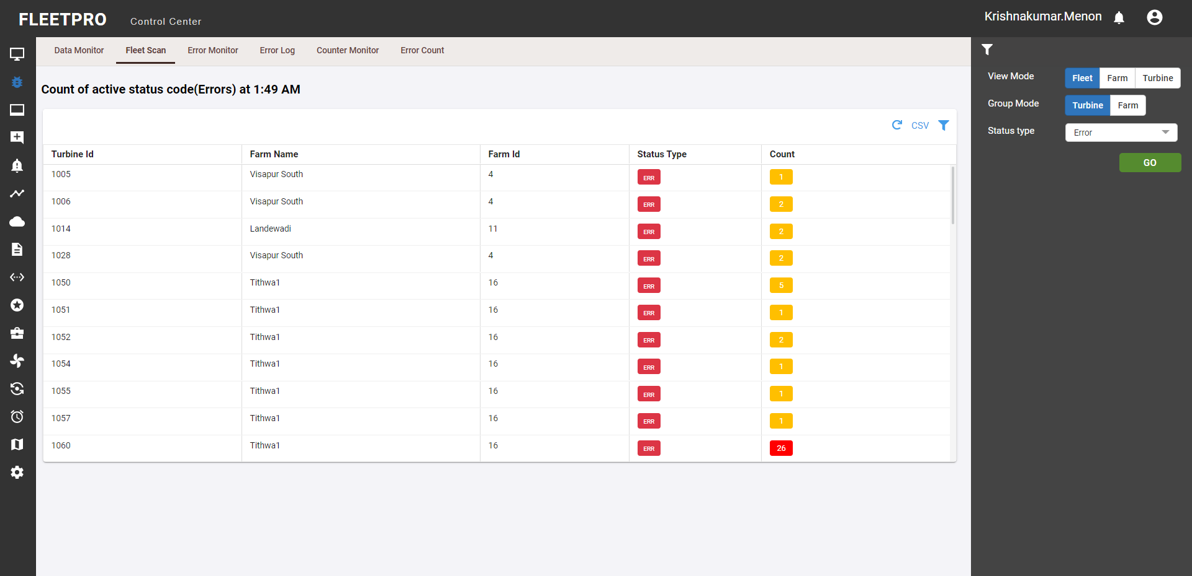

Fig 3.2: User has option to filter based on the status type selected (Error, warning, information)

## Error Monitor

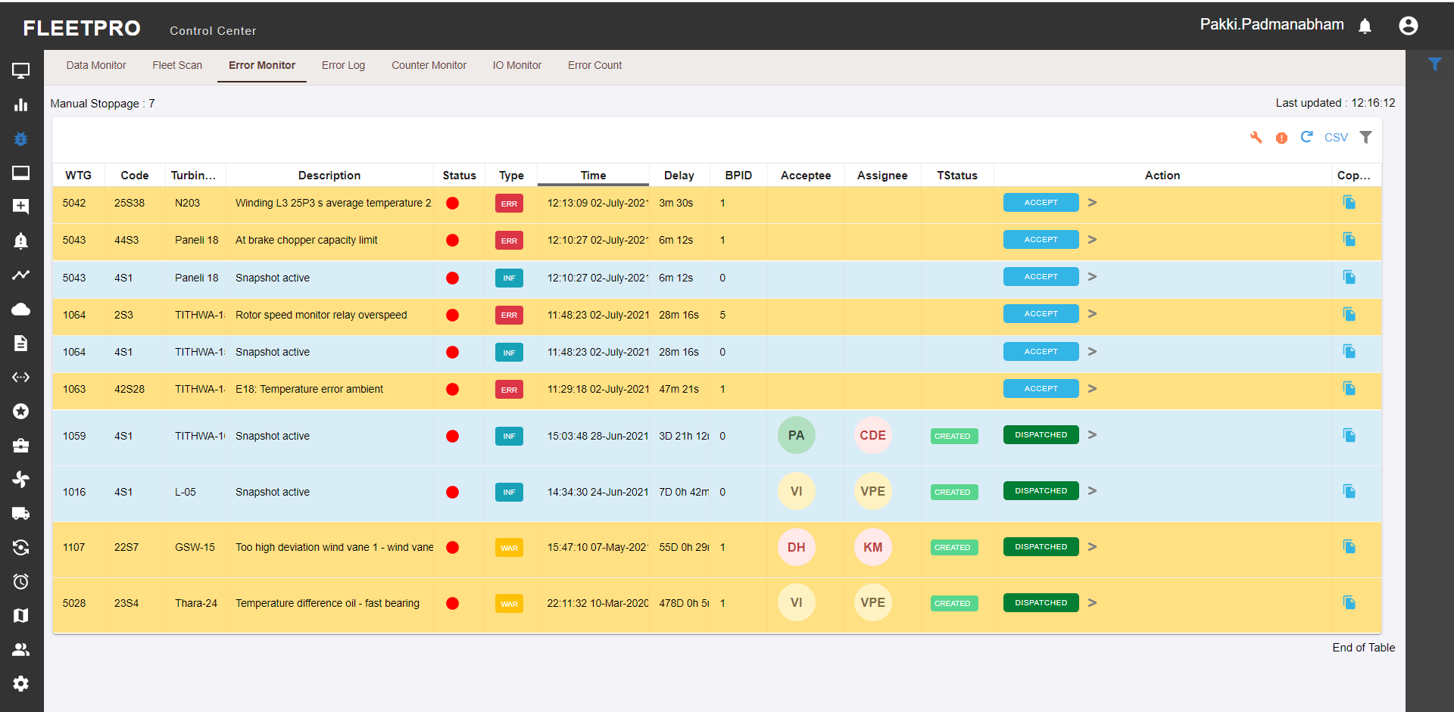

This functionality is used to monitor the errors in the entire fleet. User has option to filter the main errors. Error codes are used to provide information about the operating or technical state of the WTG and its components. The errors are then ticketed and dispatched to the respective site representatives for further actions to be taken.

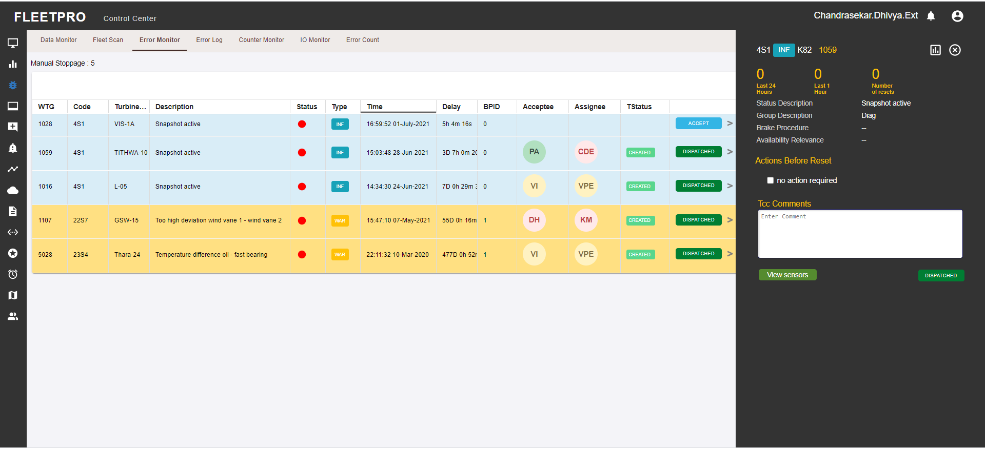

By selecting the sensor, the user can have a view of the sensor description and the chart view can be seen.

## Error Log

This functionality displays list of all errors in the fleet. Here user can download the error log report in CSV format for detail study. This menu displays the following information regarding any error that has occurred

* Error code no. WTG ID, Error code description, Error code type
* Start time, End time and Duration. Brake Procedure ID
* Blue is information and red is error. Similarly, we have orange for warning.

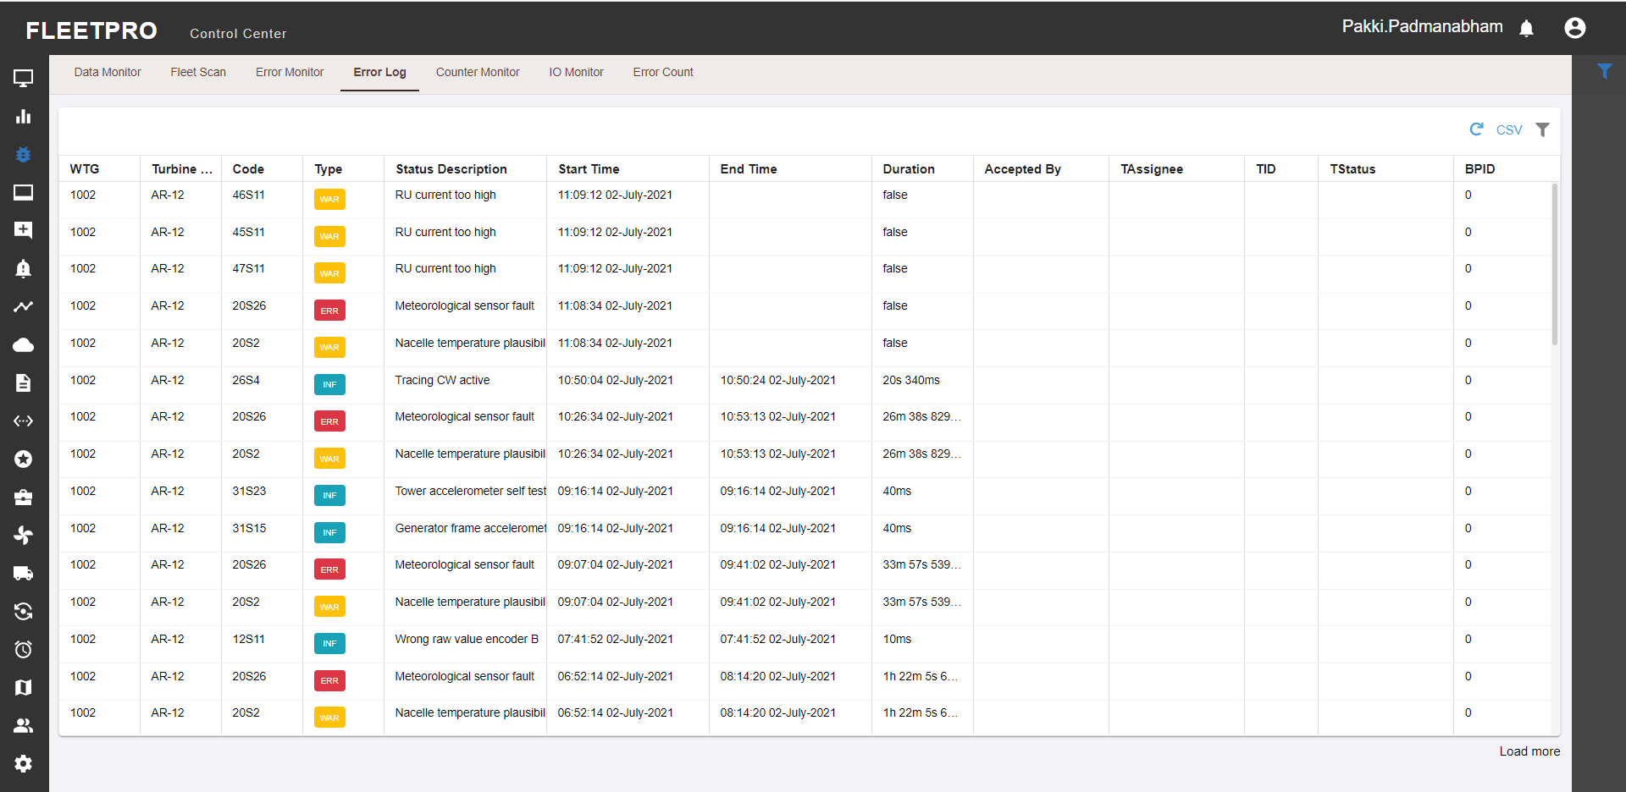

Fig 3.4: User has option to view error log for provided time frame along with filter options for Status type and Major error type.

## Counter Monitor

After data channels another important variable is Counter. This functionality helps to monitor the counter values in the wind farm. This view helps to get overview of values of critical counters through which user can check for abnormalities.

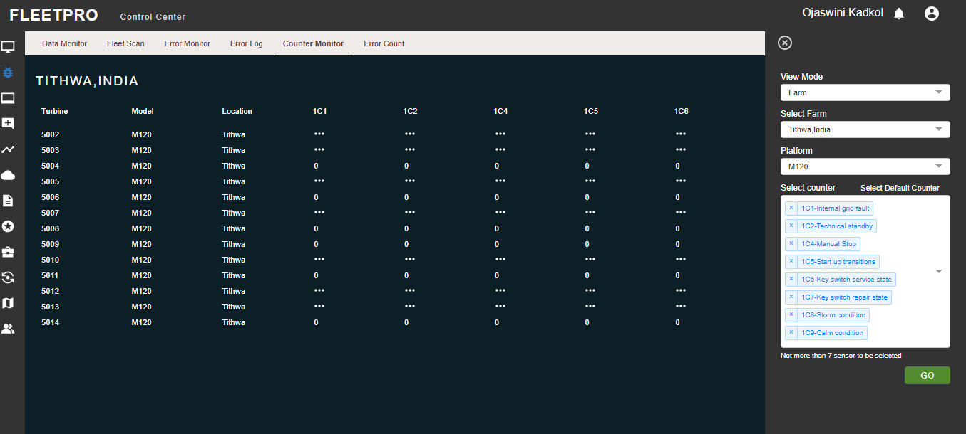

Fig 3.5a: User has option to select the counters which need to be monitored.

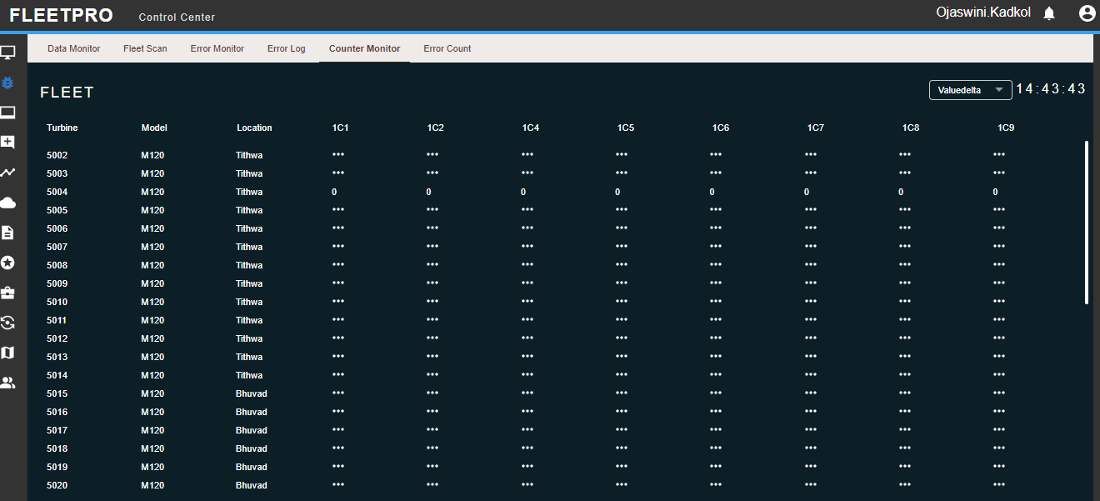

Fig 3.5b: Fleet

## Error Count

This functionality is used to get the list of total error counts in given specific time frame across the fleet. The report can be downloaded in CSV. Status code denotes the count for different period of time.

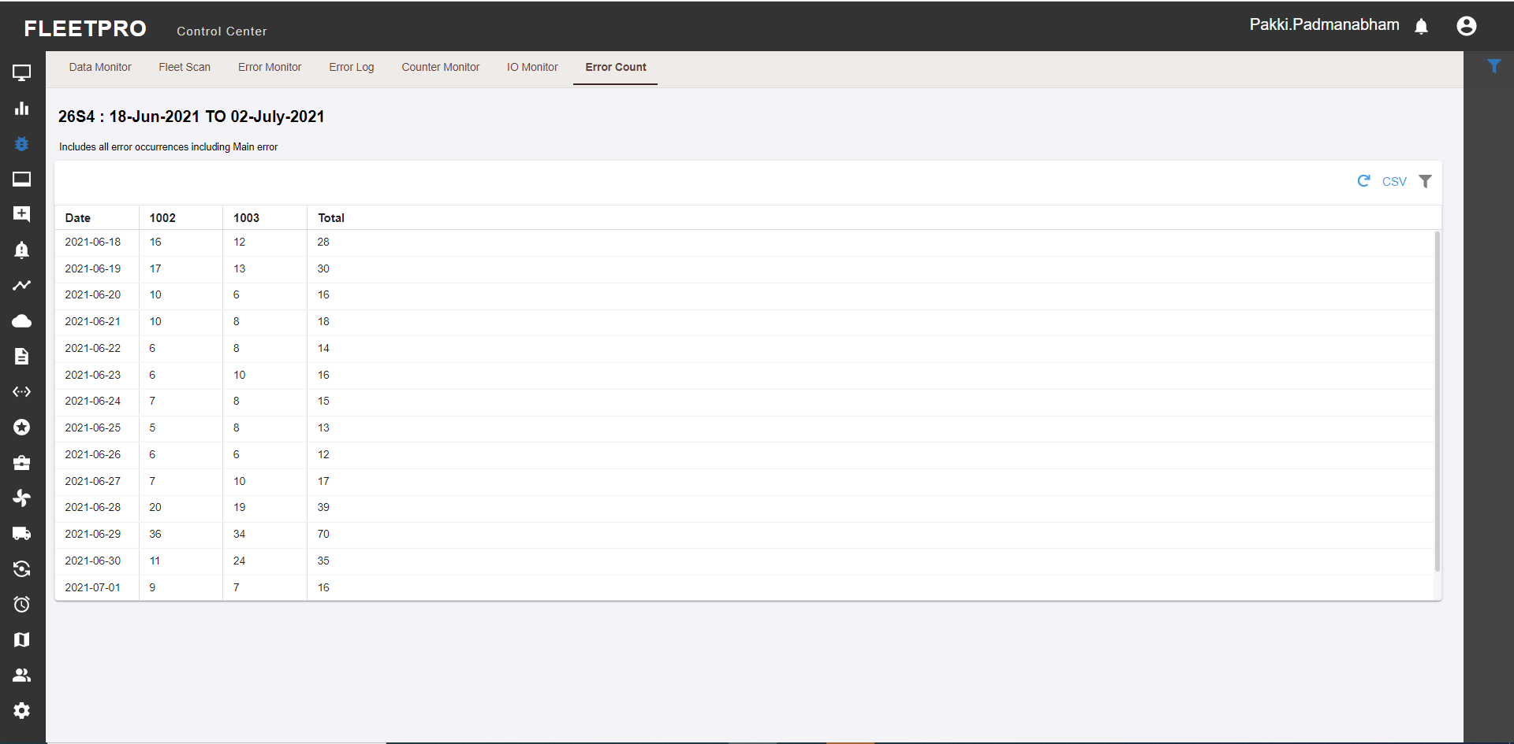

Fig 3.6: User can filter status code to get the count for the same over selected time frame. This error count can be obtained at fleet, farm, and turbine level.

**3.7 IO Monitor**

* In IO monitor there will be digital input and output states.
* Digital Inputs allow a PLC (dio model) to detect logic states
* Digital Outputs allow a PLC (dio model) to output logic states.
* It will be real time to monitor the states of signals received and given by dio model.

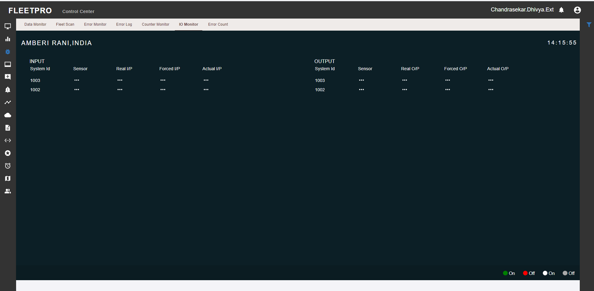

Fig 3.7 IO Monitor displaying the real time to monitor the stats of signals

# 4. Insights

Several analysis functionalities are available in Insights menu. For a better overview, the functionalities are divided in menus and corresponding sub-menus.

## Farm

The farm module in the insight has various graphical representations w.r.t Wind farm performance

### Overview

The overview screen displays geographical map of the selected wind farm and the wind farm generation summary.

* NTF: NTF stands for nacelle transfer function. This option can be selected if performance of turbine is to be checked after application of NTF.
* NTF is to assess the influence of the wind turbine's rotor and nacelle on the nacelle wind speed and to identify the relationship between the free stream wind speed and the nacelle wind speed.
* Filter: Filteration condition allows to filter allow the data at various points like based on pitch angle, power set point etc.in order to get optimum results under specific conditions. Detail view of map can be seen by using the label

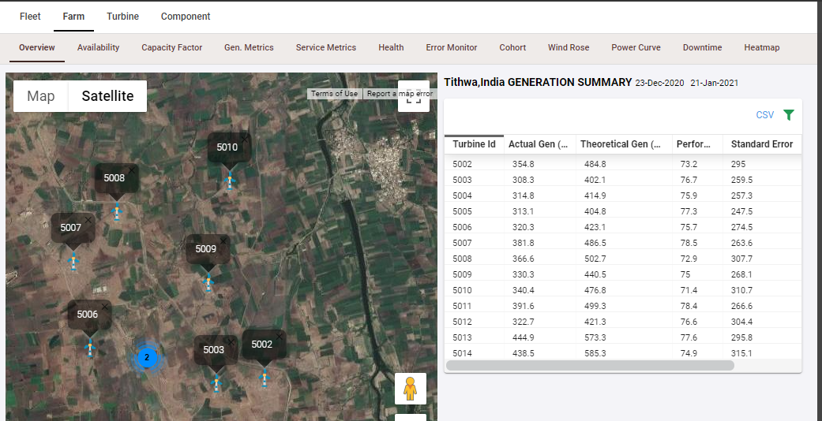

### Availability

* The calculation method for Technical Availability (A actual) per WTG shall be set forth as follows:
* Availability = (Total time - Shuttdown Not Available) / (Total time) * 100%
* where Total time = Turbine Running + Shutdown Available + Shutdown Not Available Turbine Running :
* 1C17 Shutdown Available : 1C2+1C4+1C5+1C6+1C8+1C9+1C10+1C11+1C12
* Shutdown Not Available: 1C1+1C7+1C16+iDown
* 1C1 : Internal grid fault
* 1C2 : Technical standby
* 1C4 : Manual stop
* 1C5 : Start up transitions
* 1C6 : Key switch service state
* 1C7 : Key switch repair state
* 1C8 : Storm condition
* 1C9 : Calm condition
* 1C10 : Grid fault
* 1C11 : Ice on blades detected
* 1C12 : Shadow impact
* 1C16 : Turbine fault
* 1C17 : Turbine running
* iDown : System down
* Mode: It defines in what mode the data is required i.e 10 min level/ daily level/ monthly level.
* Data quality: Defines whether the data calculation done with any error or missing data points, if True means data quality is good, else False means quality is not good. Data Source: There are provided 2 data sources i.e. Field and Scada, user can choose either one to get the data from.
* Availability defined as the percentage of time the turbine was available to run and do the defined operations unless any failure. Based on the graph shown below, more the down peaks means lesser the availability and vice versa.CSV or PNG format of the file can be downloaded for the generated data by the user

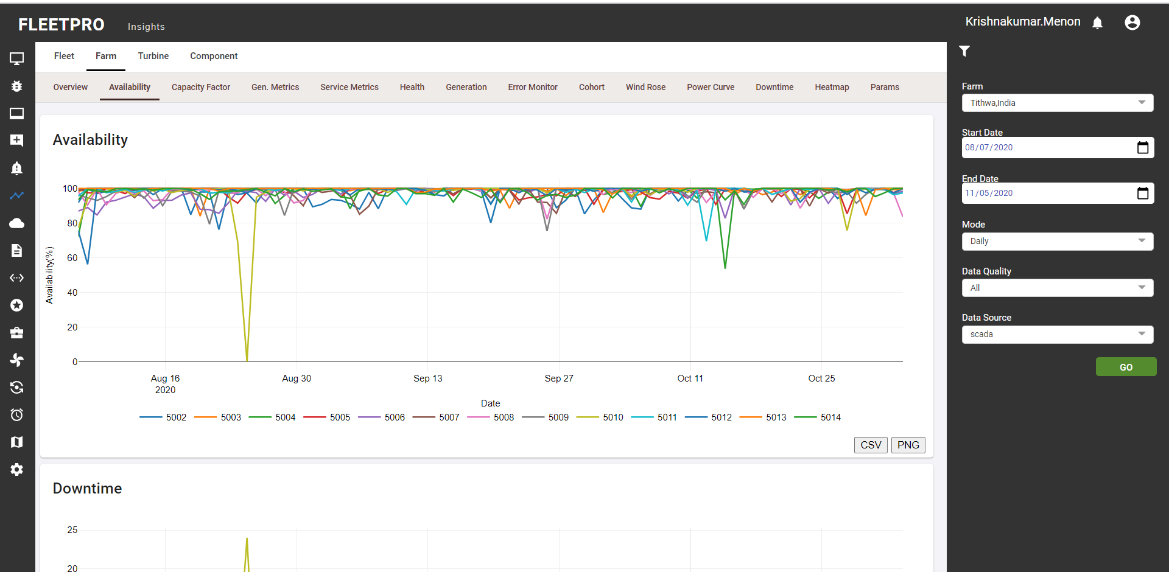

### Capacity factor

* The net capacity factor is the unit less ratio of an actual generation output over a given period to the maximum possible generation output (theoretically calculated reference generation).
* Graph deviation and conformity indicates the higher the percentage of capacity factor means that actual generation has come closer to the possible/theoretically proven generation.
* Frequency: It defines in what mode the data is required i.e. daily level/ monthly level.
* Data Source: There are provided 2 data sources i.e. Field and Scada, user can choose either one to get the data from.

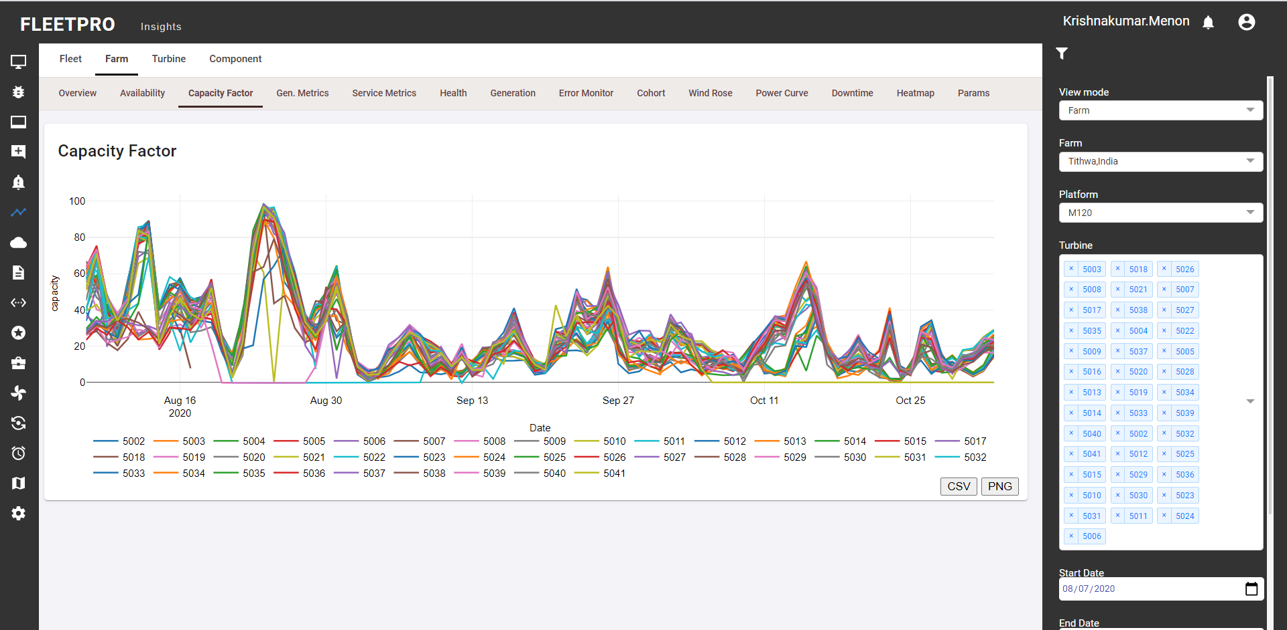

### Gen. Metrics

* Gen. Metrics provides details of Loss Production Factor (technical and commercial), Production based availability (technical and commercial) and Generation in Million kwh. User has option to select specific farm.
* LPF: LPF stands for Loss Production Factor, which means it’s a factor of how much loss there has been i.e. it tells for long there has been downtime and the asset was not operational due to that.
* PBA: PBA stands for Production Based Availability, which means the potential energy which is supposed to be generated at full performance under optimal circumstances.
* GEN: GEN stands for Generation i.e. the amount of energy produced.
* CM LM in tabular denotes what?:
* CM: Current Month
* LM: Last Month
* L3M: Last 3 Months
* CSV format of the data generated can be downloaded by the user.

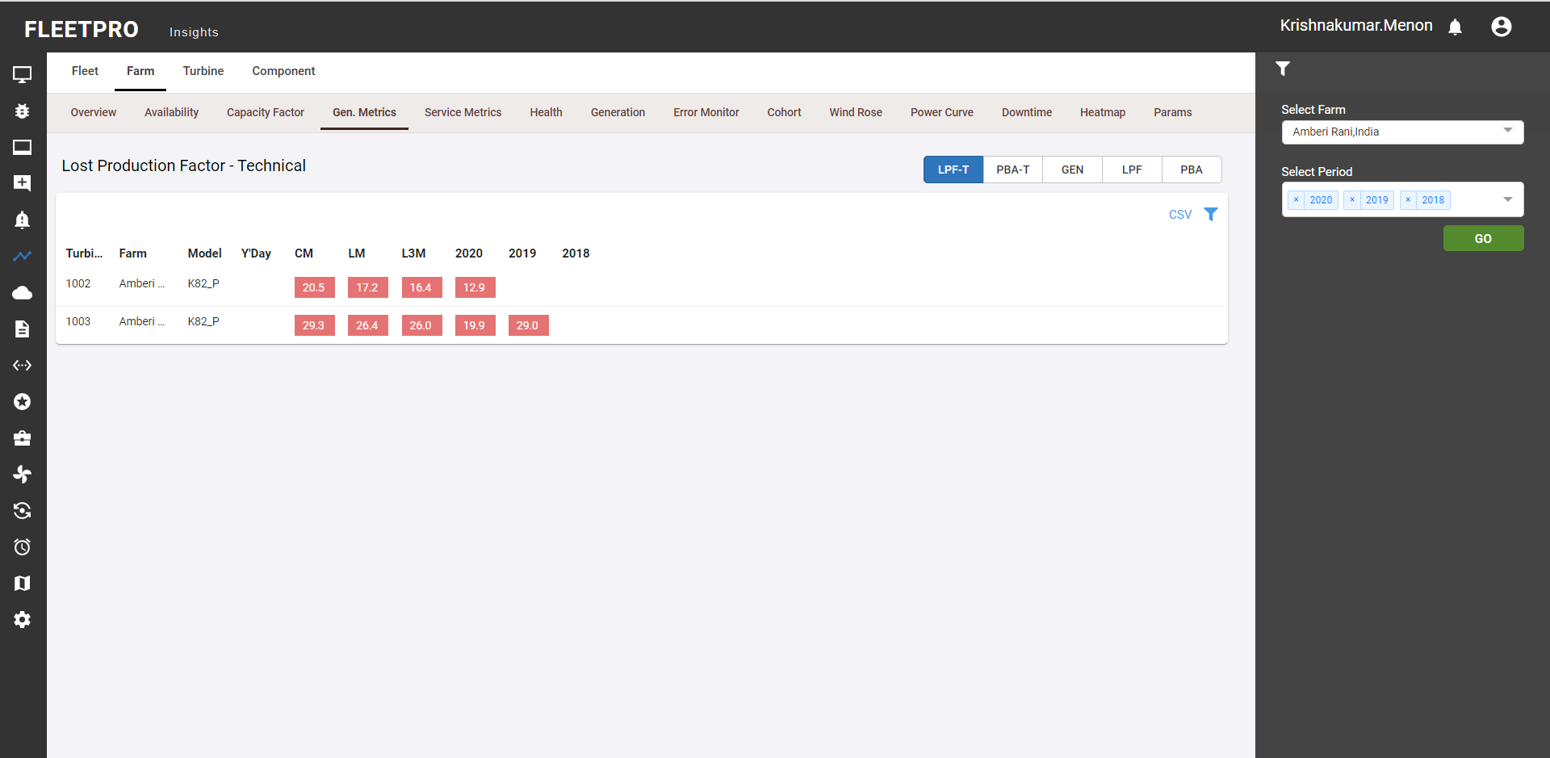

### Service Metrics

Service metrics provides details of MTBF (Mean Time Between Failures) and MTTR (Mean Time To Repair) for the selected wind farm. CSV or PNG format of the generated data can be downloaded by the user.Graphical of the below given snippet shows a heatmap kind of graph designed to understand the variation in the values with the help of color which basically means if the values get too high it comes under red region and if too low then represented by blue region and so on.

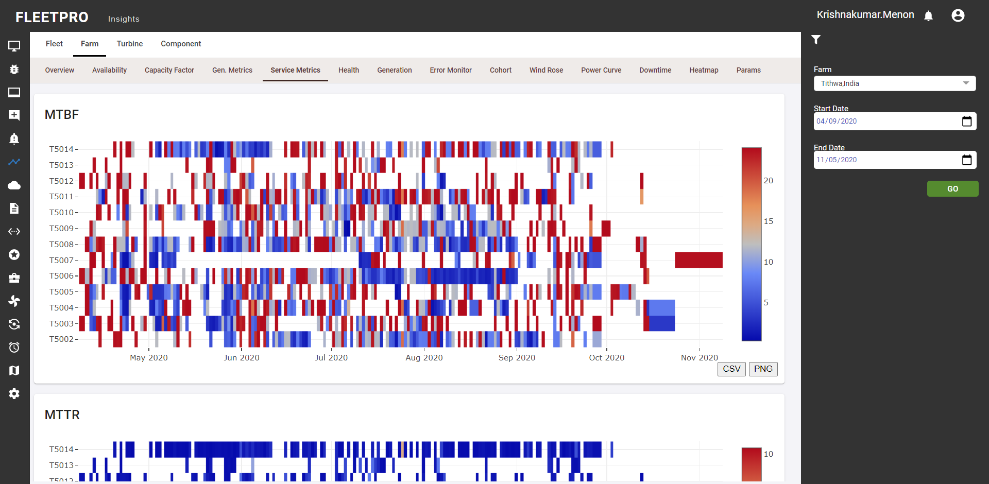

### Error Monitor

This functionality is used to monitor the errors in the selected farm. User has option to filter the main errors. Error codes are used to provide information about the operating or technical state of the WTG and its components. The root fault errors which might have cause failure. Red indicates the issue/error is active currently and need to be resolved. Green indicates the issue/error is inactive currently and need to be resolved.

**Monitor:** CSV format of the generated data can be downloaded by the user.

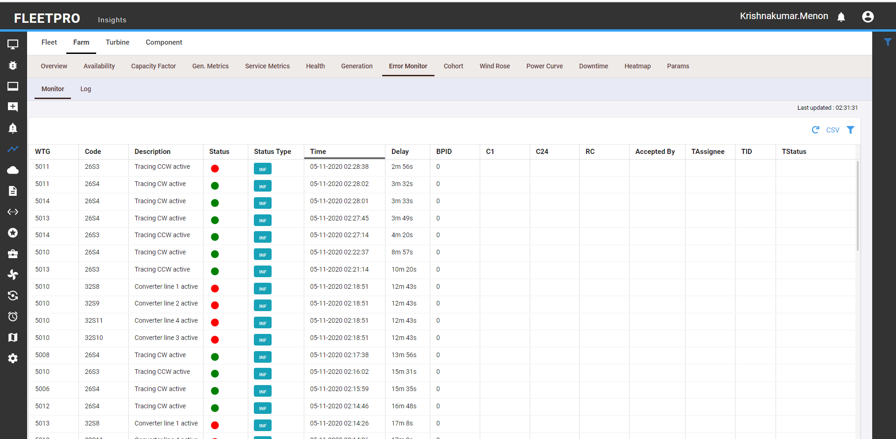

**Log:** CSV format of the generated data can be downloaded by the user. Specific tab for status code in log filter is used to select specific status codes for the selected duration Multiple specific status codes be selected at a time using Specific status code tab in

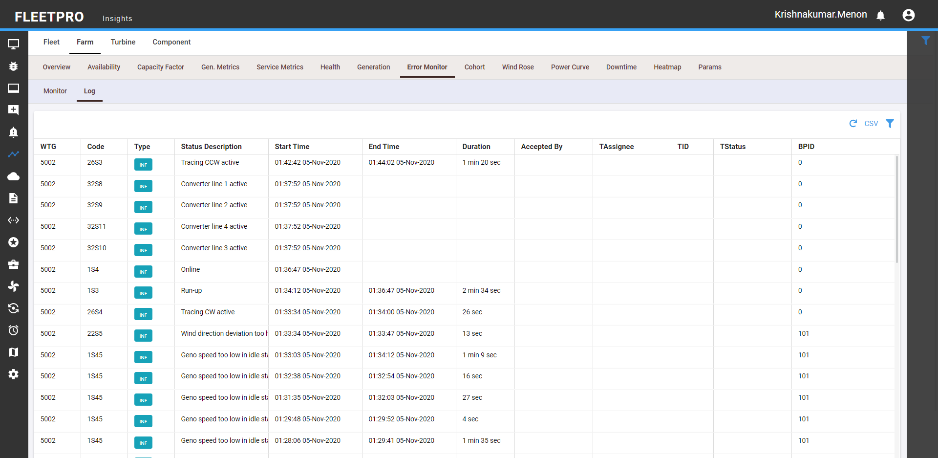

### Cohort

Cohort displays average values of selected sensor for all the machines in the farm. This helps in visualising the difference in the values at specific time over the entire farm.

* Rolling Window: It is used to calculate Moving average i.e. average values for each row based on the rolling window specified
* Mean window: (How both are calculated on basis of day and seconds): defines by what interval need to take average of values, it can be given 1hr (3600 sec), 1day (86400 sec) etc.
* Type: can be min, max, mean and std deviation.
* Sensor select the sensor for which required the data.
* Addition of new sensor is to provide some filteration criteria
* Min indicates minimum value of sensor, max indicates maximum value of sensor.

CSV format or PNG format of the generated data can be downloaded by the user

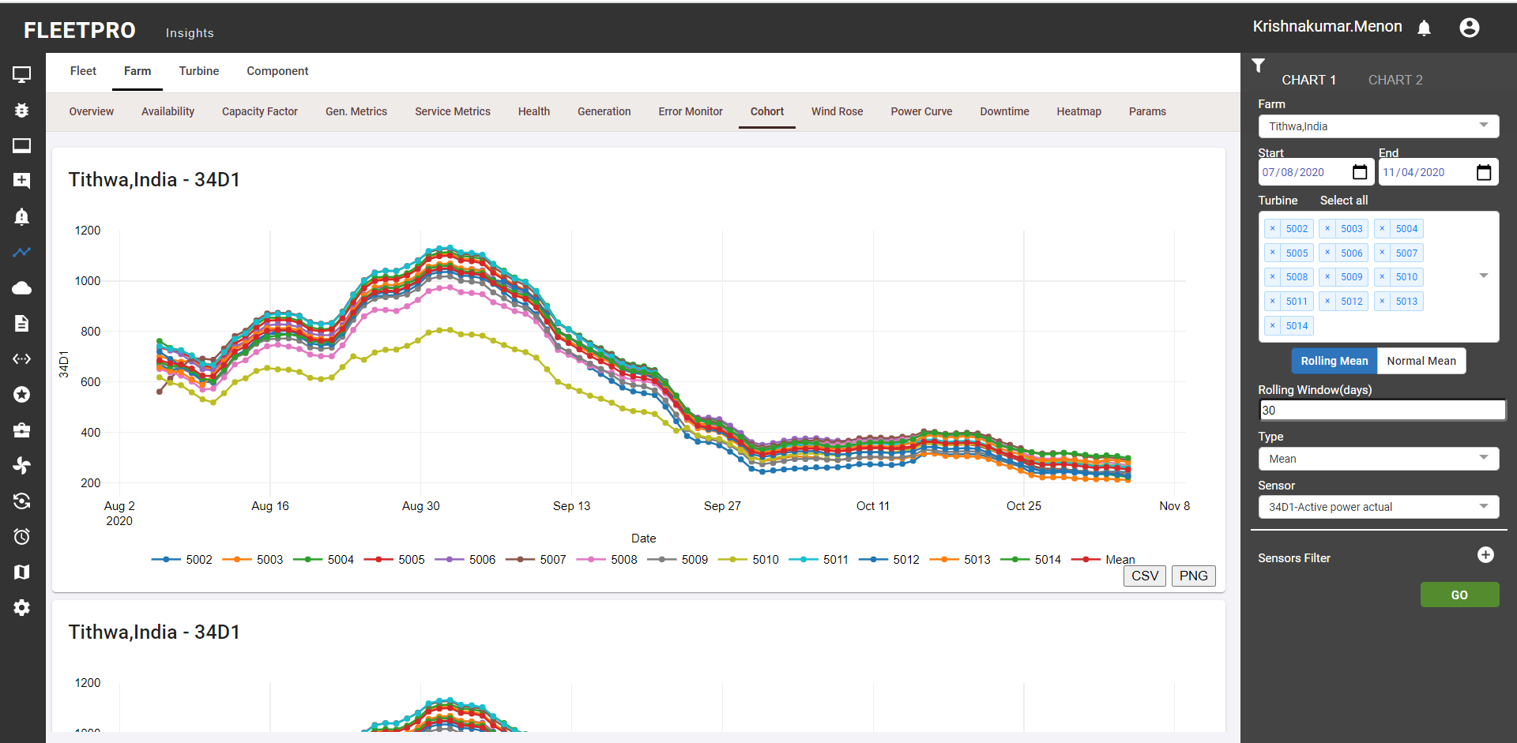

### Wind Rose

### Power Curve

* Power curve represents as how much energy has been produced as per the corresponding wind speed, it also shows the reference curve in order to compare the actual generated results in comparison to theoretically provided one. If actual curves match and obtain the peak power as provided in reference curve means the generation is going as expected else not.
* X axis – wind speed, Y axis - Power
* Bin type: binning done on wind speed can be 0.5 or 1
* Air density: ref curves values are generated at the corresponding air density like 1.0, 1.15 etc. Ref wind speed denotes sensor of wind speed to be considered to power curve for corresponding one.
* Day night is used to fetch data for only day or night time

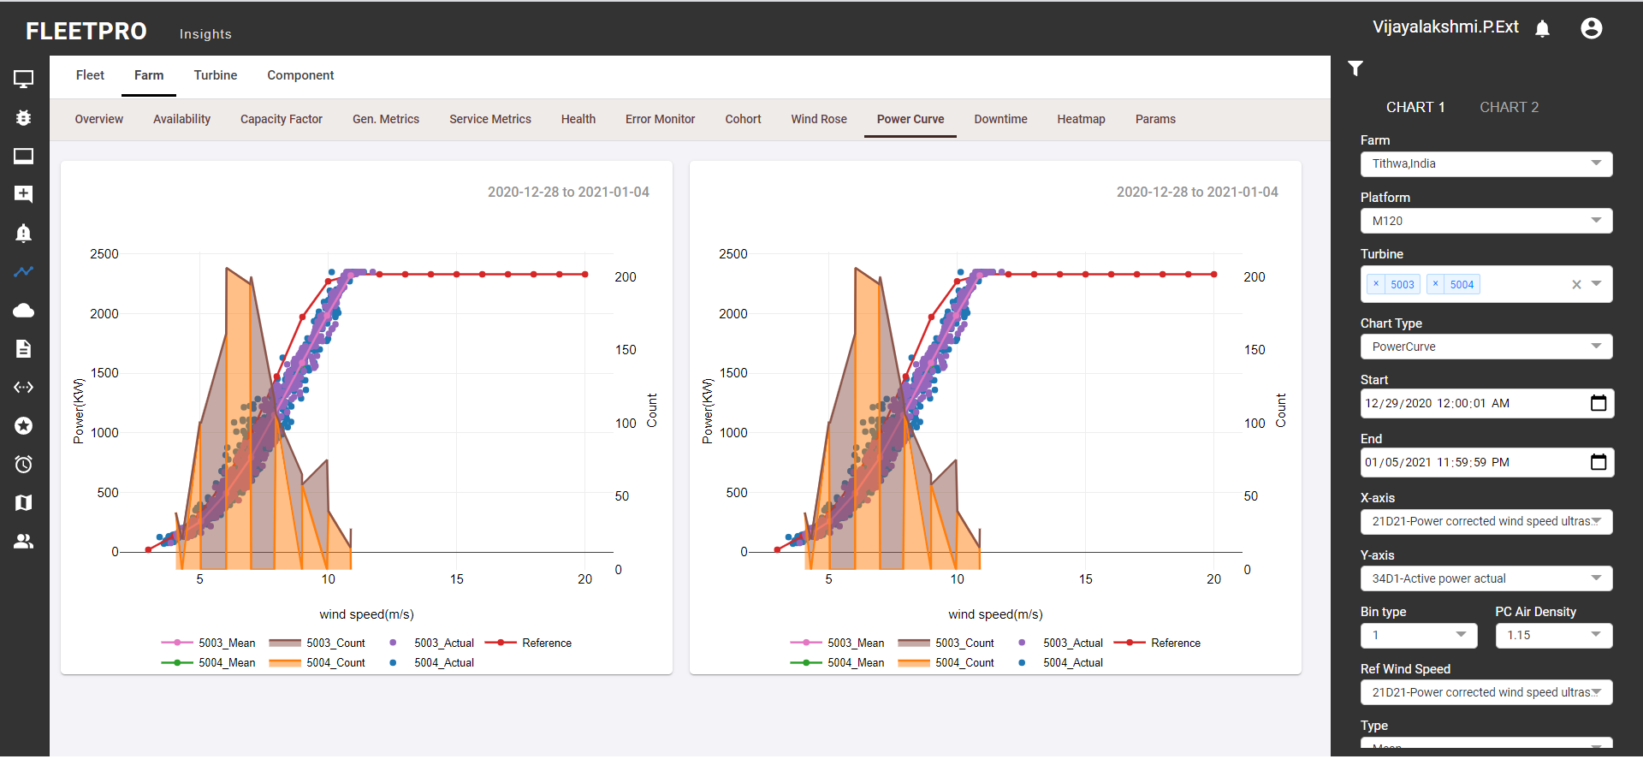

### Downtime

Provided the total downtime (in hours) meaning when the turbine was not available, might have been shut down or any failure and unable to do any production in that time period. Top Error provides the list of top errors occurred and responsible for highest downtime. Top Error Trends provides a visualization to represent top errors based on either the downtime or the count of that error.

* Cumulative hours indicate the total summation of downtime hours caused due to that particular error code.

**Top Error:** Top count in top error filter is to get the list of top n errors

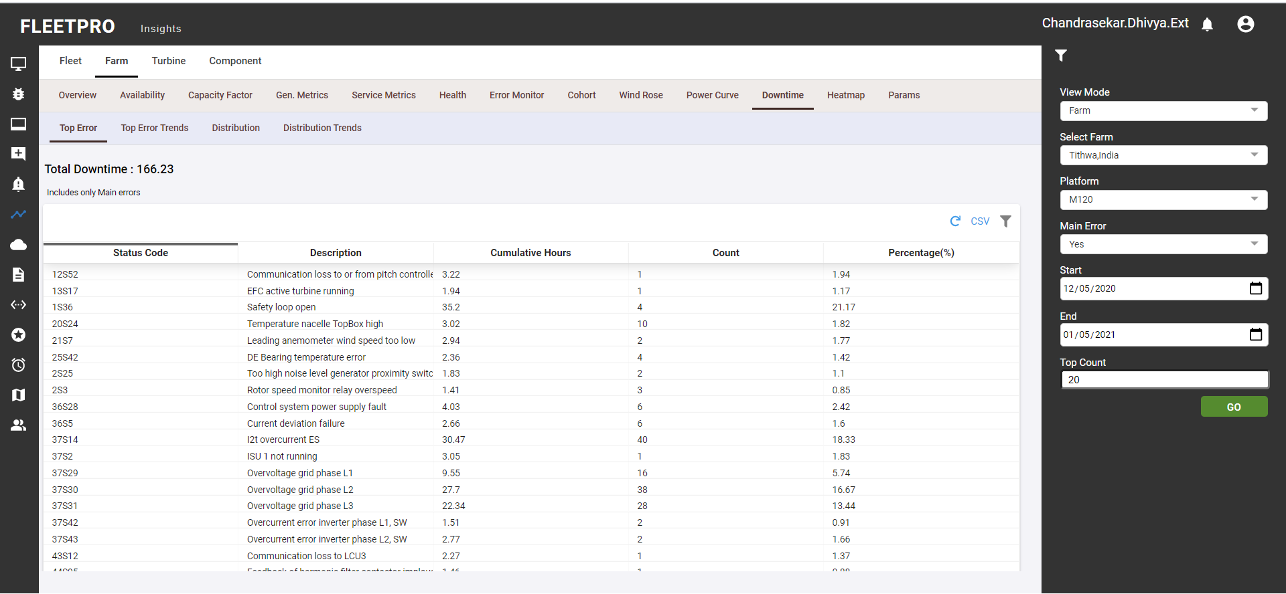

**Top Error Trends:**

* Red orange colour indicates condition that color should be marked accordingly in the graphs.
* Bin: denotes daily/monthly level data.
* Top count: Describes count of top error codes to select

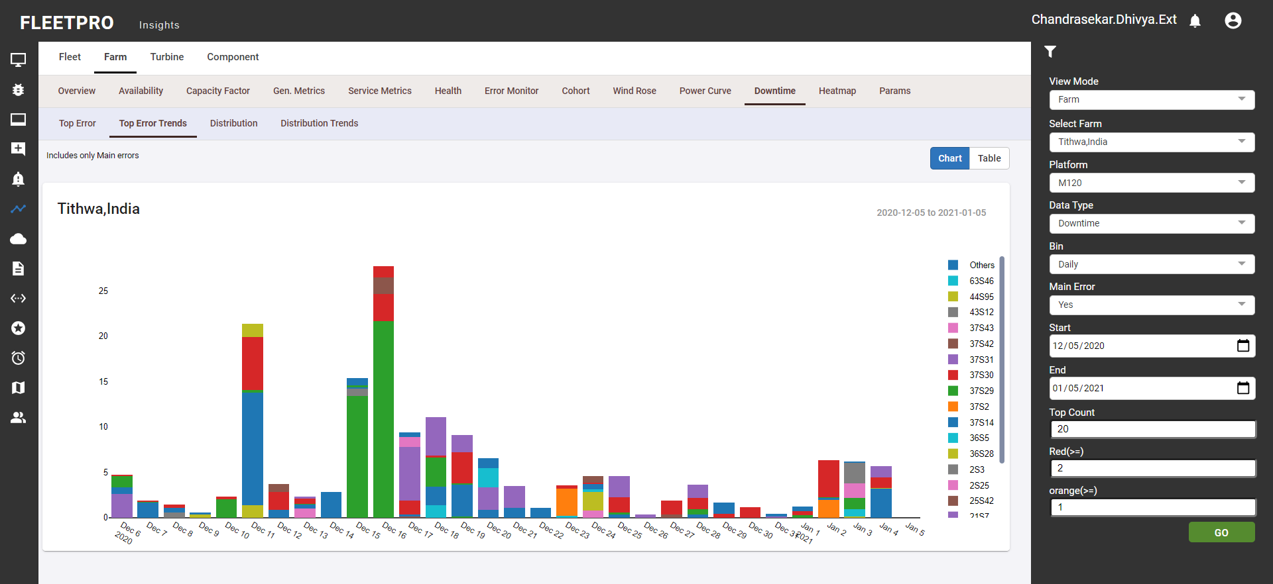

**Distribution:** Top count: Describes count of top error codes to select. Status code: Also known as error code, raised in case of any issue/warning/info.

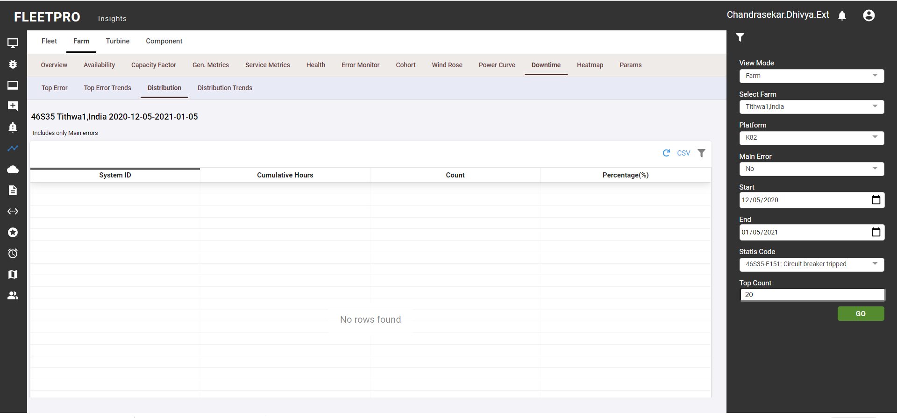

**Distribution Trends:**

* Bin type: denotes daily/monthly level data
* Red orange colour variation: Based on this values condition that color should be marked accordingly in the graphs.
* Status code: Also known as error code, raised in case of any issue/warning/info

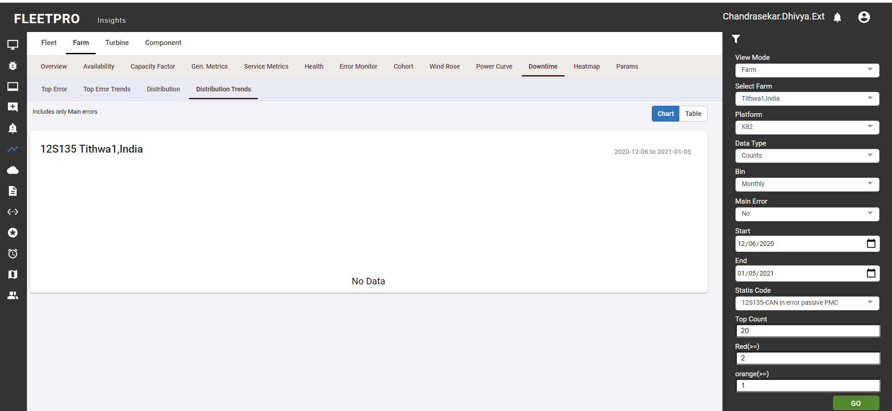

### Heatmap

This functionality provides data visualization for selected sensor. Values can be read by rolling the mouse pointer over the specific point in the heat map. CSV PNG format of the generated data can be downloaded by the user.The colour variation in the graph denotes defines how the values vary. For ex: red colour indicates the highest or peak value and blue colour indicates the lowest value.

* Value type in filter includes min/max/mean/std, select either one.
* Seconds in filter indicates to calculate the average of channel data as per provided seconds.

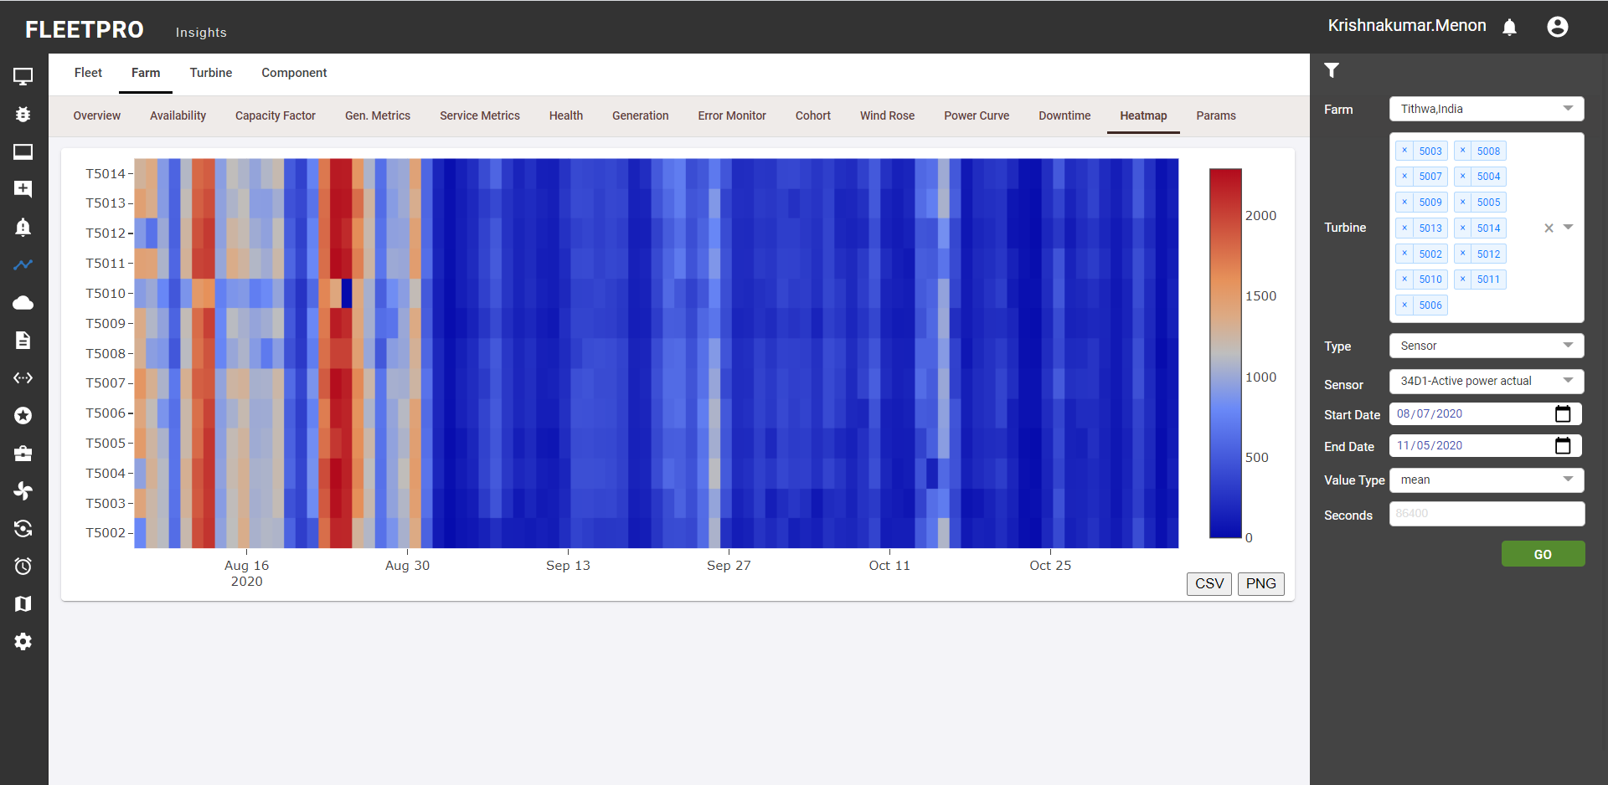

### Params

Displays the current parameter values present in the turbine. The parameter log displays the changes made in the parameter along with details of user Id and old-new values. CSV reports can be downloaded.

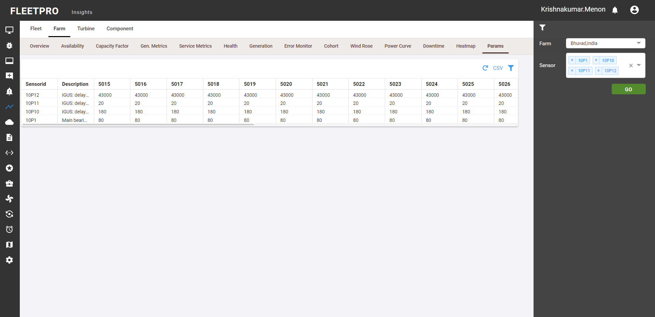

## Turbine

### Availability

* The "Technical Availability" of the Turbine is measured in hours and is regarded as the sum of the periods in which the Turbine Equipment is operational and available to produced energy under normal circumstances and local conditions (e.g. sufficient wind speeds, functioning electricity grid etc).
* Mode provides option to select Daily, monthly or 10 min average availability
* Data Quality denotes two values True if no issue, False if any issue or missing data.
* Data Source includes Field/Scada, can choose one to get the data from.

CSV format or the PNG format of the generated graph can be downloaded by the user.

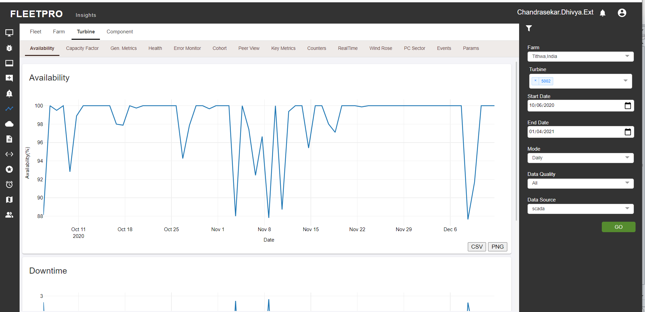

Fig 4.2.1: User gets the option to view the graphical representation of data for the selected values in the filter

### Capacity Factor

* Multiple turbines can also be generated in graph view
* Each line denotes a turbine (differentiated using colour)
* Frequency denotes Daily/Monthly level data
* Type denotes min/max/mean/std, can select any one of these values

CSV or PNG format of the graph generated can be downloaded by the user.

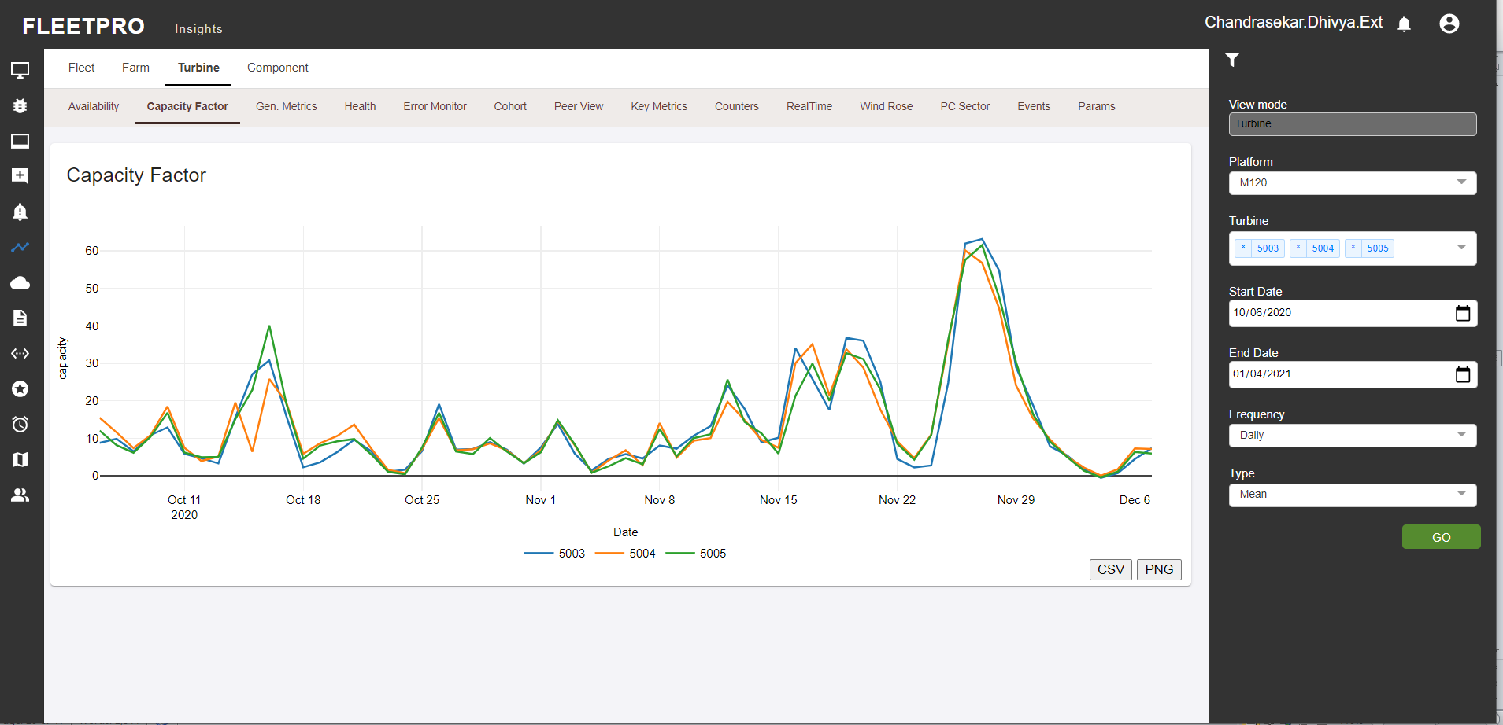

Fig 4.2.2: For the selected number of turbines in a selected platform the graph is generated

### Gen. Metrics

* Technical and commercial graph sub modules represent two different sections like LPF and LPF Technical, PBA and PBA Technical.
* LPF: LPF stands for Loss Production Factor, which means it’s a factor of how much loss there has been i.e. it tells for long there has been downtime and the asset was not operational due to that.
* PBA: PBA stands for Production Based Availability, which means the potential energy which is supposed to be generated at full performance under optimal circumstances.
* GEN: GEN stands for Generation i.e. the amount of energy produced.
* Mode denotes 10min/daily/monthly levelTime Label denotes (Full life, 7D, 30D) automatically set date range as based on the selected category

**Technical:**

CSV or PNG format of the generated graph can be downloaded by the user.

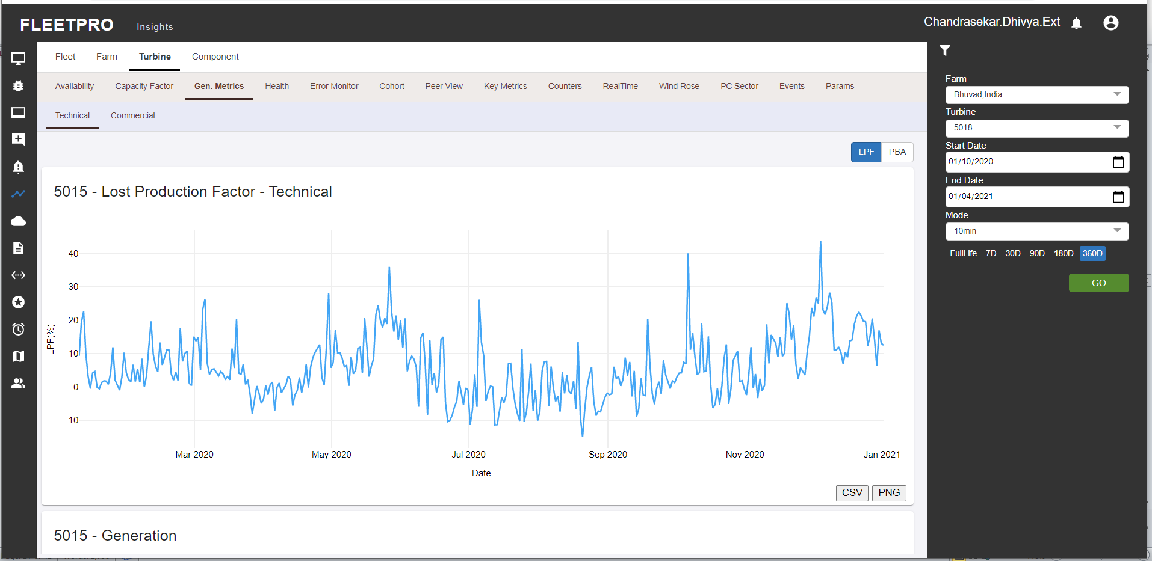

Fig 4.2.3.1: The graph generated for the options selected which can be viewed in LPF and PBA format

**Commercial:**

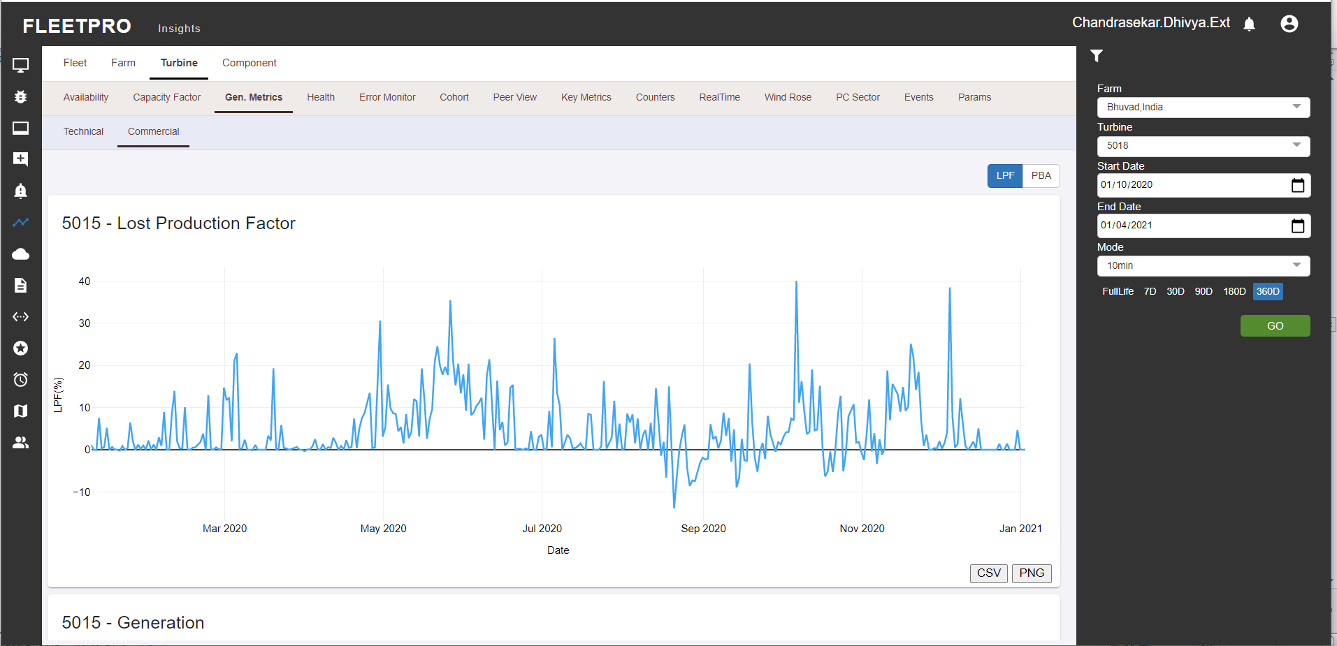

Fig 4.2.3.b Graph generated for the turbine in a particular mode selected by the user.

### Health

### Error Monitor

Error Monitor displays the most active or inactive errors.

* Error Log: displays the log file of all the active or inactive errors.
* Note on the Status colors in the tabular column (red and green) defines active (red) or inactive (green)
* Log- Log data definition and provides user to view Historical data (Add these)
* Specific tab in the log used for selecting the specific status codes
* Status type can be Error, information or warning
* Major error type denotes Yes/No, either to select the major errors or not. Active status denotes error is in active or inactive state.

**Monitor:**

CSV format of the generated data can be downloaded by the user

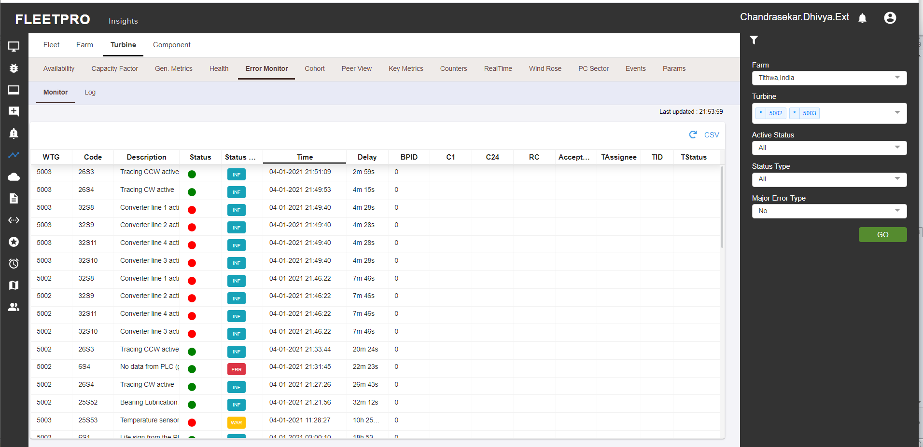

Fig 4.2.5.a. Error monitor lists the turbines for the selected set of values in the filter with the status

**Log:**

CSV format of the generated data can be downloaded by the user**.** Specific tab(For selecting the particular status code) detail can be added: Is used to select specific status codes for the selected duration.Status type can be Error, information or warning

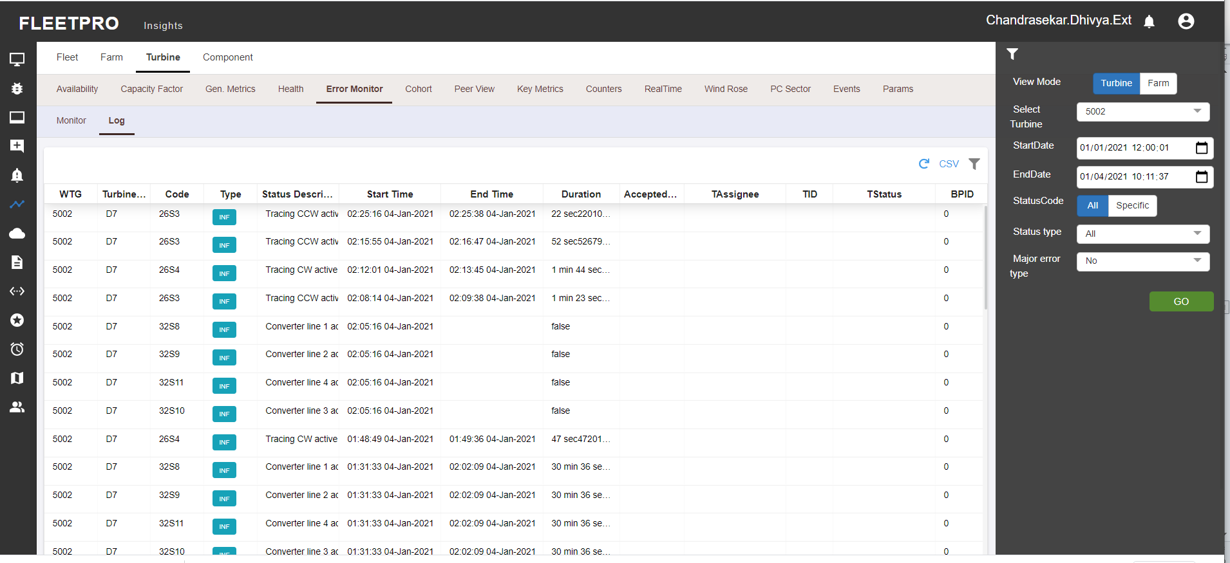

Fig 4.2.5 User can view the log data depending upon the values given in the filter by the user

### Cohort

* Filter out data based on provided sensor and its min and max value criteria.
* Rolling mean and normal mean difference and calculation(in means of day and seconds) is used to calculate Moving average i.e. average values for each row based on the rolling window specified and normal mean takes average based on defined seconds like 1hr (3600sec).
* On what basis the min max values are given (in add new sensor): to filter data based on defined range of the selected sensor. Type denotes min/max/mean/std
* CSV or PNG format of the generated data can be downloaded by the user

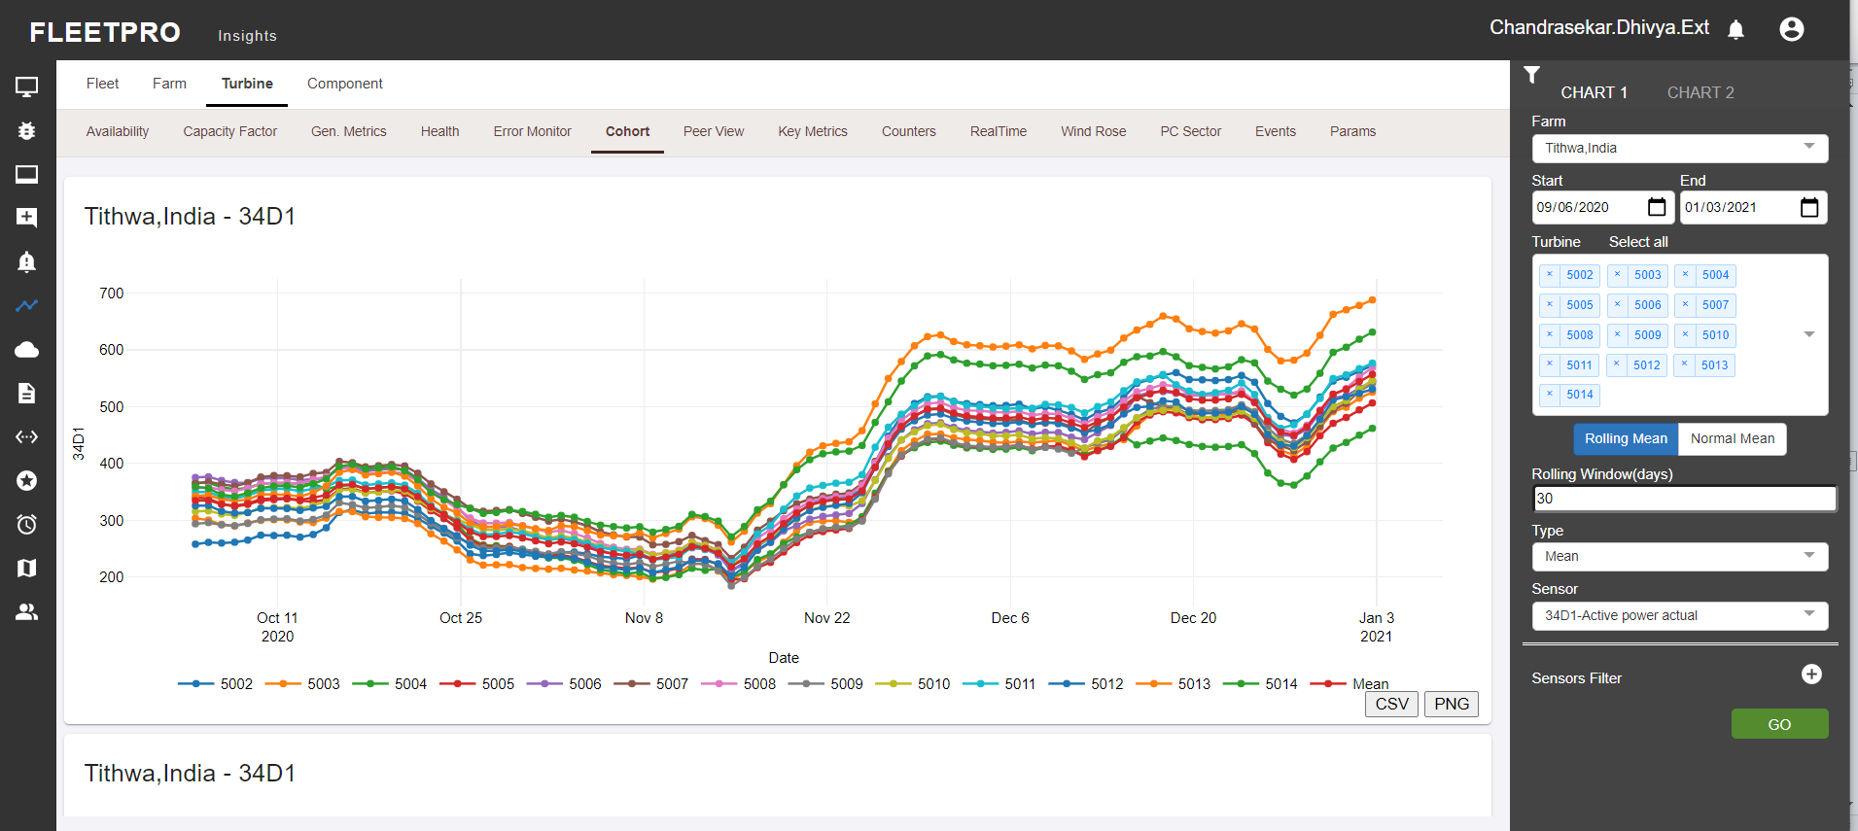

### Peer View

CSV or PNG format of the generated data can be downloaded by the user

* Graph must be changed and inter and intra turbine report info can be added (1 turbine with diff sensor and diff turbine with same sensor)
* Data Type can be scatter/line chart. Mode denotes 10min/daily level data
* Day, night, all denotes provides day level/night level/ full day data
* View of chart in list and grid format can change view depending on user convenience

Scatter:

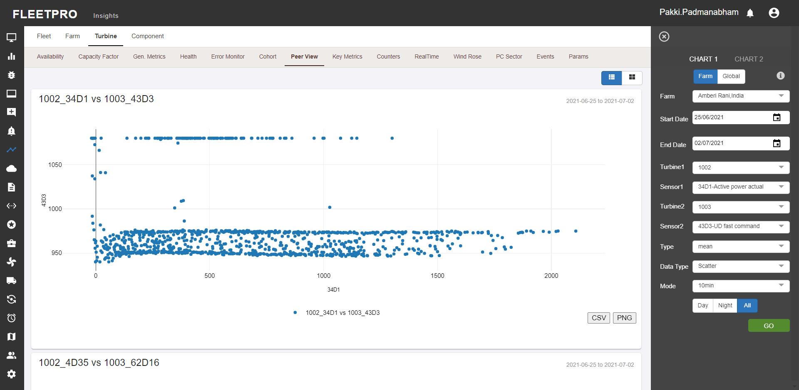

Timeseries:

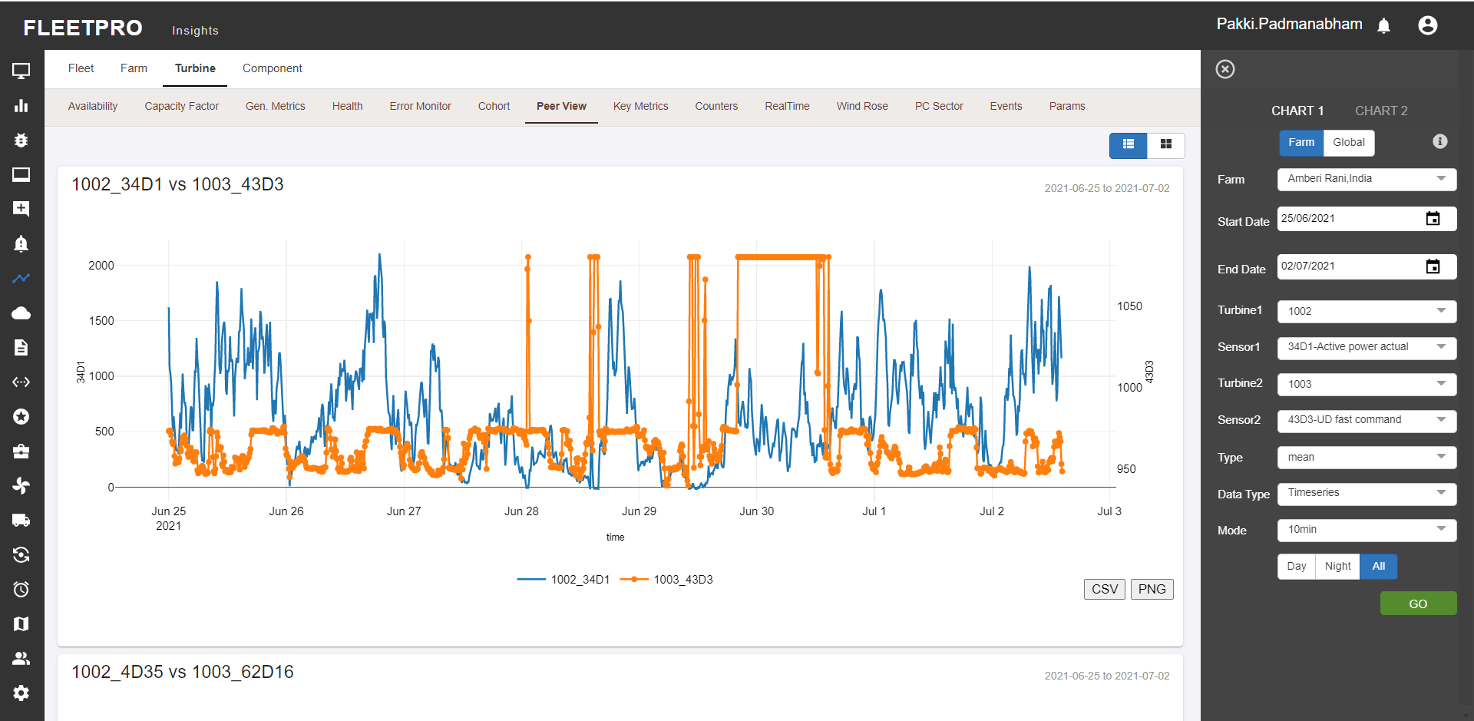

### Key Metrics

Key metrics facilitates graphical comparison of sensor values between the turbines. This helps to understand how two different turbines are performing during the same period.

* Power/WS: power curve; power generated based on corresponding wind speed
* RPM/WS: rpm based on corresponding wind speed; how much rotation per minute happened depending on the wind speed.
* Pitch/WS: pitch based on corresponding wind speed; what is the pitch angle to respective wind speed.
* RPM/Power: RPM based on corresponding Power; how much rotation per minute happened depending on the power.
* RPM/Pitch: RPM based on corresponding pitch; how much rotation per minute happened depending on the pitch
* Vane Align: provides info on the wind direction and the respective nacelle direction.
* ROT: provides info on the nacelle temp and the respective rotor temp.
* GBX: provides info on the nacelle temp and the respective gearbox temp.
* Bin type: wind speed binning (0.5/1). Air density denotes the density of air at what calculations are done (1.15 is standard). Wind speed denotes sensor for wind speed
* Time period 2 denotes selection of 2 different time periods to get data for.
* X axis and Y axis denotes selection of X and Y axis sensor

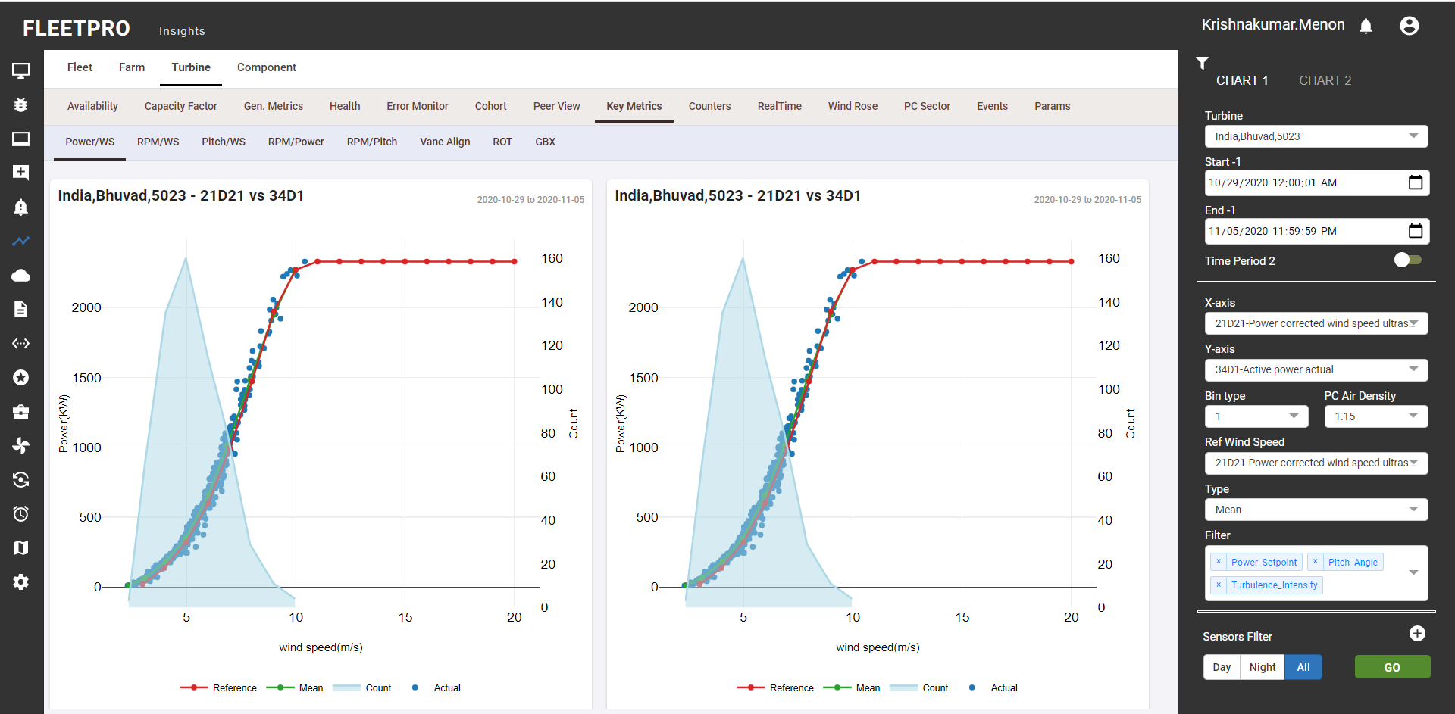

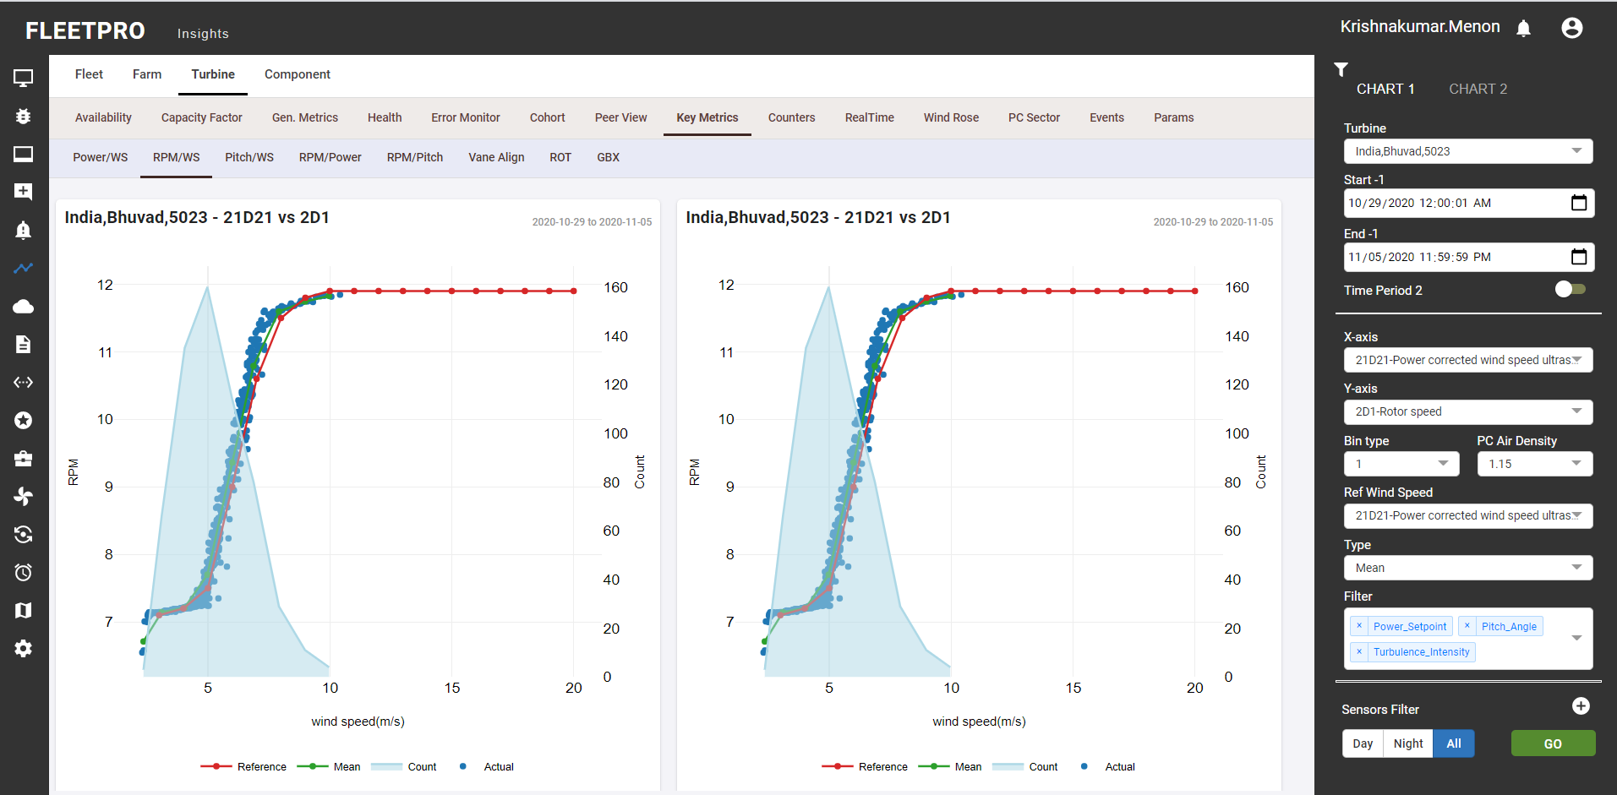

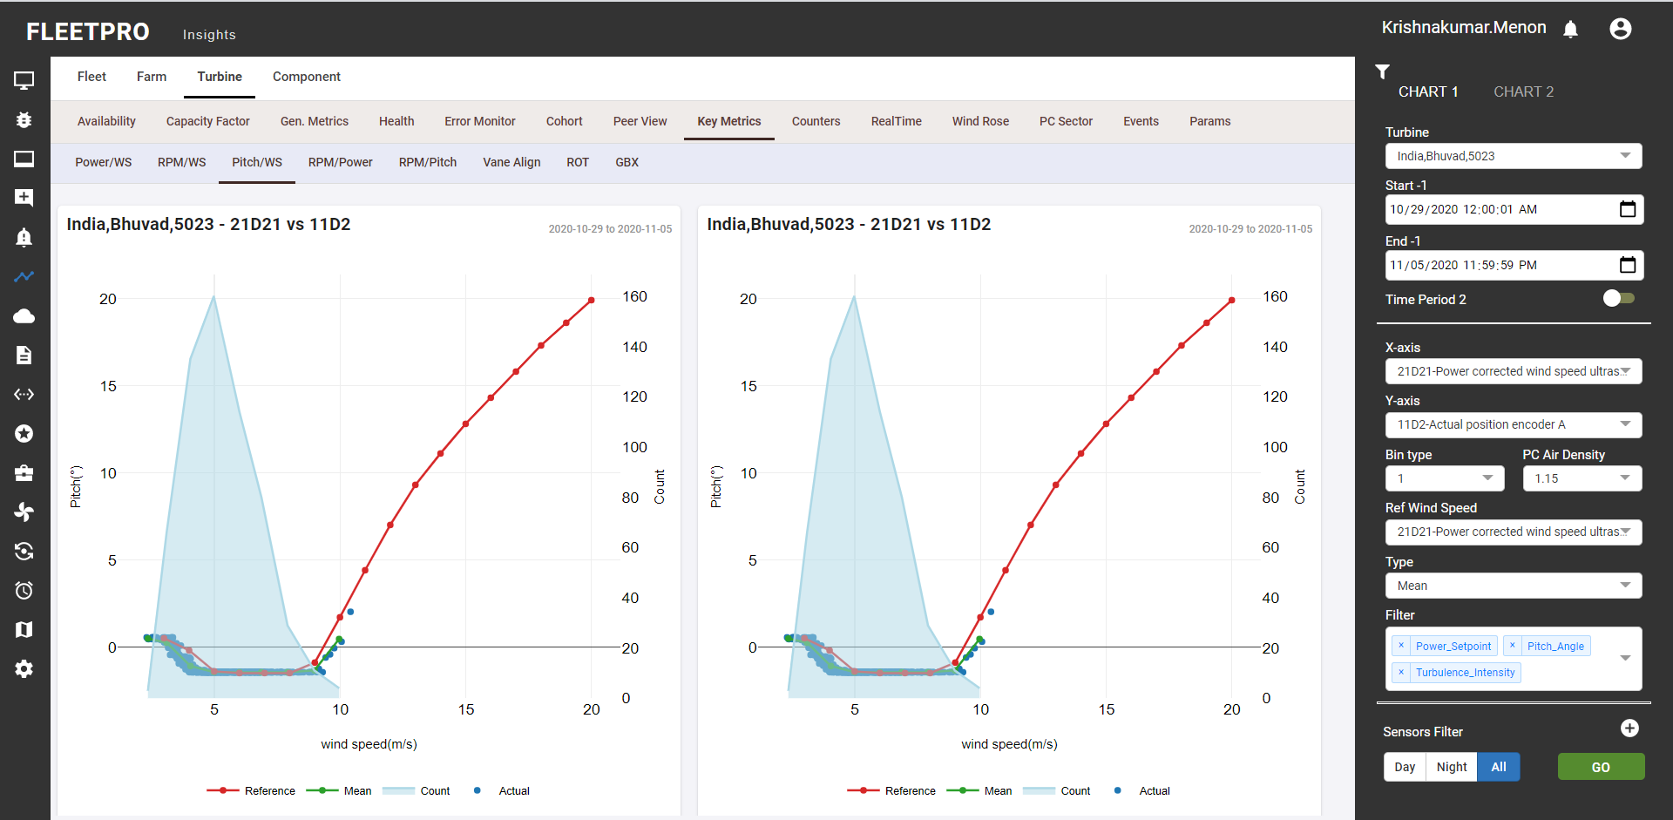

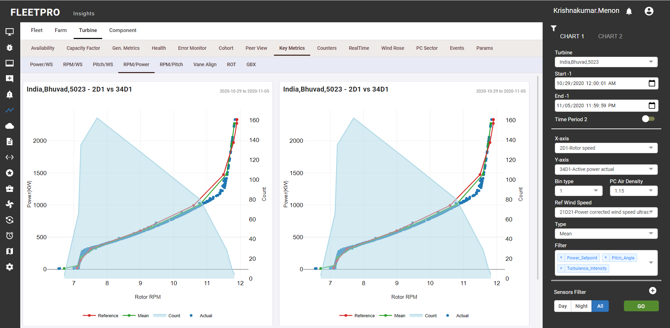

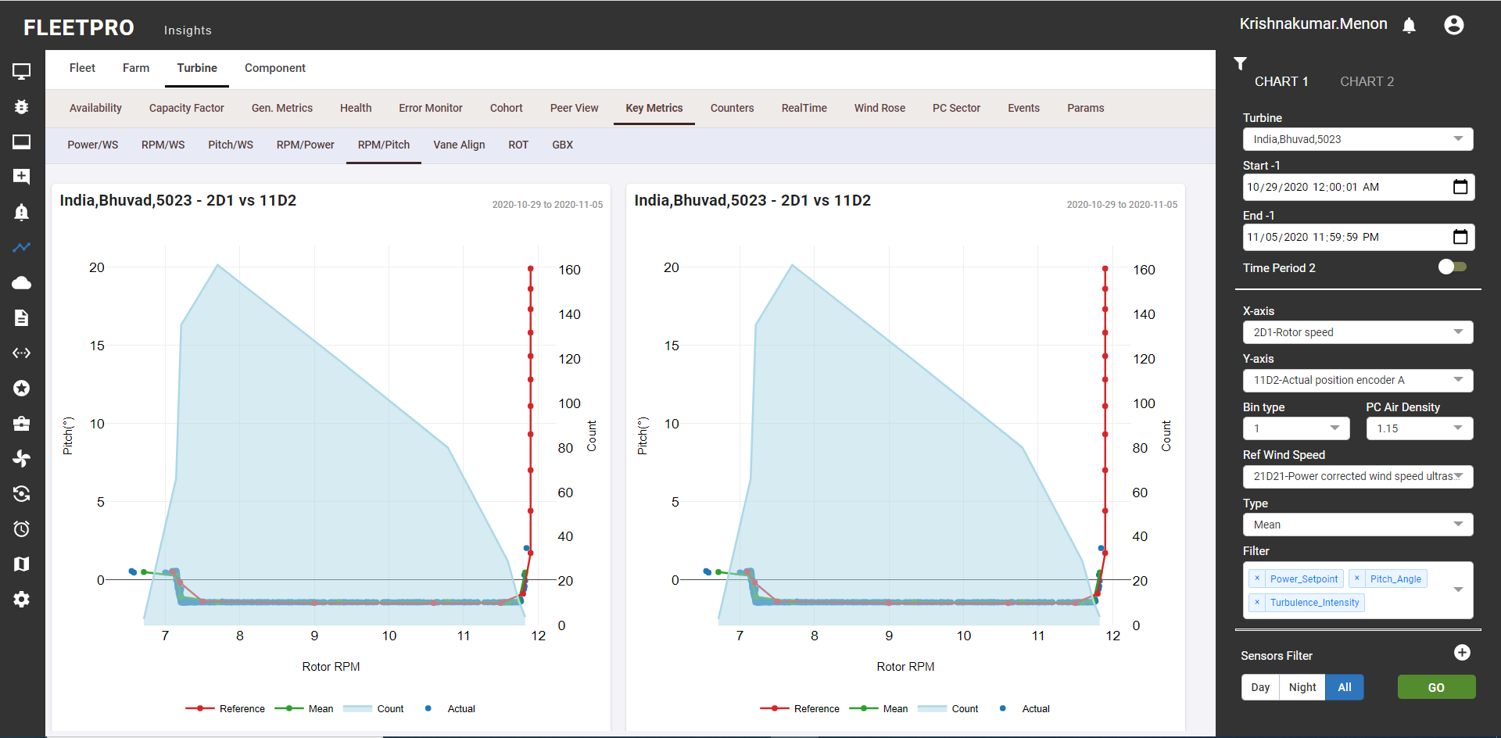

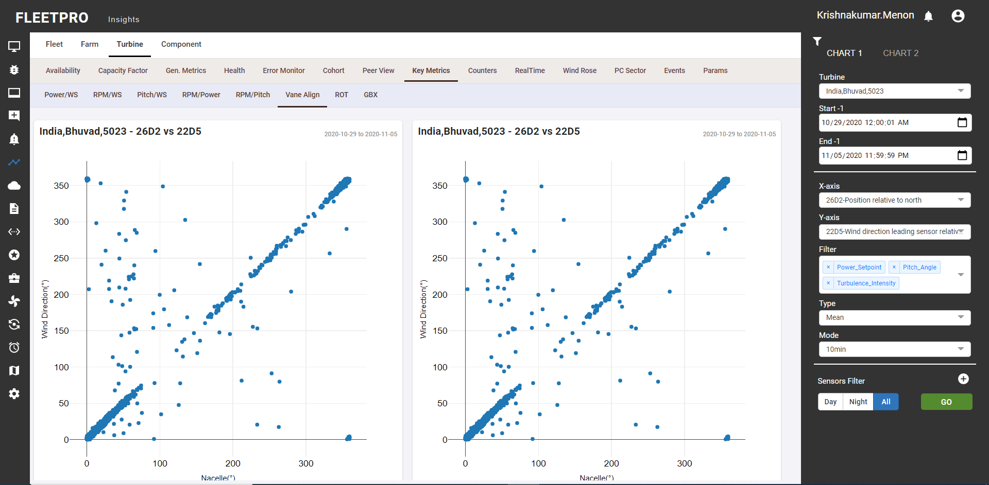

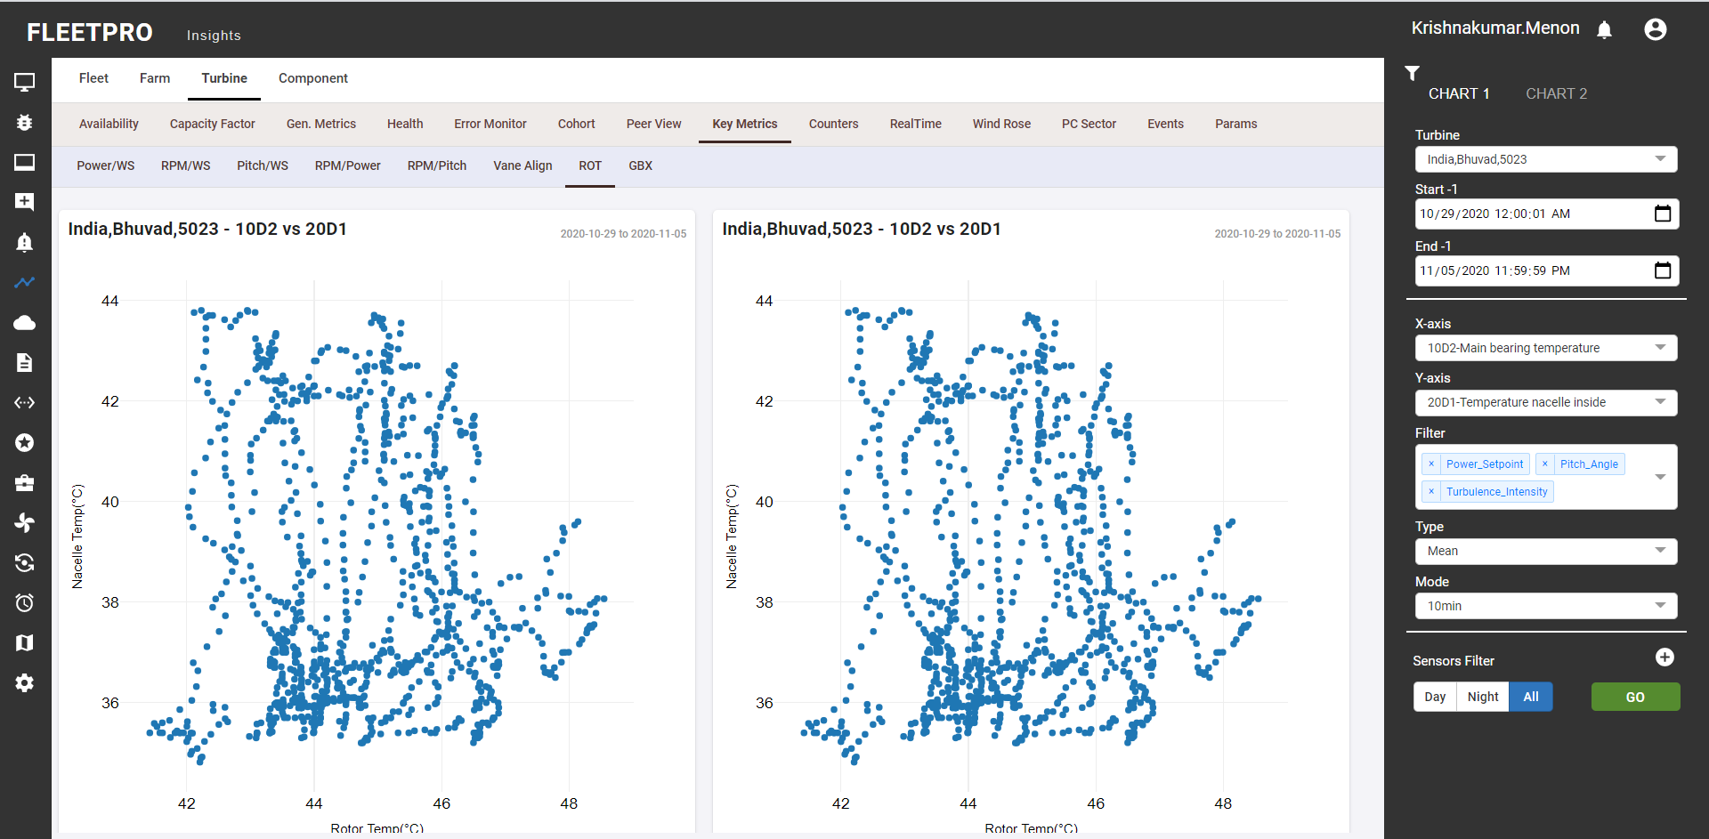

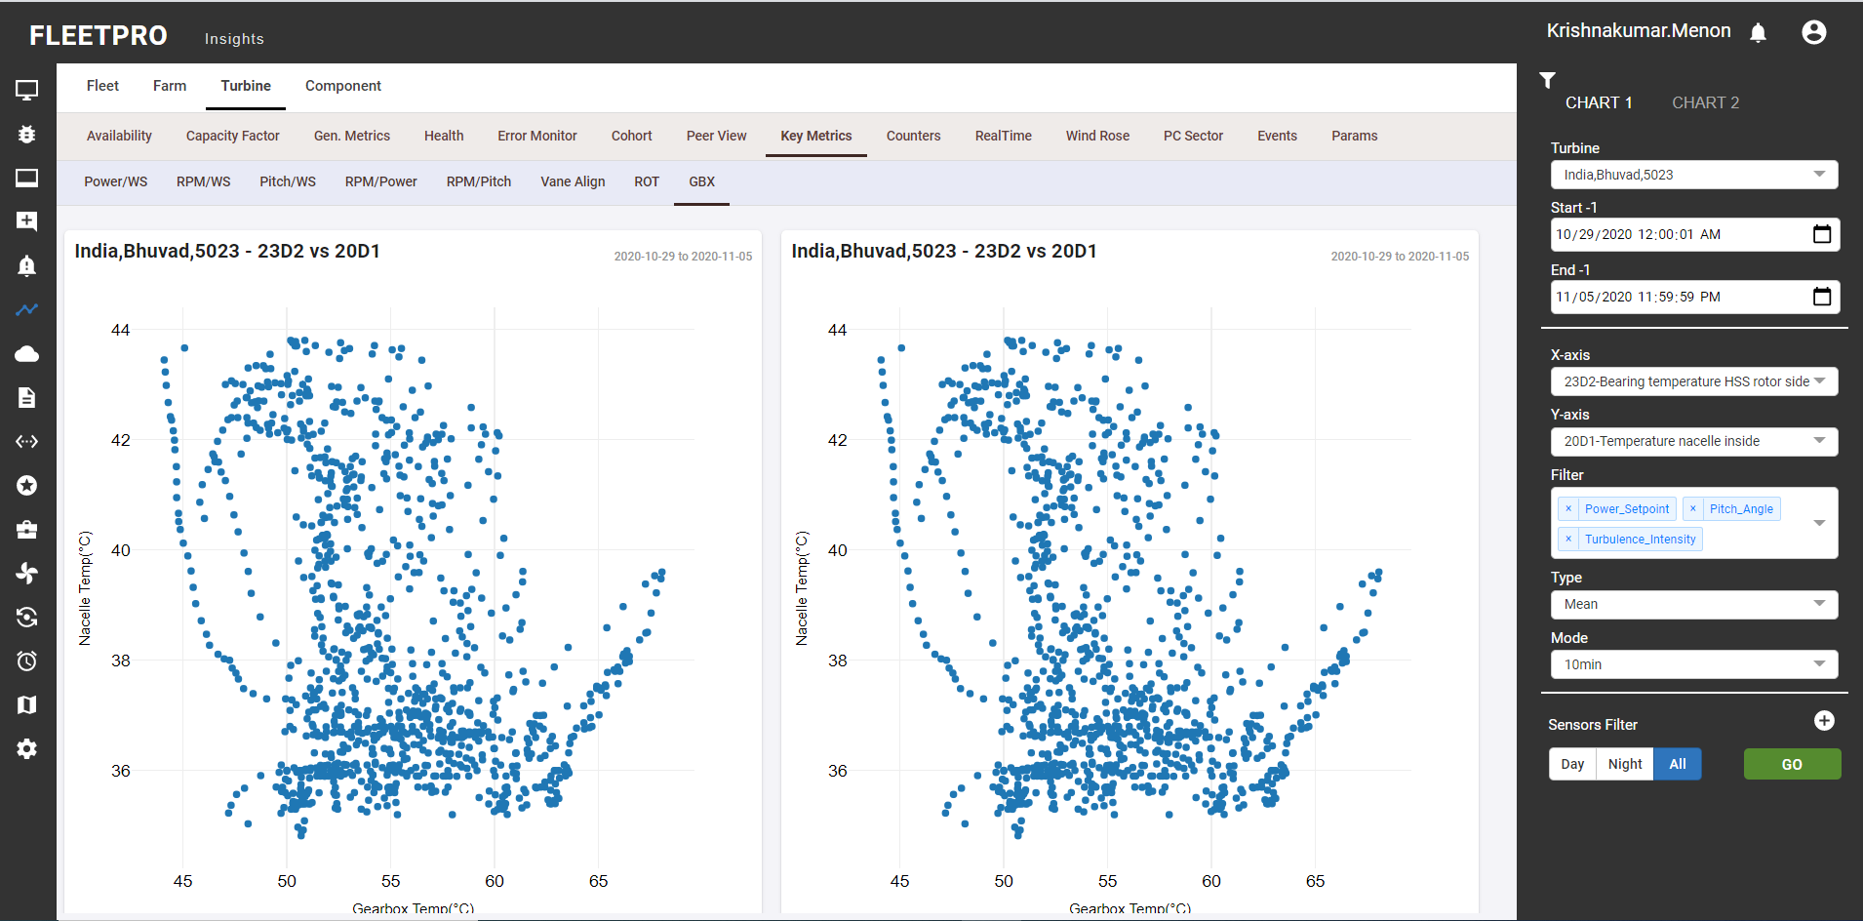

### Counters

* Type (Actual and diff) section provides data related to counters
* Aggregation: Raw/Daily provides data in the selected order.
* 10 min level or daily level respectively
* Graph with single turbine with the respective counter
* Graph with multiple turbine with the counter selected can also be pasted.
* CSV or PNF form of data generated can be downloaded by the user.

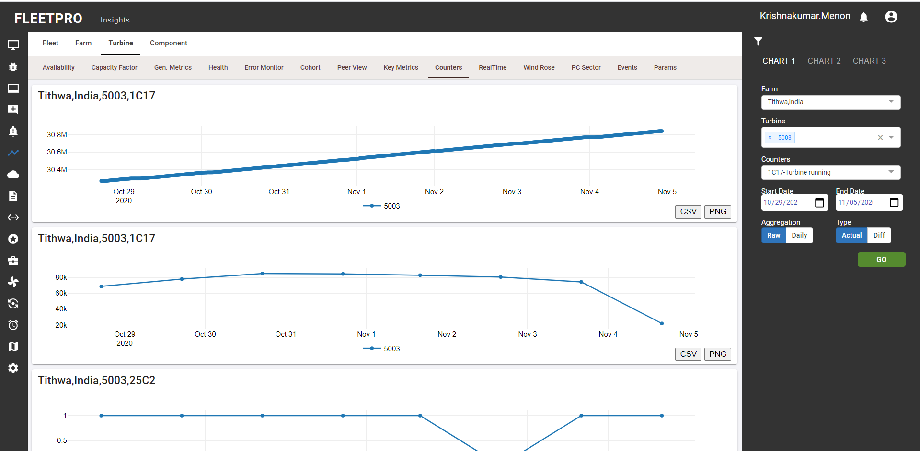

### Real Time

* Real time and the Sensor selection provides real time generated data for selected sensor.
* Operation: This will give the real time data for the selected turbine and sensor at 10 min level. CSV or PNG format of the generated data can be downloaded by the user.

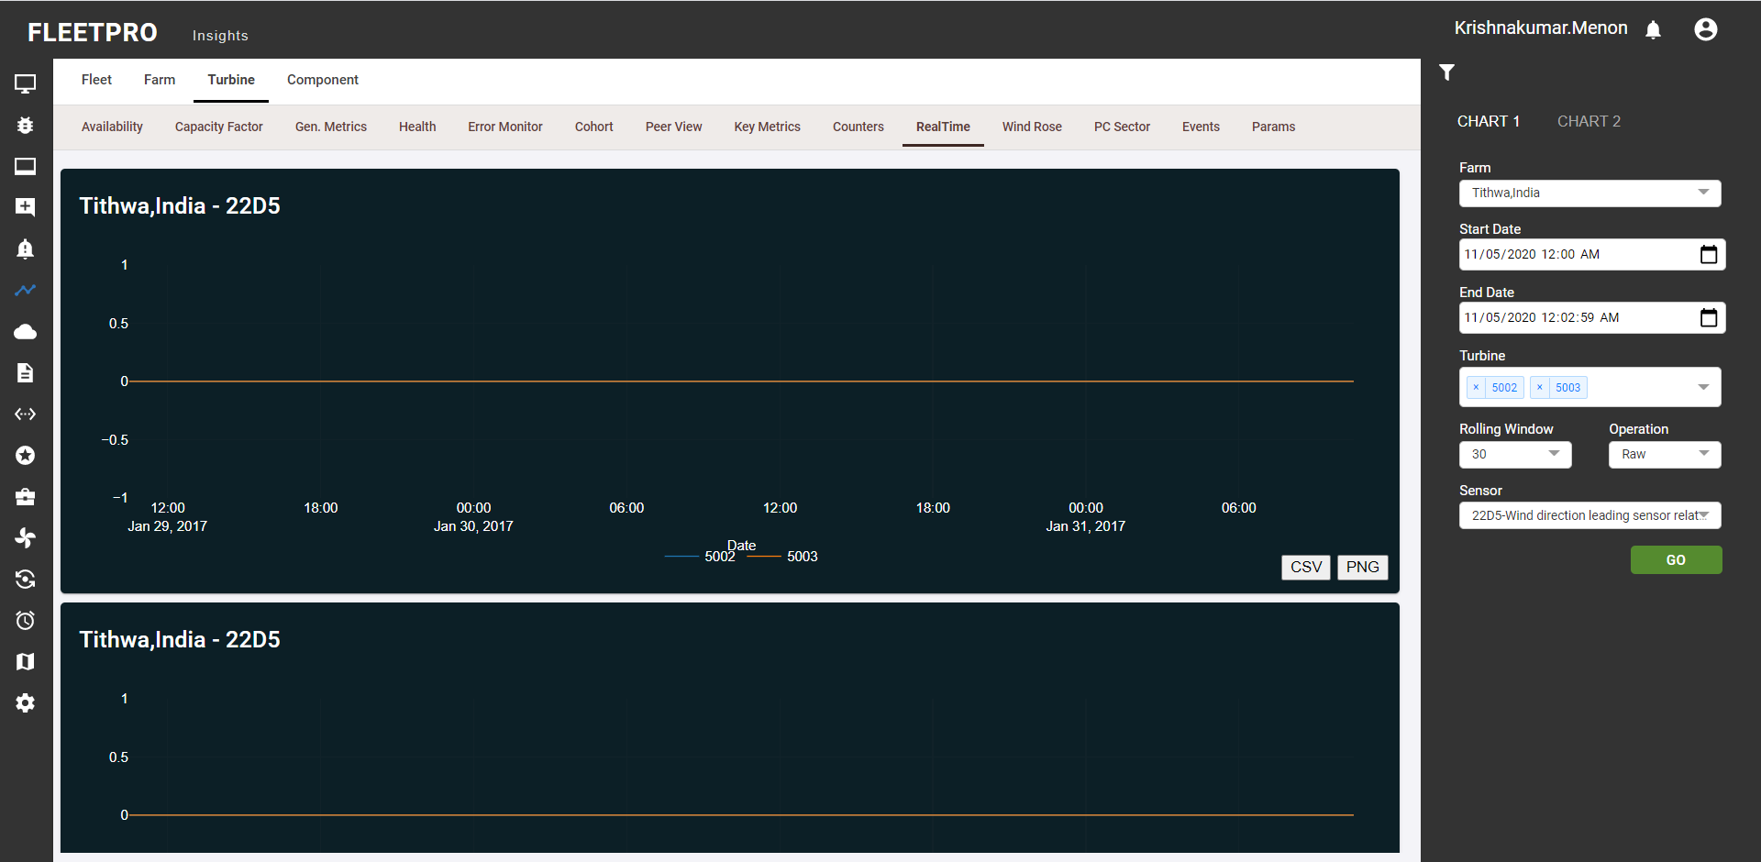

### Wind Rose

* Compare: This section allows us to compare wind rose graph between 2 turbines.
* Annual: This section provides the behaviour of wind direction and the corresponding wind speed for the complete year in format of month-wise.
* Farm View: This section gives the wind rose result for selected farm turbines.
* Map View: This section provides the map view where turbine is located and its corresponding wind rose to get better picture of where the turbine is located and details for wind direction and speed.
* Clear image on how the annual and map view is generated
* Wind speed bin width: defines the width of binning wind speed.
* Wind speed start: starting value for wind speed.
* Wind speed end: ending value for wind speed.
* The comparison is made in the compare sub module by selecting 2 different turbines and can check how much wind direction is varying at 2 different locations.
* Each color in the sector denotes the range of wind speed.

**Compare:**

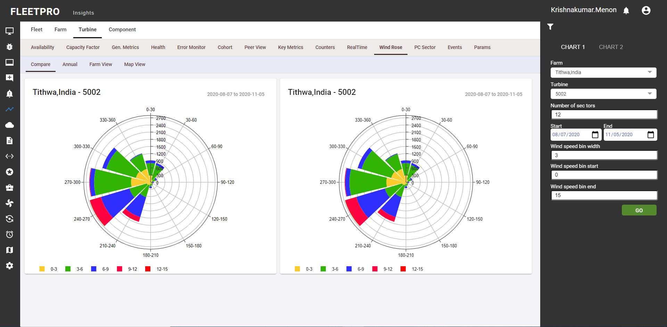

**Annual:**

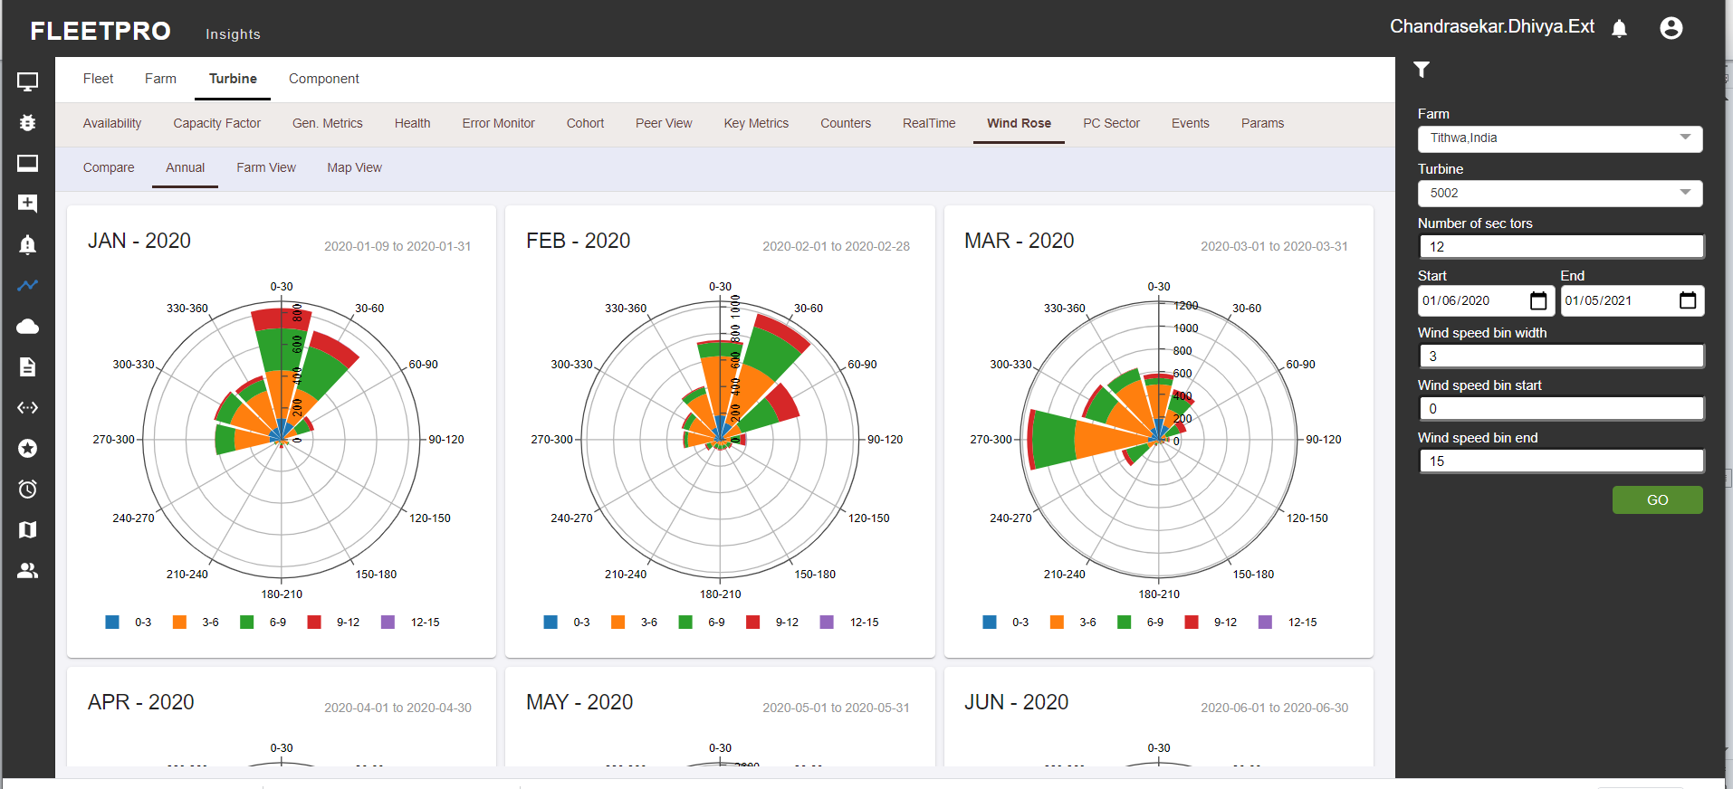

**Farm View:**

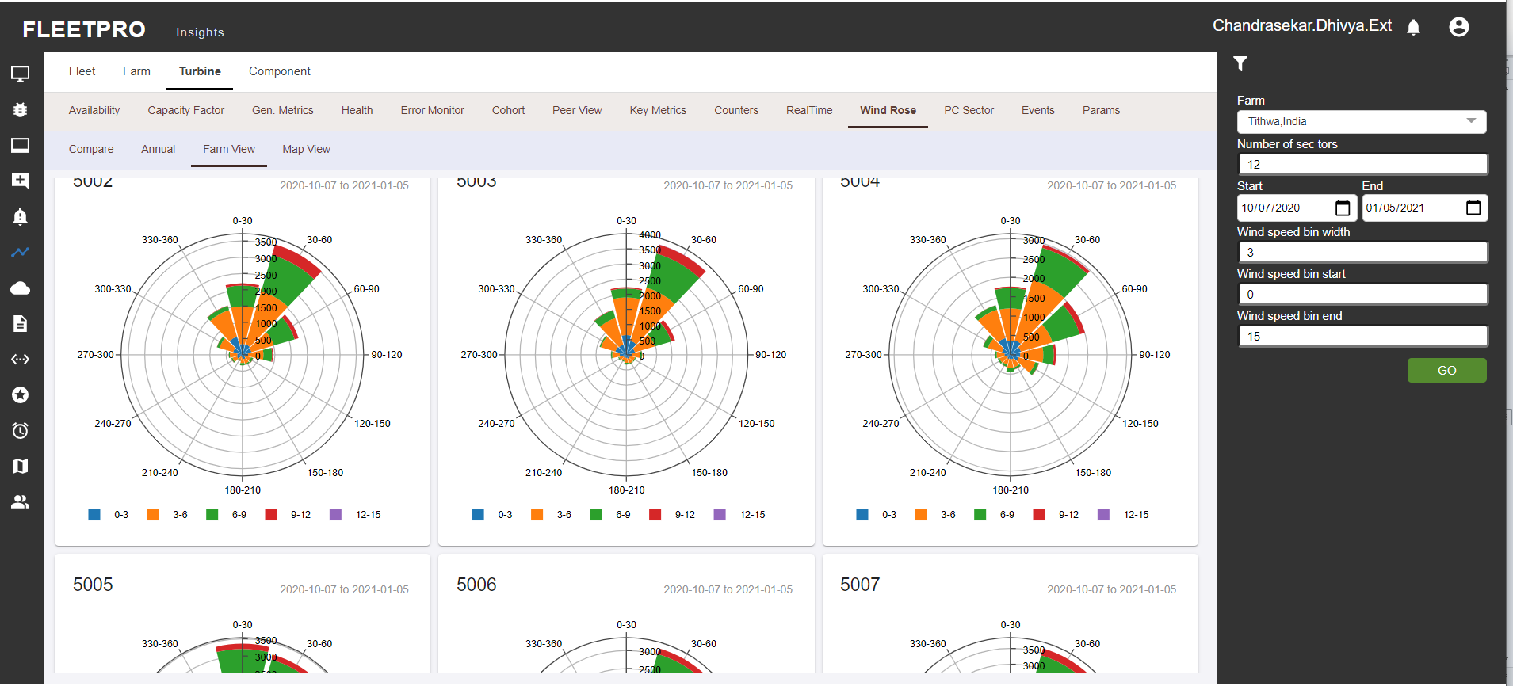

**Map View:**

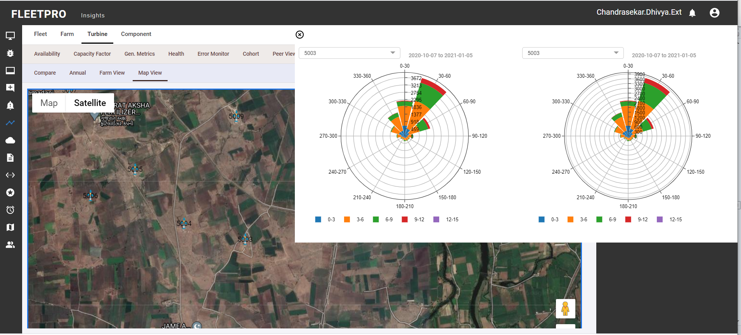

### PC Sector

* Sectors are divided based on the wind directions, for corresponding direction range the power curve is generated (like 0-30,30-60,…)
* X axis Y axis and wind speed denotes: X-axis – wind speed and Y-axis – power
* Bin type: binning done on wind speed can be 0.5 or 1
* Air density: ref curves values are generated at the corresponding air density like 1.0,1.15 etc. Direction sensor: provide the sensor name to consider to divide into sectors.
* Day night all tabs are used to get data for either day/night time respectively. Data in the filter denotes options to filter out the data points to get the outcome under set of circumstances.

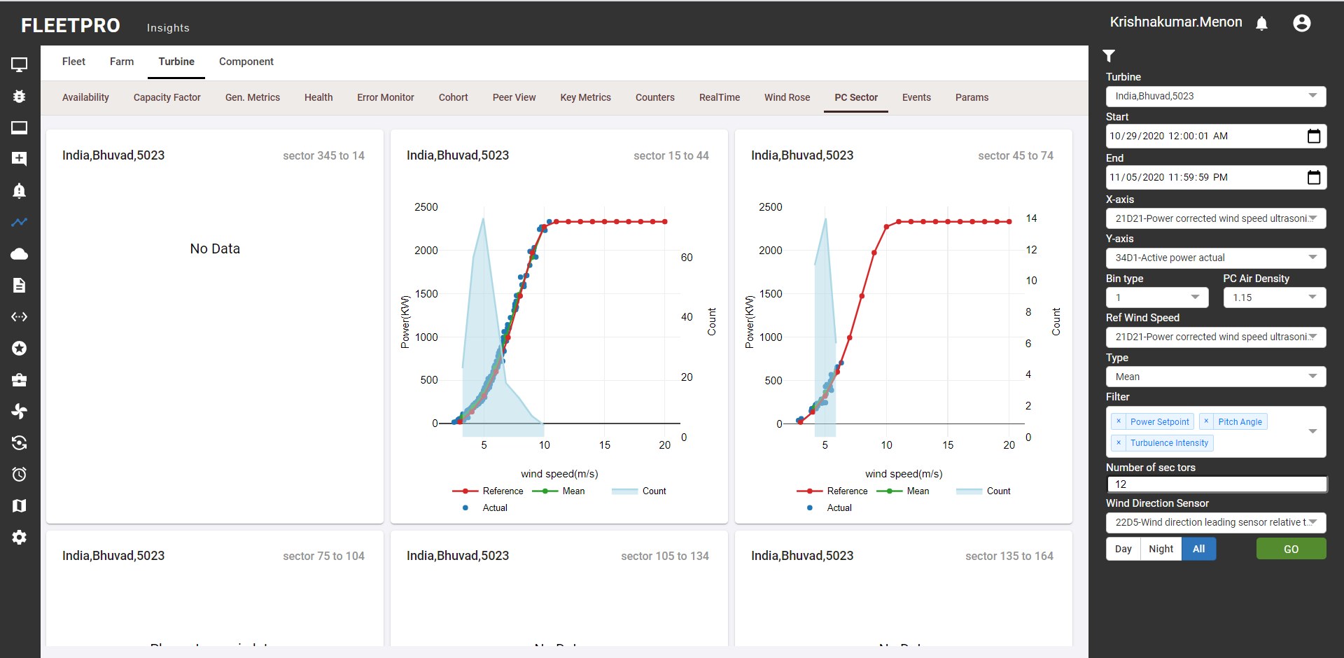

### Events

* Events basically provides the input to understand when a particular event happened, post that is the turbine generating or stopped or any rise in temperature etc.
* Mode option and sensor axis can be explainedMode: 10min/daily level
* Sensor Y-axis1 and Y-axis2 represent two sensor data on sample graph. Status code category denotes Error/Information/Warning. Need of two Y axis are used to to understand the change in values for two sensors. CSV or PNG format of the file can be downloaded for the generated set of data

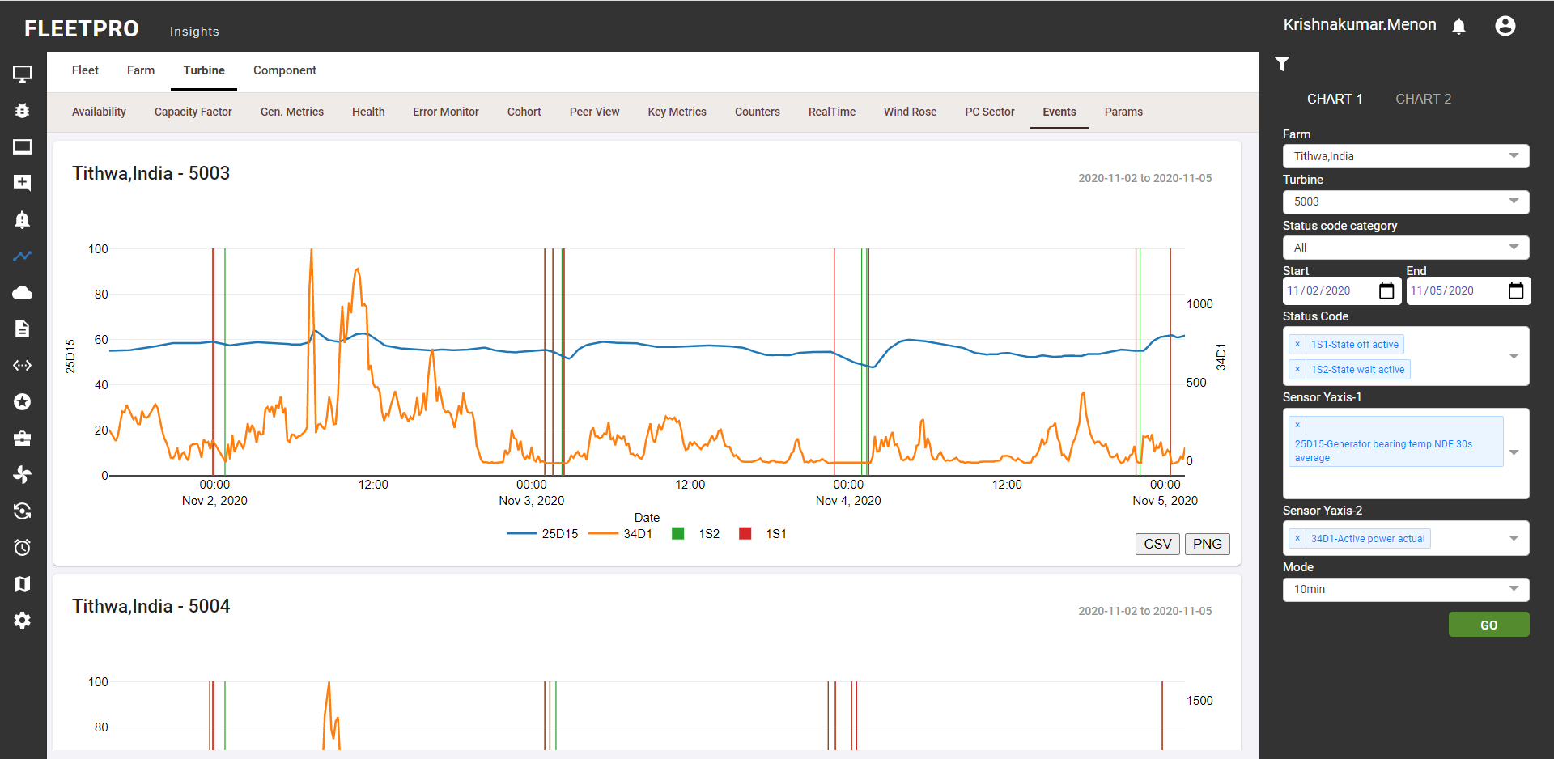

### Params

The log file is updated whenever the parameter value is changed by the user. This log file will consist of both old and new value. The latest parameters in the turbine and the change log can be viewed in this functionality.

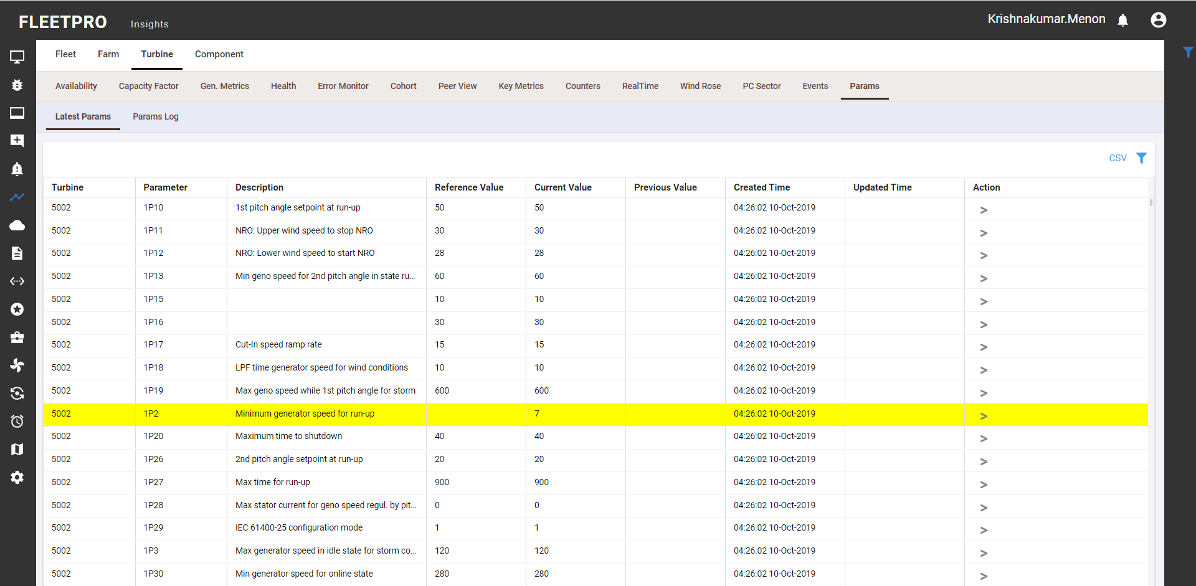

The parameter log displays the details of old and new values along with the user ID who changed the value. This helps us keep track of historical parameters.

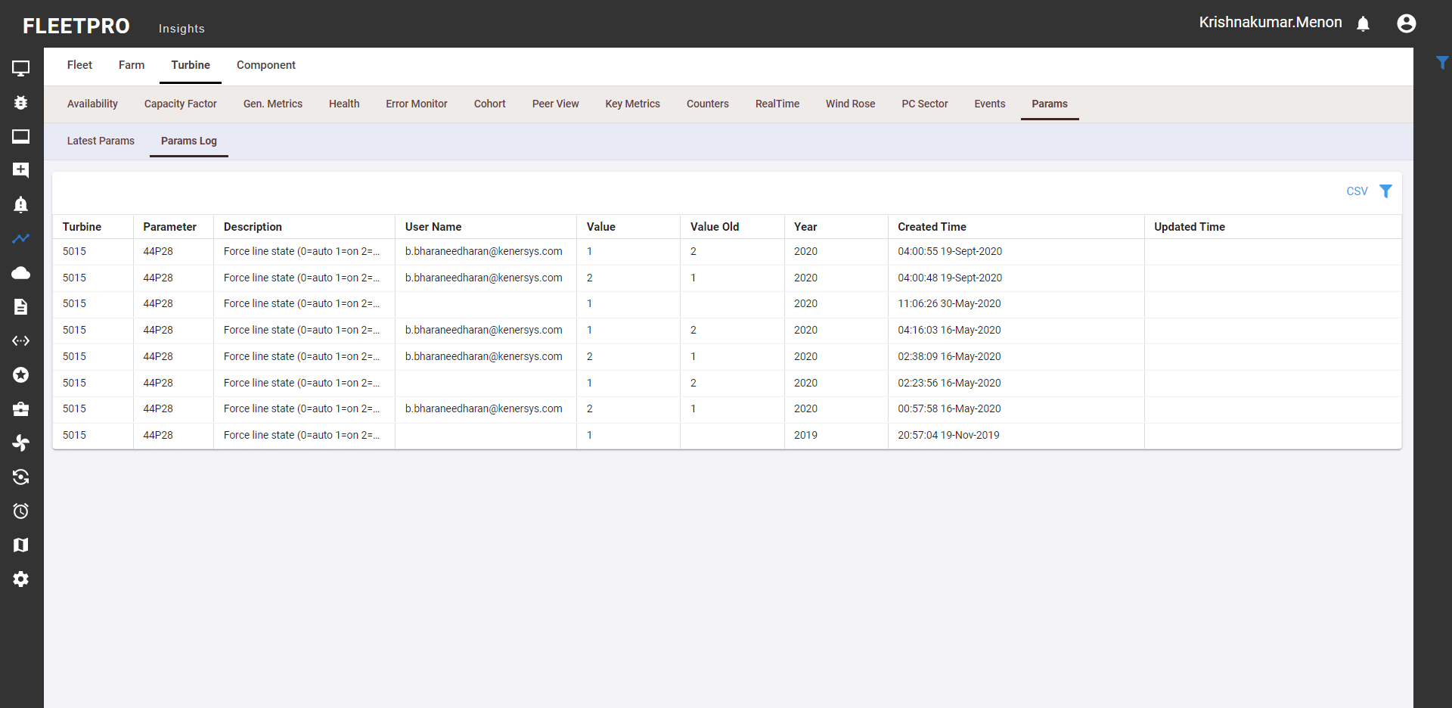

# Ticketing System

Ticketing system is used to log the error resolution process. Below mentioned is the flow diagram.

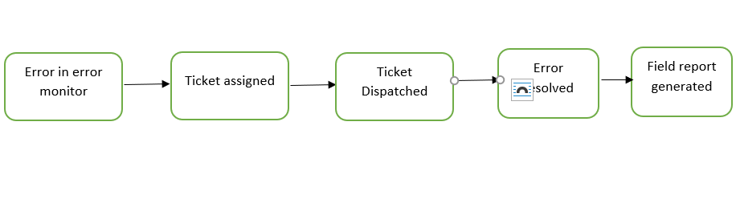

**Ticket Creation:**

1. Once error is displayed in error monitor, the error is then assigned to site personnel using a ticket.
2. Ticket is created by the user for the respective error (in tickets module) / in error monitor. The site person receives email for the ticket raised.
3. The ticket that is created by the user is seen in My tickets
4. The user can perform edit actions(edit or save) in My tickets
5. The tickets assigned for the user is seen in assigned tickets
6. User can either accept or reject the tickets
7. Based on the ticket details site person takes necessary action and resolves the error.
8. Accepted tickets can be submitted by the user
9. Submitted tickets are approved in the approvals (EASY APPROVE) which will be later displayed in the ticket history
10. After error resolution the field report is generated by using the inputs entered by Site person.
11. Ticket history displays the overall history of all the tickets which are submitted approved

**Ticket Creation in Error Monitor:**

On accepting the issue, the user can create the ticket. Created ticket is dispatched in the My ticket (can be added)

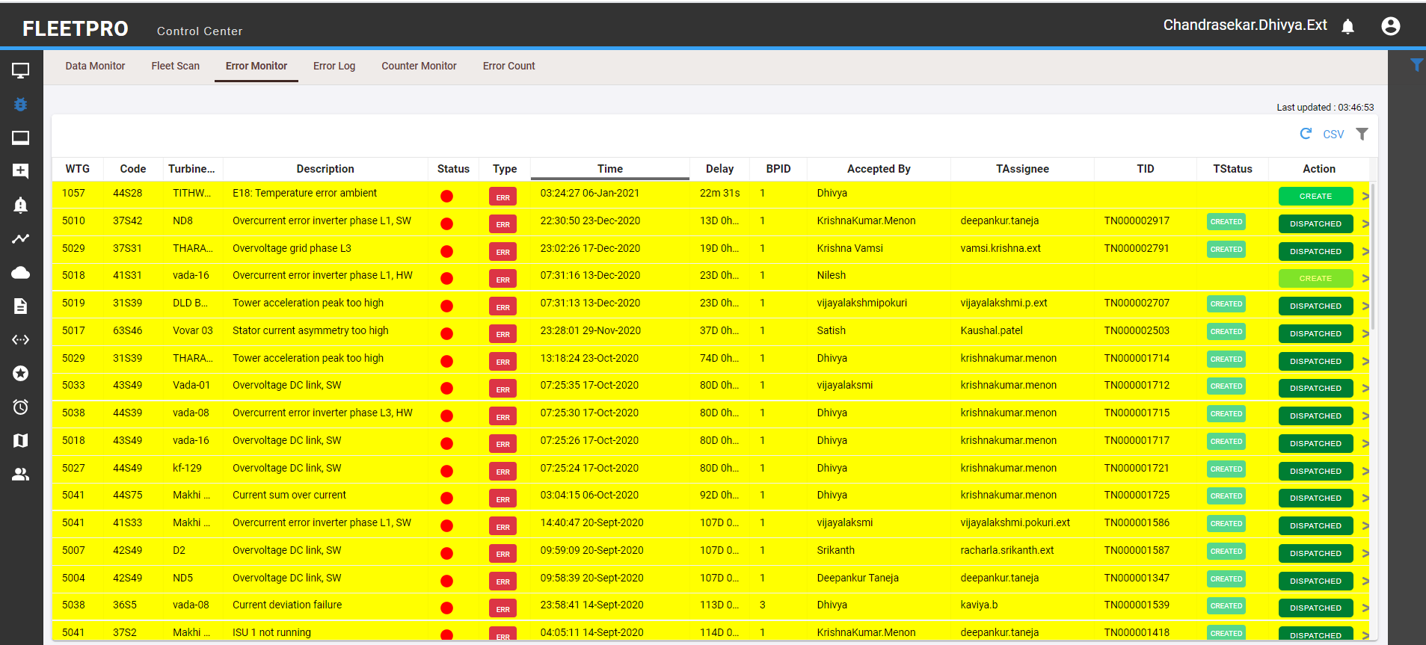

By accepting the issues from the click of status code, the user can create the ticket. The description and type of the error can be mentioned by the user. Once the ticket is created the user gets a notification that the ticket is successfully created. The user can view the created ticket in the My Tickets.

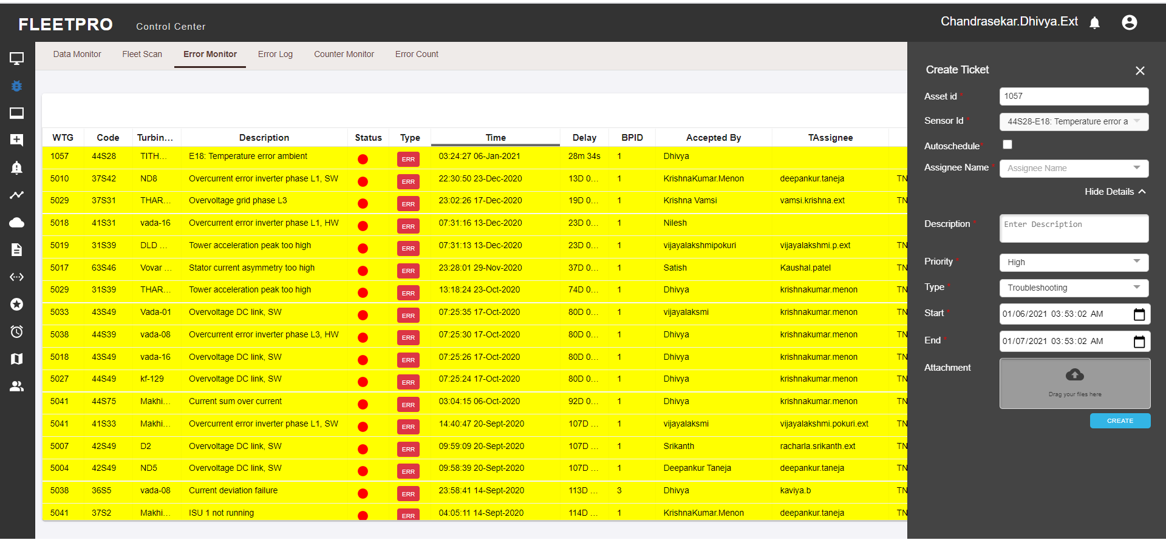

**Ticket Creation in Tickets Module:**

* Tickets are created and assigned to a member
* Any conflict in the ticket creation is indicated to the user

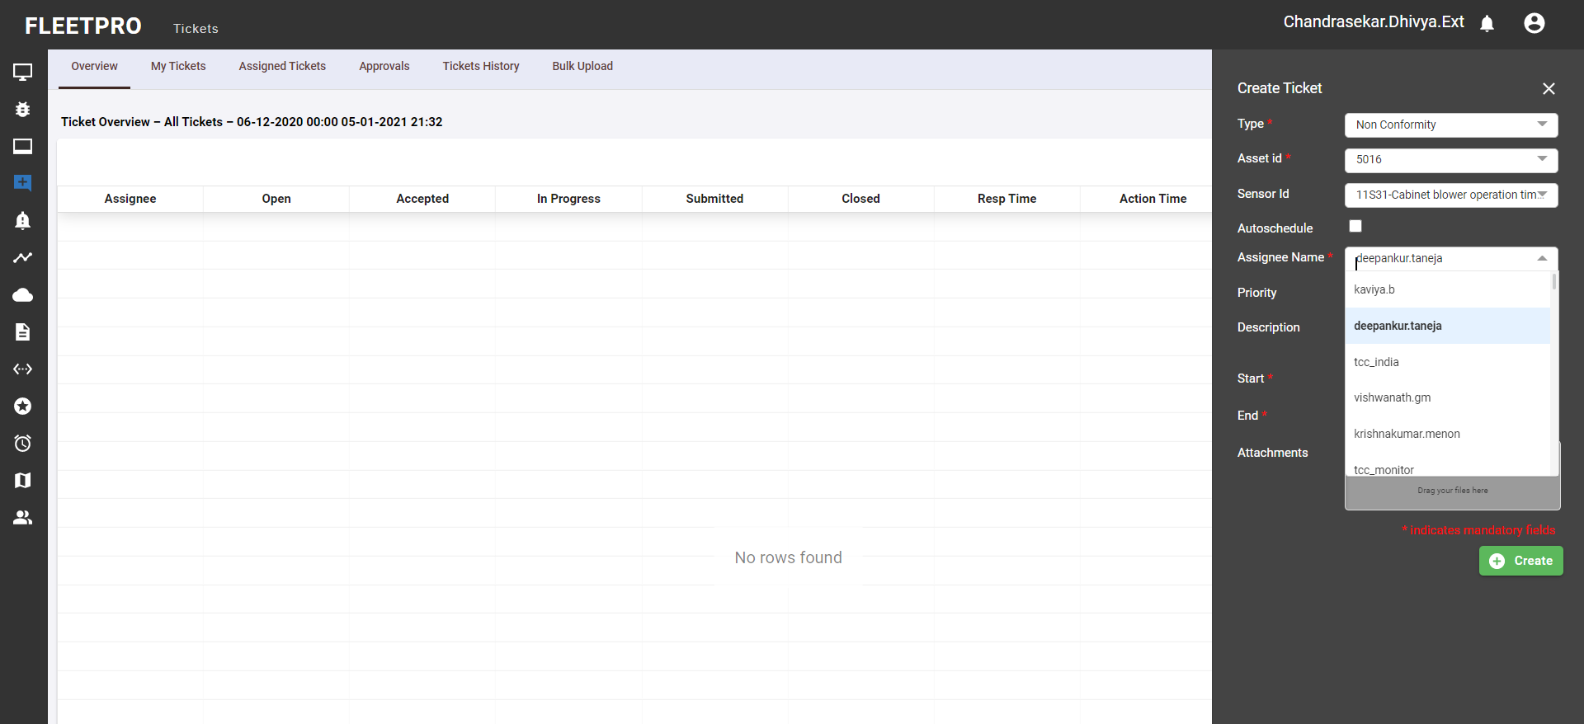

## Overview

Overview tab provides list of the tickets created by user. This displays the assignee, ticket status and response, resolution time.

* It provides visual understanding for the count of tickets based on the status of ticket (created, accepted, submitted, approved). Response time: difference between acceptance of issue and creation of issue
* Action time: different between submission of issue and acceptance of issue
* Resolution time: difference between approval of issue and creation of issue

Csv file can be downloaded for the generated set of data. Group in the filter denotes the type of tickets that are to be displayed.

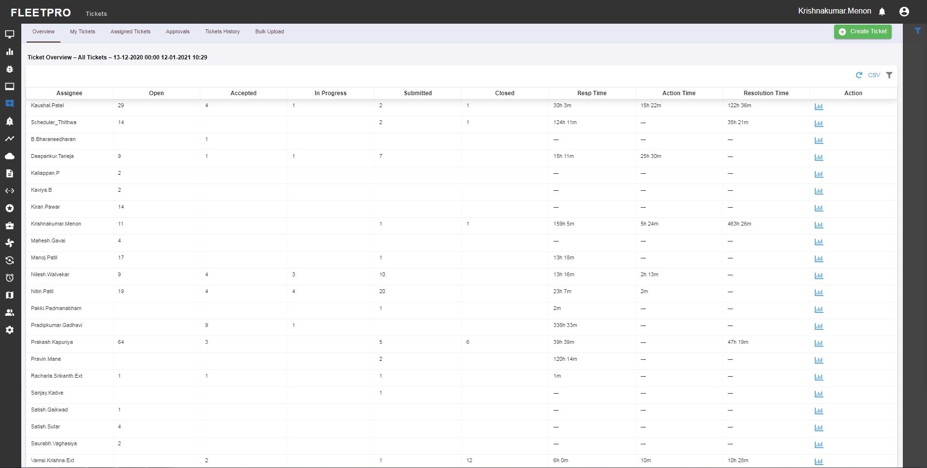

## Tickets

Tickets that are created by the user are displayed in the My tickets. User can perform edit actions in the ticket. The lock symbol beside the ticket id denotes the tickets that are open and are yet to be submitted. Delay here denotes how long the error has been opened and repeat denotes the number of times the same error has occurred.

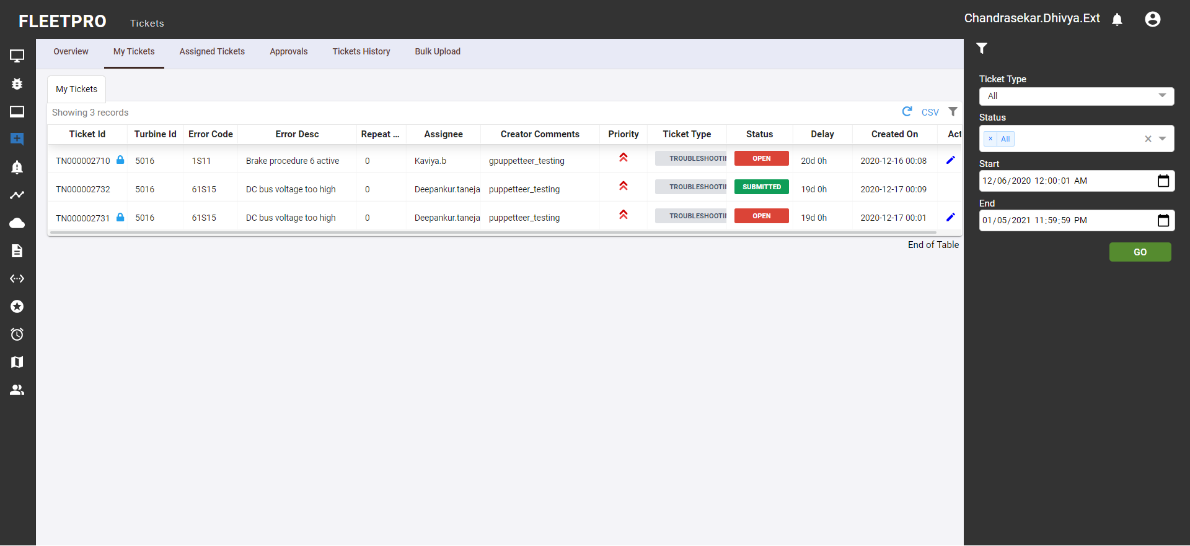

**Edit Action in My Tickets:**

User can perform actions like editing the assignee name, priority of the error and add Comments. Once the edit function is done the user can save or discard the changes made. NOTE: User can perform changes only for the open tickets.

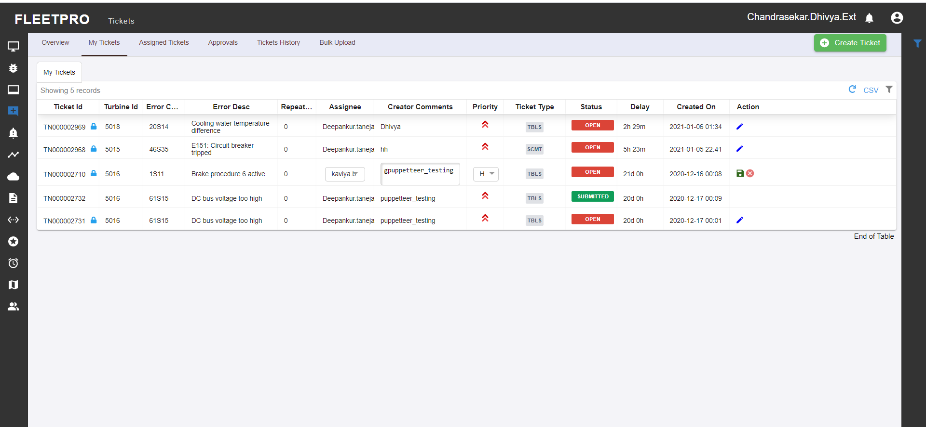

## Assigned tickets

Assigned tickets display the tickets that are assigned for the user by another user. Status in the filter bar denotes the type of the ticket id. Lock symbol beside the ticket id denotes the open tickets. Delay here denotes how long the error has been opened and repeat denotes the number of times the same error has occurred.

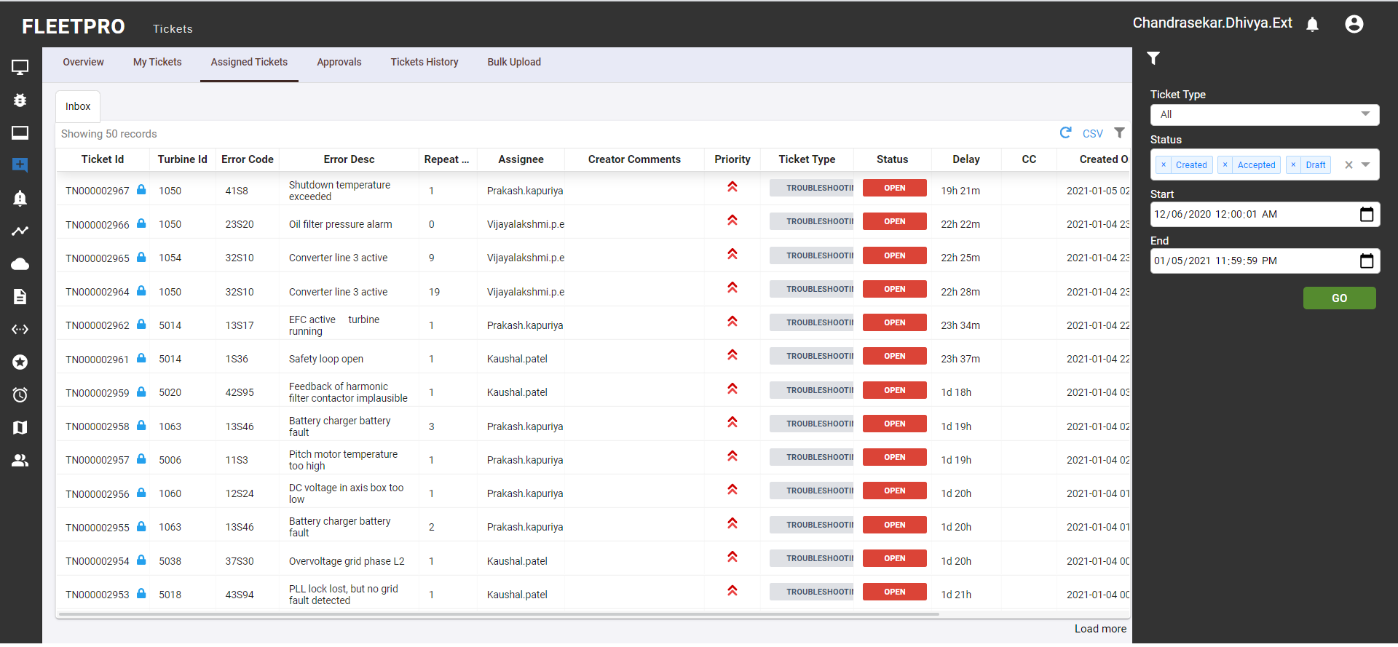

**Edit Action in assigned tickets**

User can accept or reject the ticket in assigned tickets. Accepted tickets can be submitted (By click of EASY SUBMIT). Then the user can Approve the ticket (By click of EASY APPROVE). The user can add another user in CC by providing the user id in the Shared with option

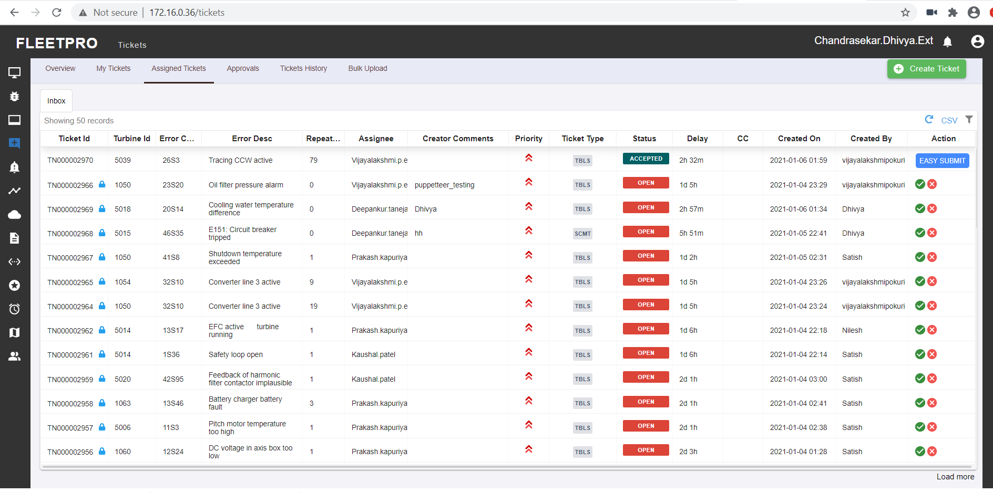

**Ticket detail view option:**

* Asset History: It displays the list of same issues previously created for the same asset.
* Material consumed: in order to do the necessary repair

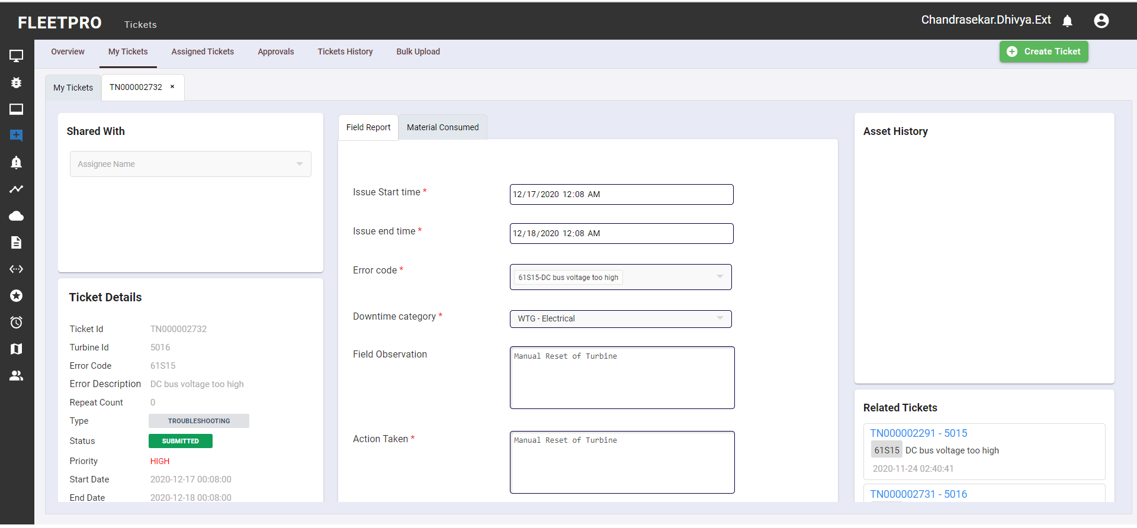

**Add user in CC:** The user can share the ticket with another user by adding the id of the user. Once it is shared it will be displayed in the table and the confirmation message will also appear at the right bottom.

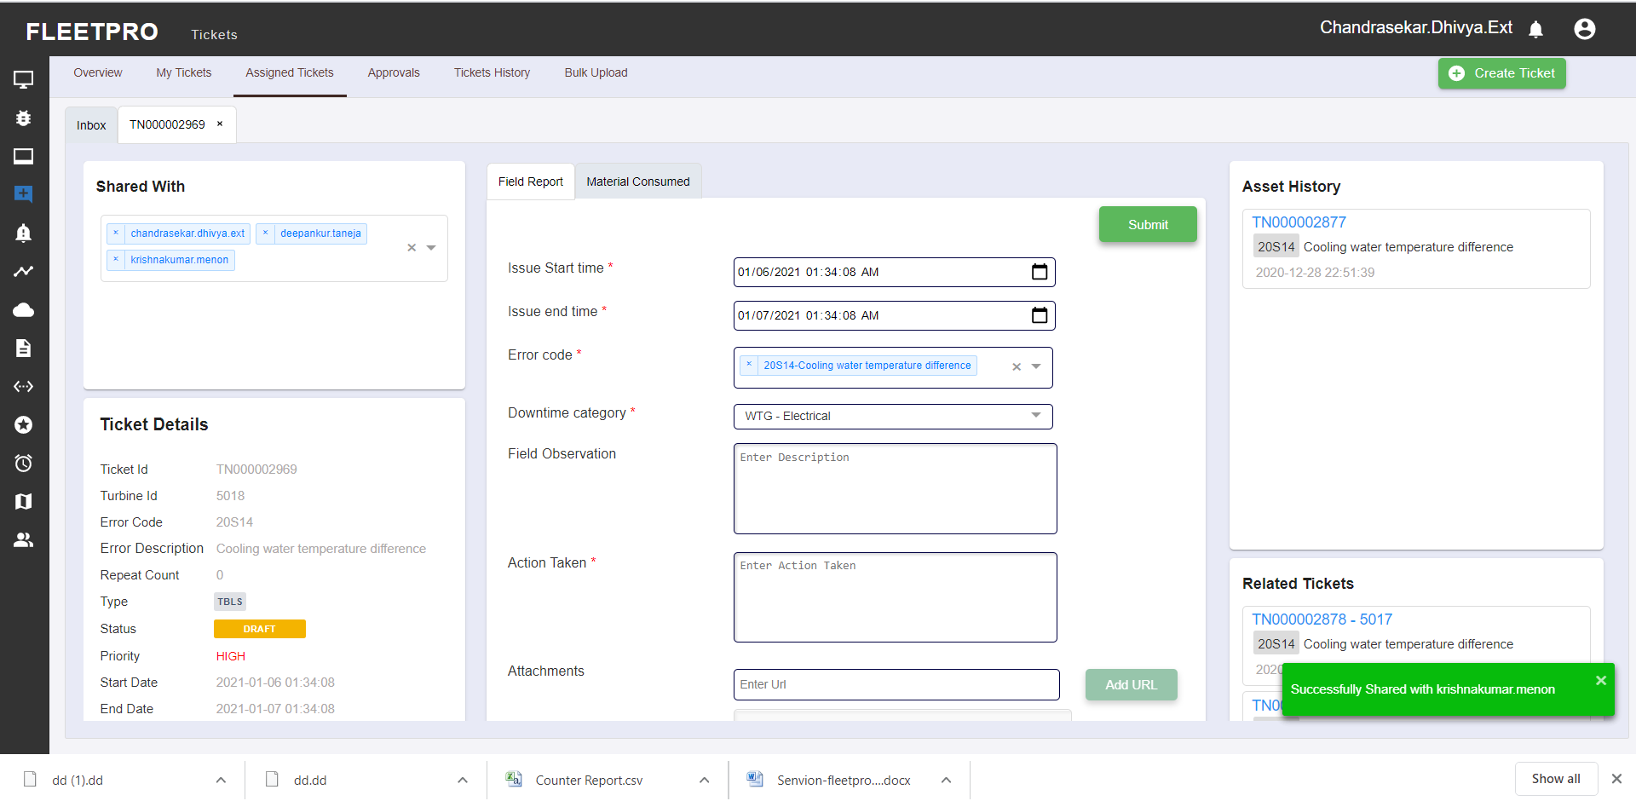

**Comments:**

User can add comments for the respective ticket. It will be displayed above the comments box.

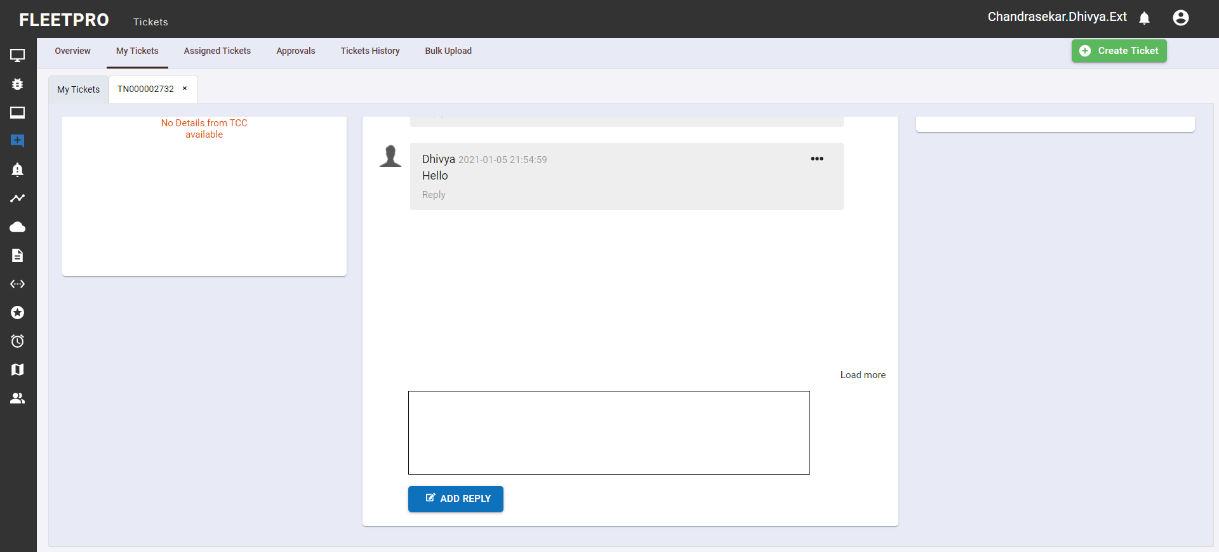

## Approvals

The tickets that are approved can be viewed here. Once the action of (Easy approve) is performed it gets submitted and will be displayed in the ticket history. Delay here denotes how long the error has been opened and repeat denotes the number of times the same error has occurred.

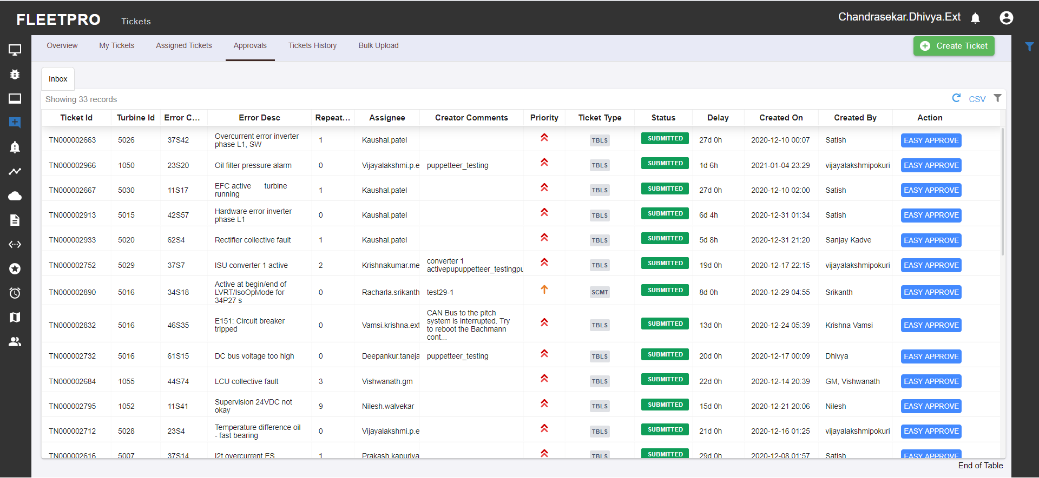

## Ticket History

Ticket history displays the overall history of all the tickets. The Status type in the filter denotes the type of tickets (submitted, approved). By selecting the column the user can search any detail of the tickets by typing on the Search Tickets search bar.

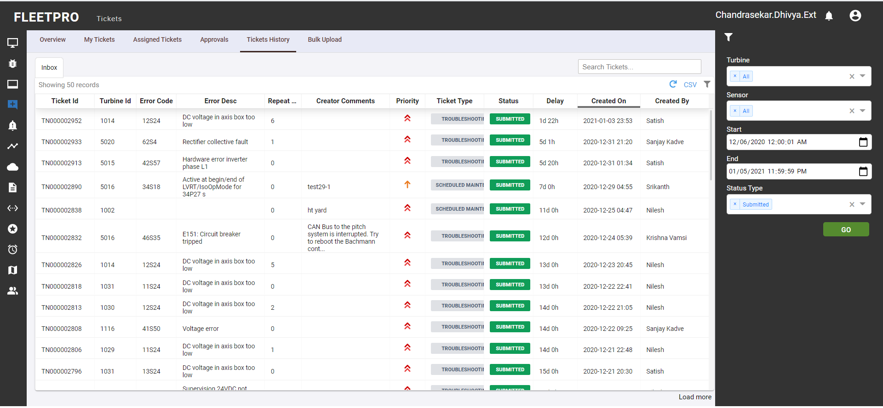

## Bulk Upload

The user can upload a csv data by clicking on the Upload CSV option to get the data displayed.

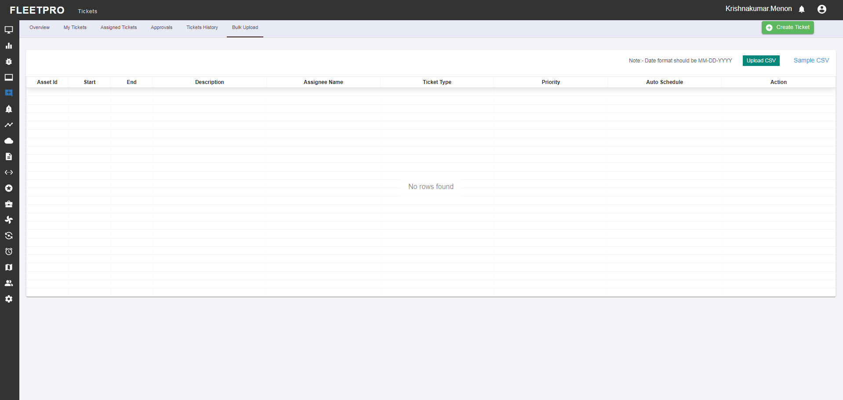

Here is an example of how the data will be displayed once the data is uploaded using the Upload CSV and the user can either Submit or cancel the actions made.

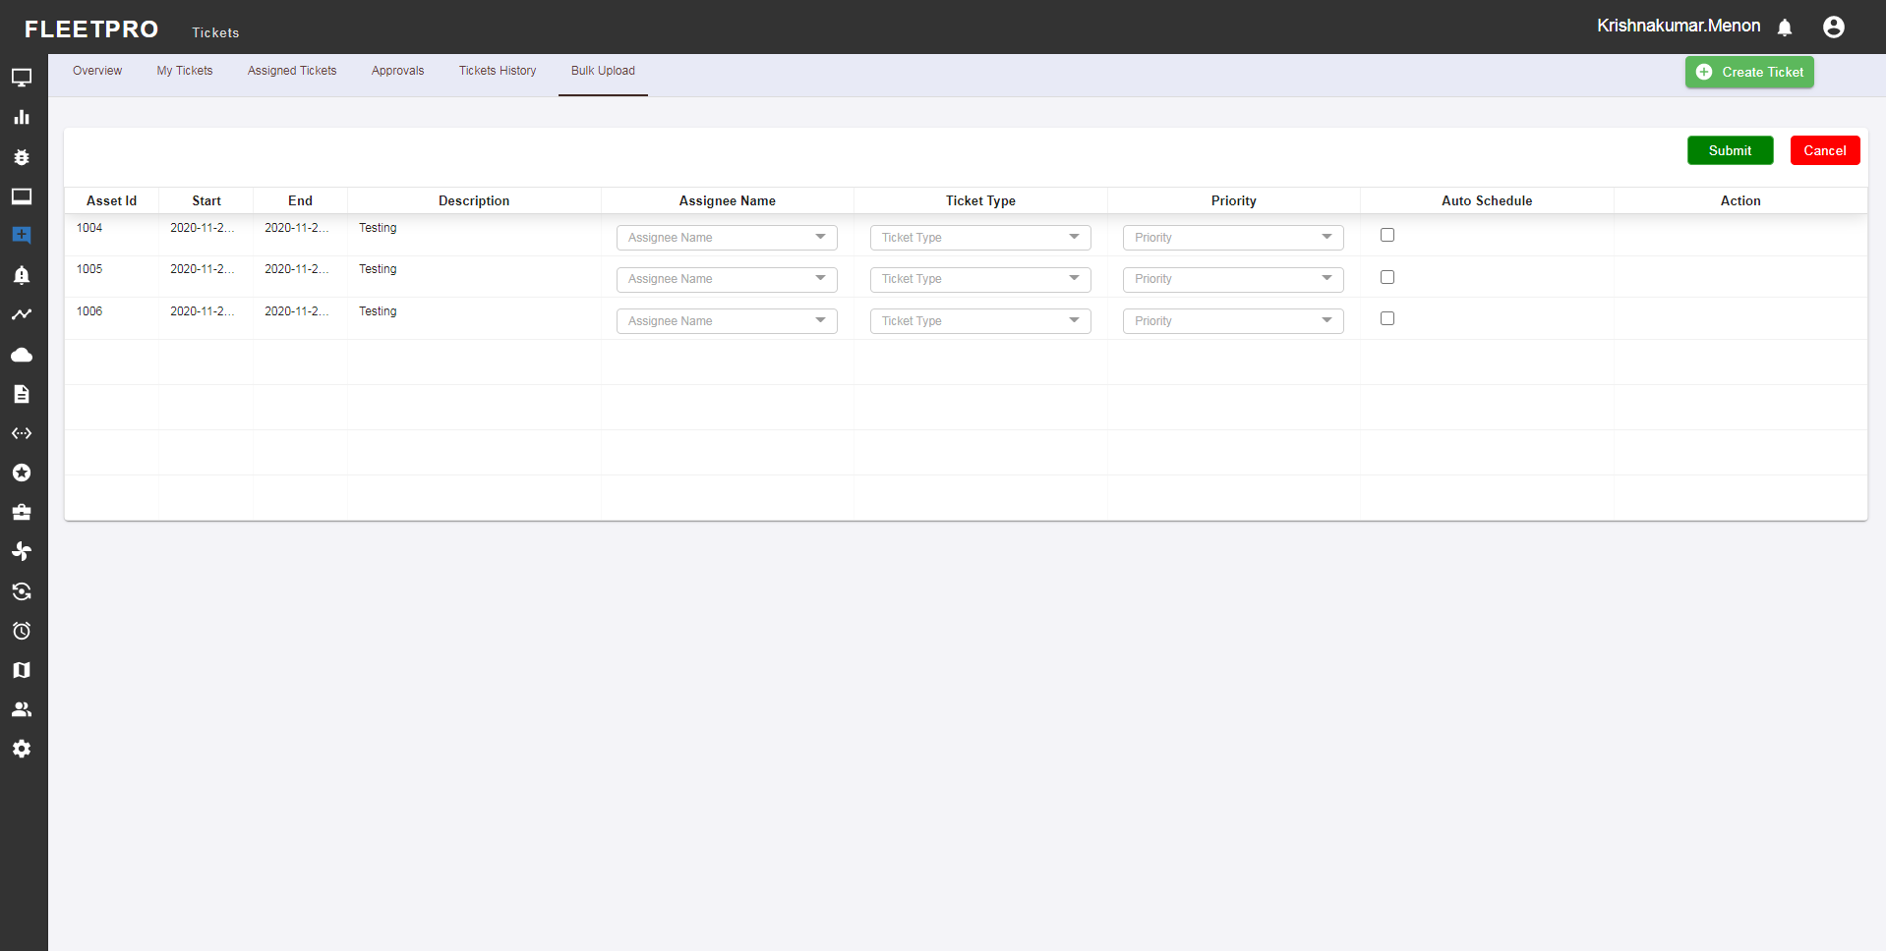

# Data Flow

## Network Trends

Network trend is used to monitor the network connectivity between the FleetPro server and wind farm WTGs. The non-connecting turbines will show red colour. The non-connecting turbines will show red colour. The user can inform SCADA team over email if the connectivity loss is for more than a day.

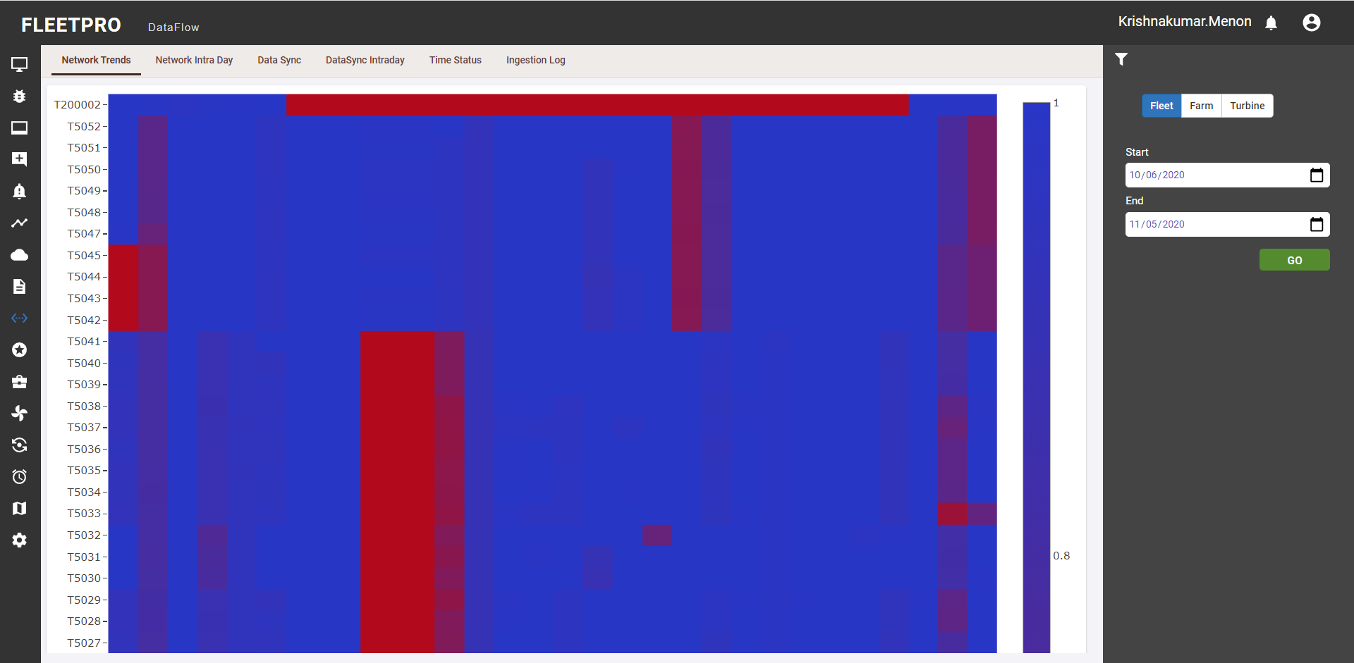

## Network intra day

* Network intraday is used to monitor the network connectivity between the FleetPro server and wind farm WTGs in an entire day.
* The non connecting turbines will show red colour.
* On selecting the start date and the end dates the map will display the set of all the turbine’s connectivity
* Blue denotes the set of turbines that are connected to the server.
* Where red denotes the non- connecting turbines.

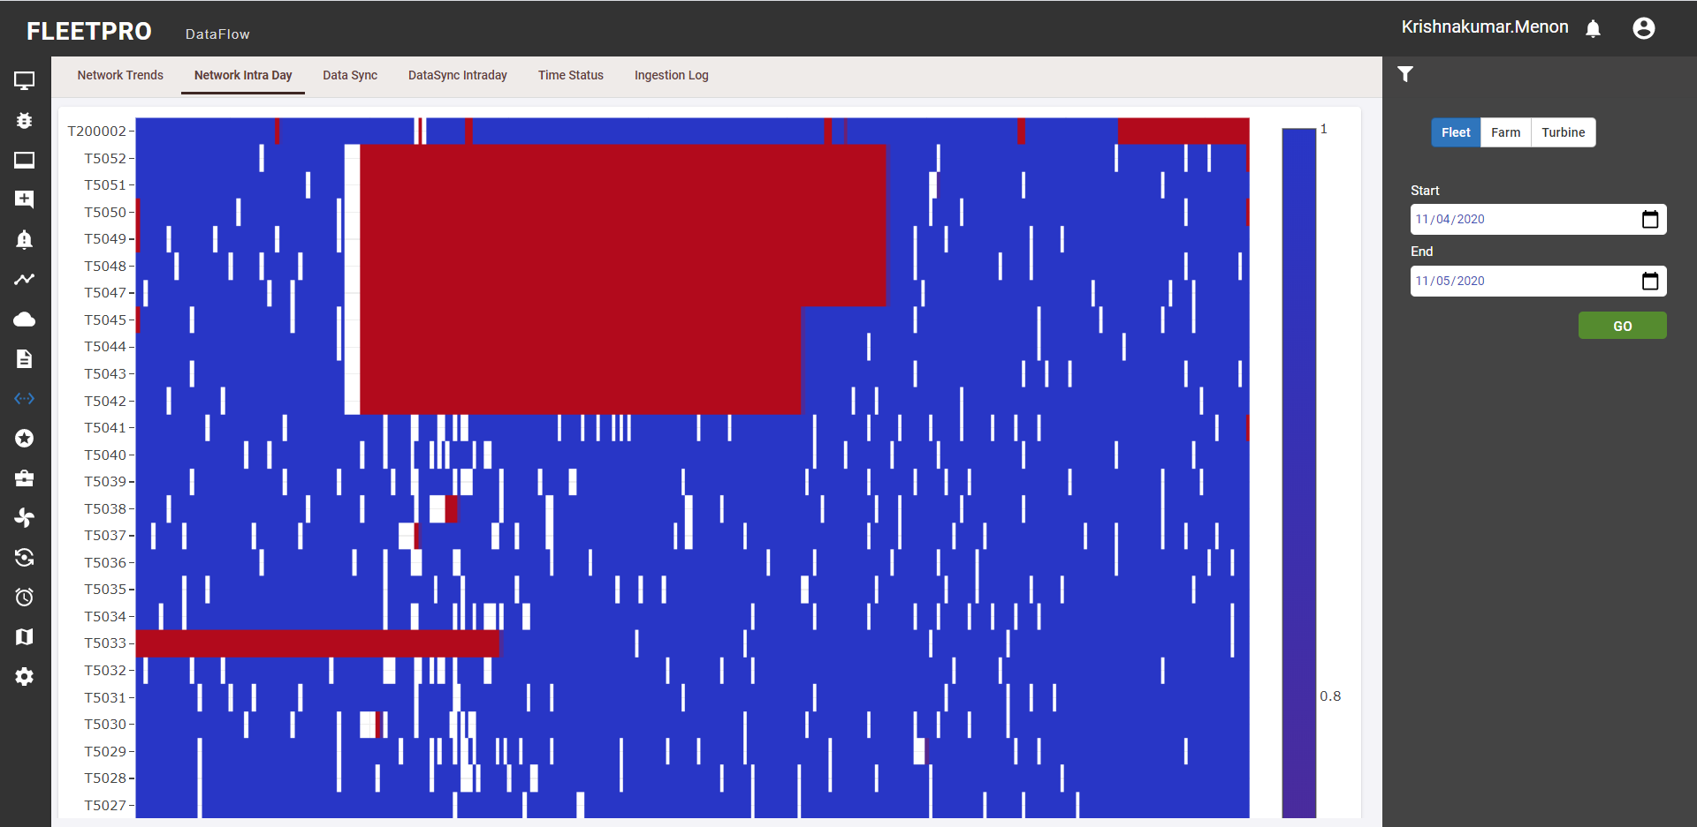

## Data Sync

Data sync displays status of the data synced from turbine to the FleetPro server. The non-syncing turbine will be displayed in red colour. The user can inform SCADA team if the data is not syncing for more than one day.

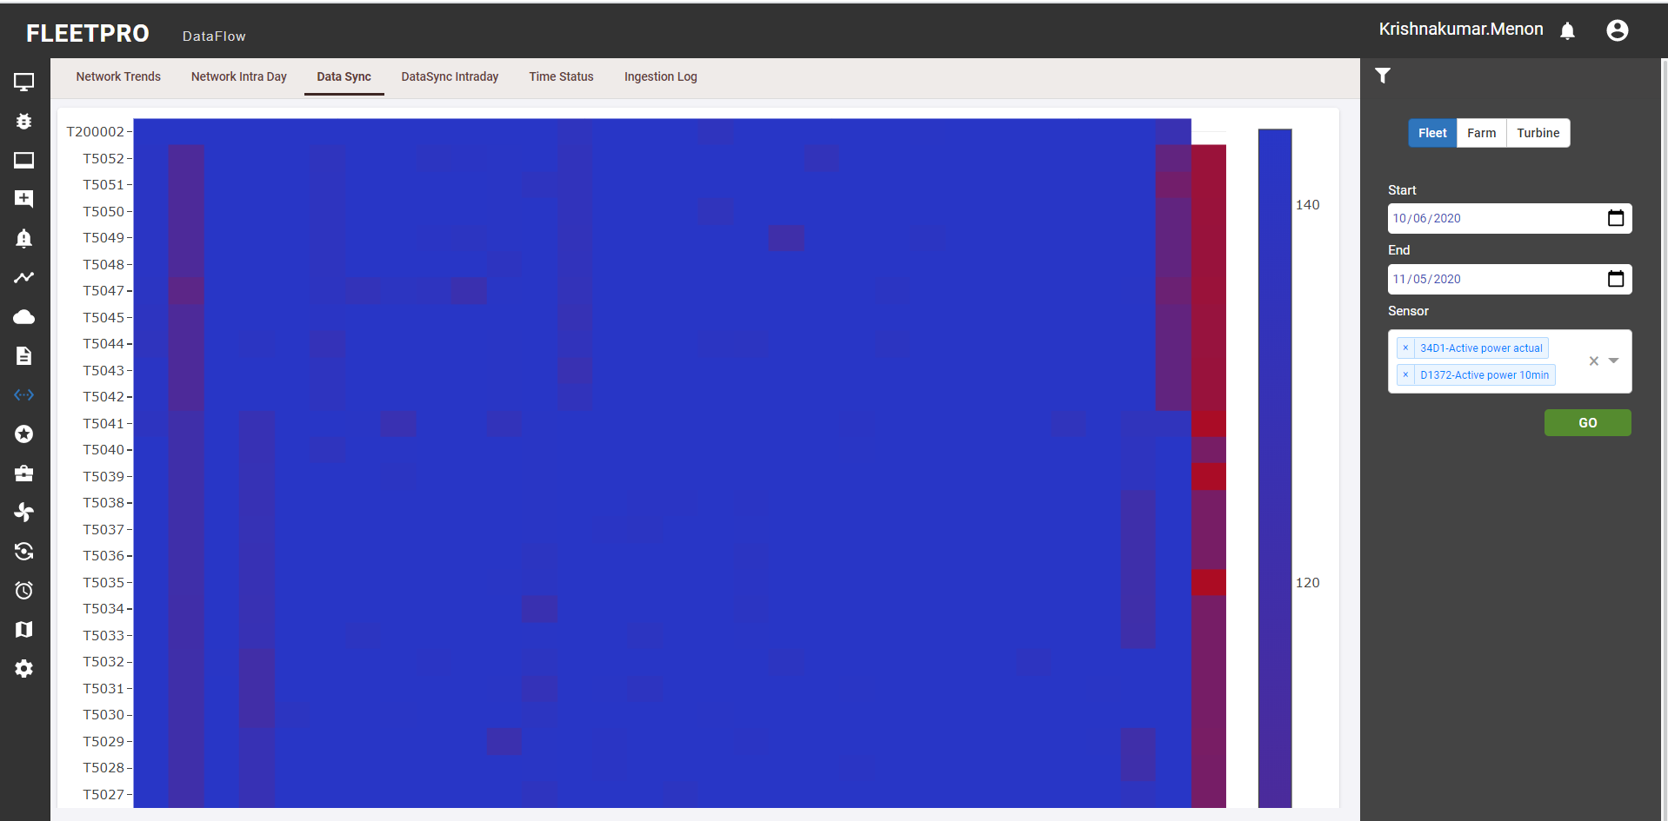

## Data Sync Intraday

Data sync displays the status of the data synced from turbine to the FleetPro server in one entire day. The non-syncing turbine will be displayed in red colour.

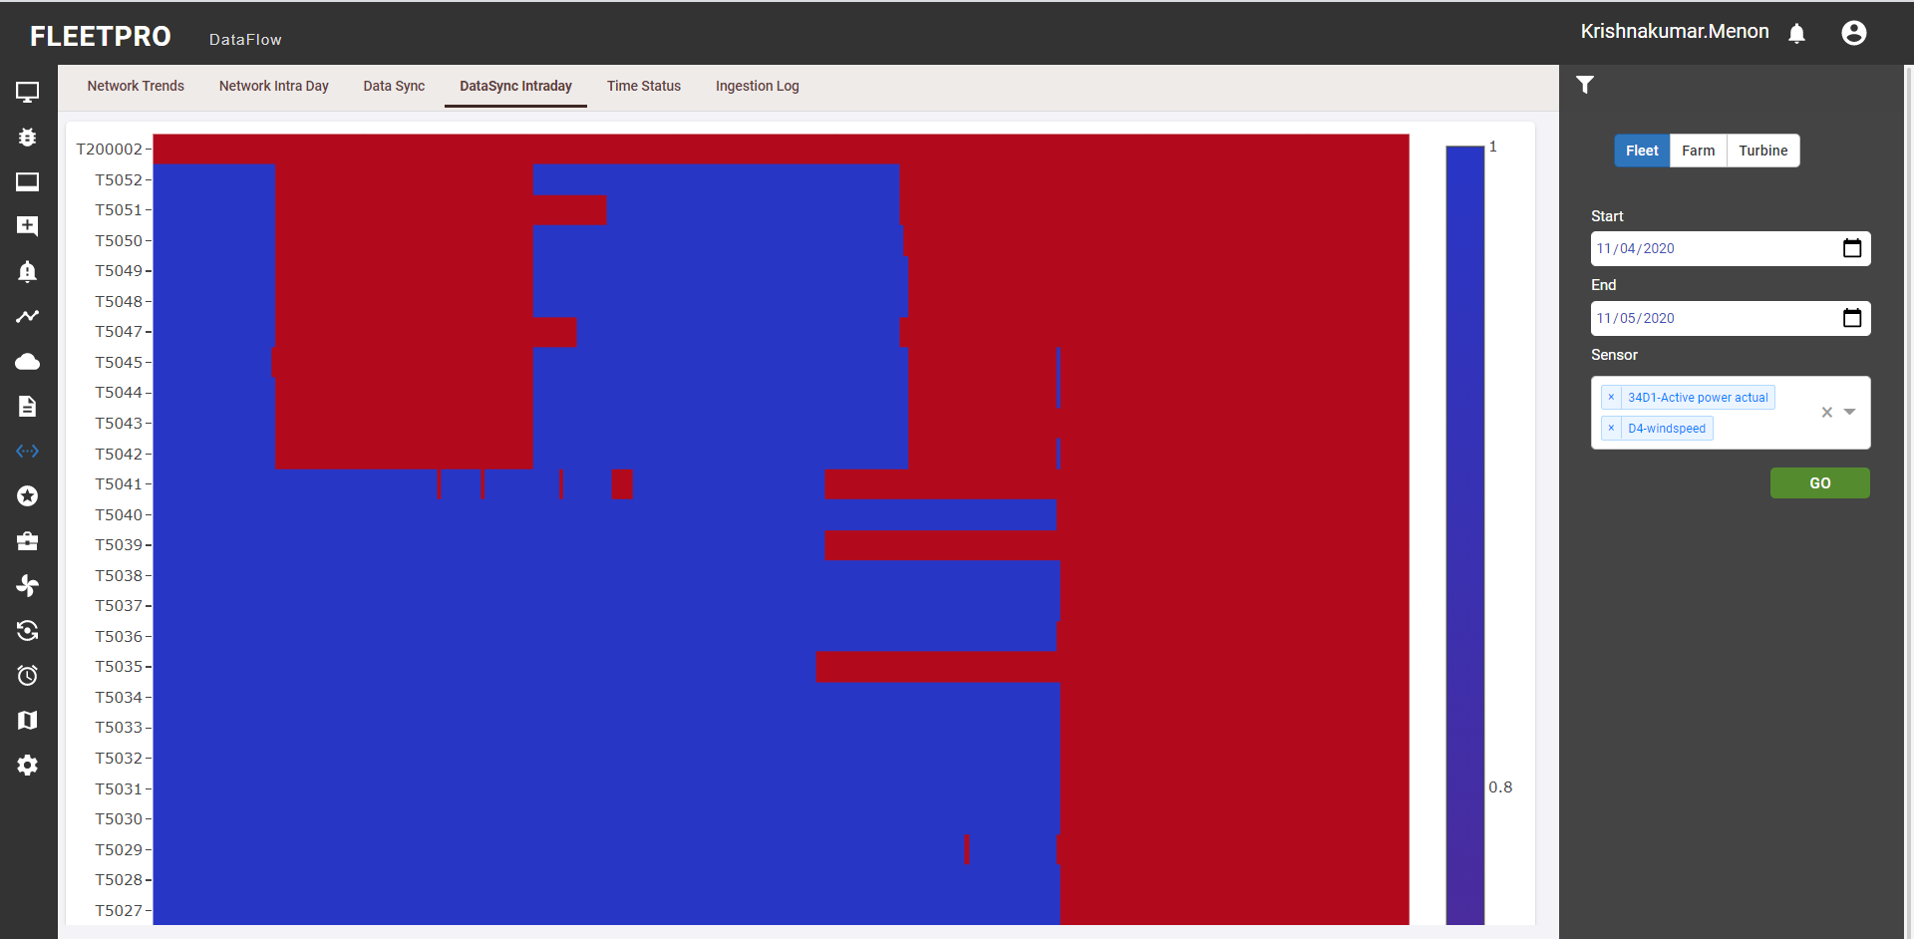

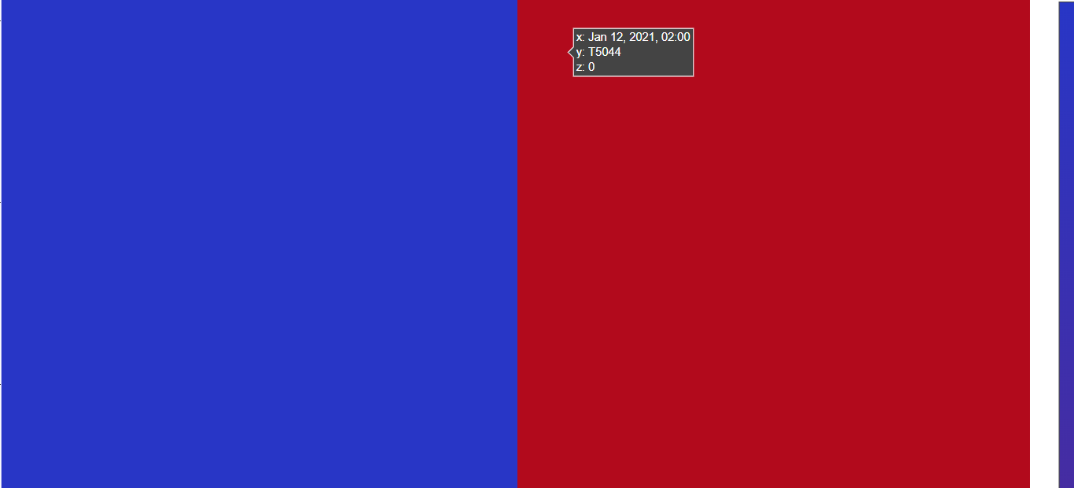

* User can zoom the graph by dragging it. On pointing the cursor on a point in the graph the user can view x, y and z axis data.
* X axis- displays the date
* Yaxis- displays the turbine id
* Z axis – value ( 0 means the network is not okay and 1 means the network is okay)

## Time Status

* Time status shows the last synced time for all the data point types like Channel, counters, status, parameter etc.
* The user can select the category which includes (channels, parameter, status, counter, all).
* Based on the selected category the set of time status will get displayed.

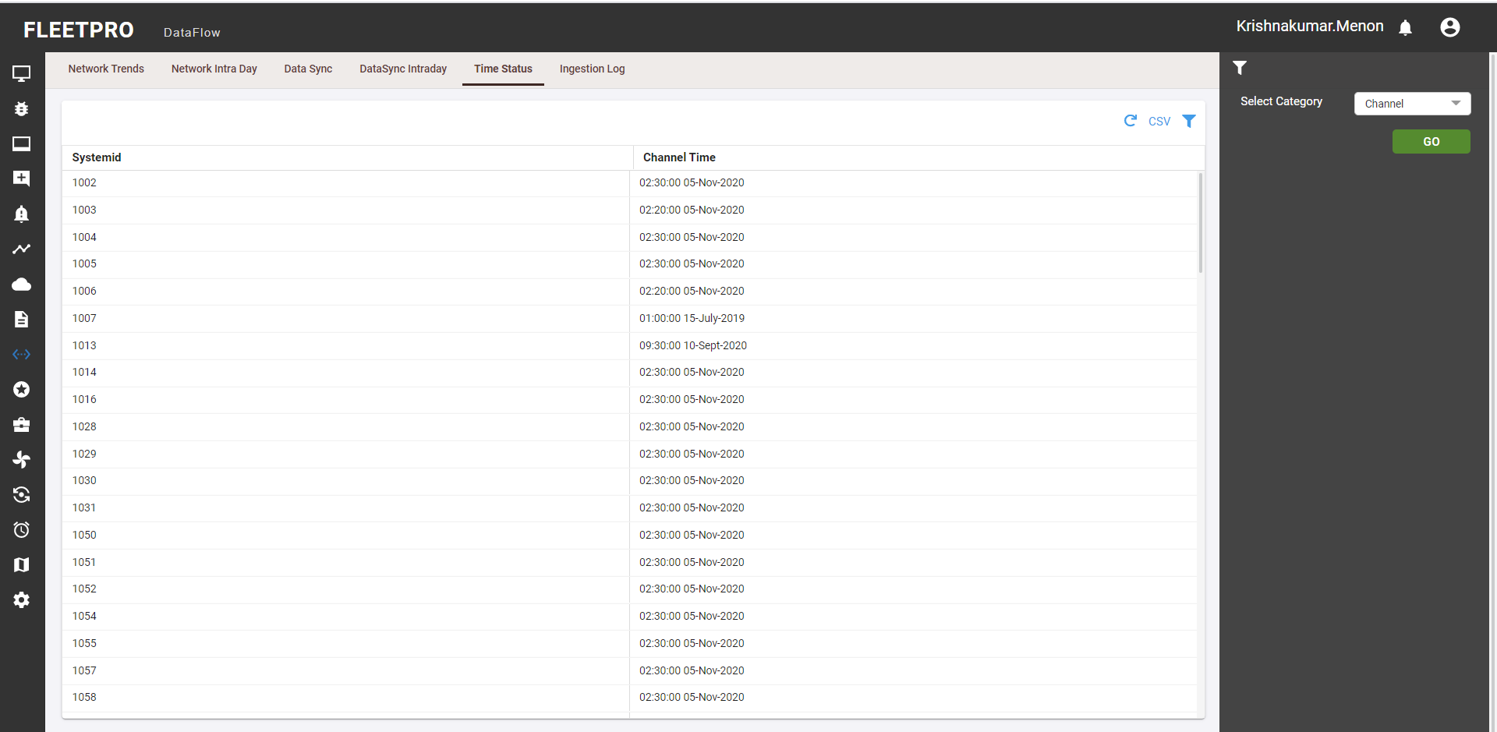

## Ingestion Log

Ingestion Log show full details of each ingestion job with start time, end time, processed data etc by selecting specific turbine, specific data point type and start time. Pagination here provides the last 1 ½ hour of data depending on the pagination window passed.

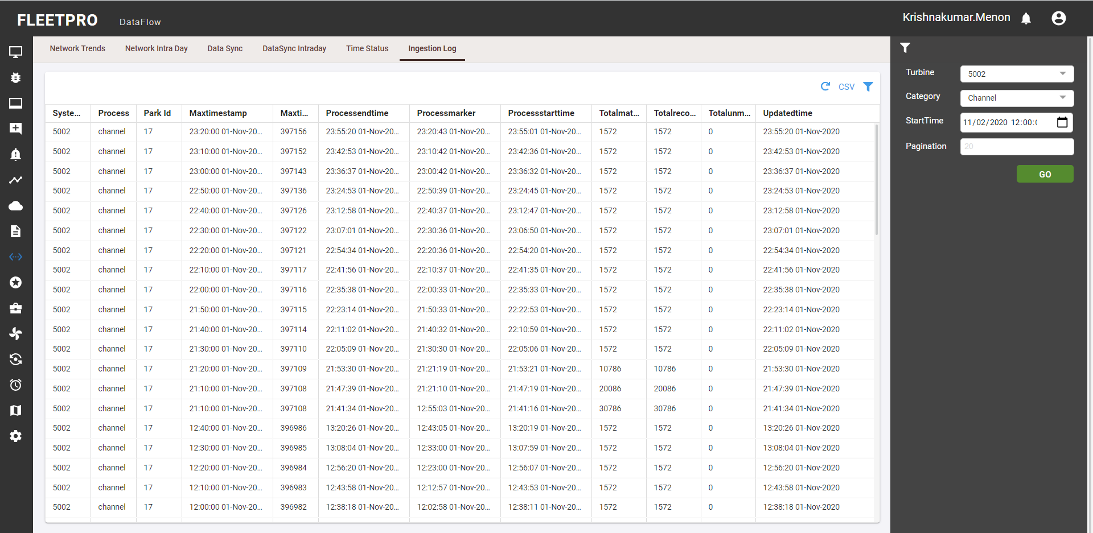

# Report

Fleet pro has various reporting functionalities to understand and compare the performance of the turbines over entire fleet. The filters for reporting help to obtain the data as required.

## Engineering Report

* Engineering report is used to download the 10min channel, counter data for selected sensors.This data can be used for further detailed analysis.
* Counters dropdown denotes the general counters data
* Counter type here denotes two types of counters. One is cumulative and other is diff. Cumulative will provide the total time taken for any counter and the diff will provide the delta between the two timestamps.
* User can select the sensor type and the counters by choosing the dimensions.
* The report can be downloaded by clicking on the download button.

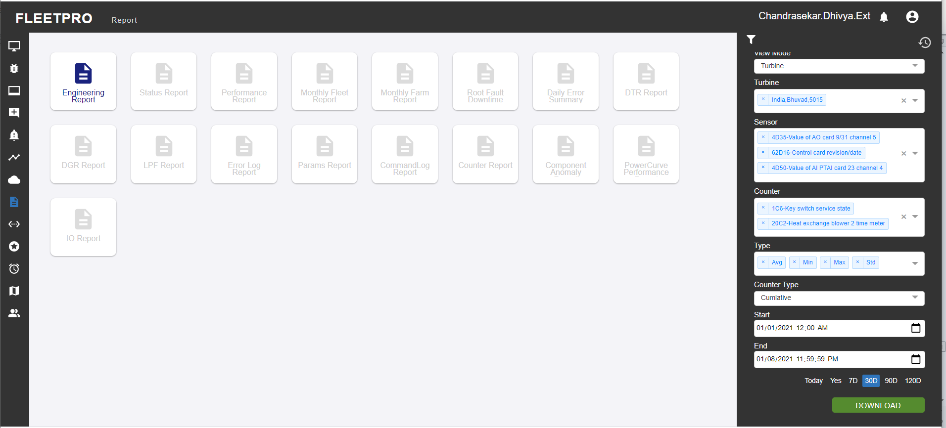

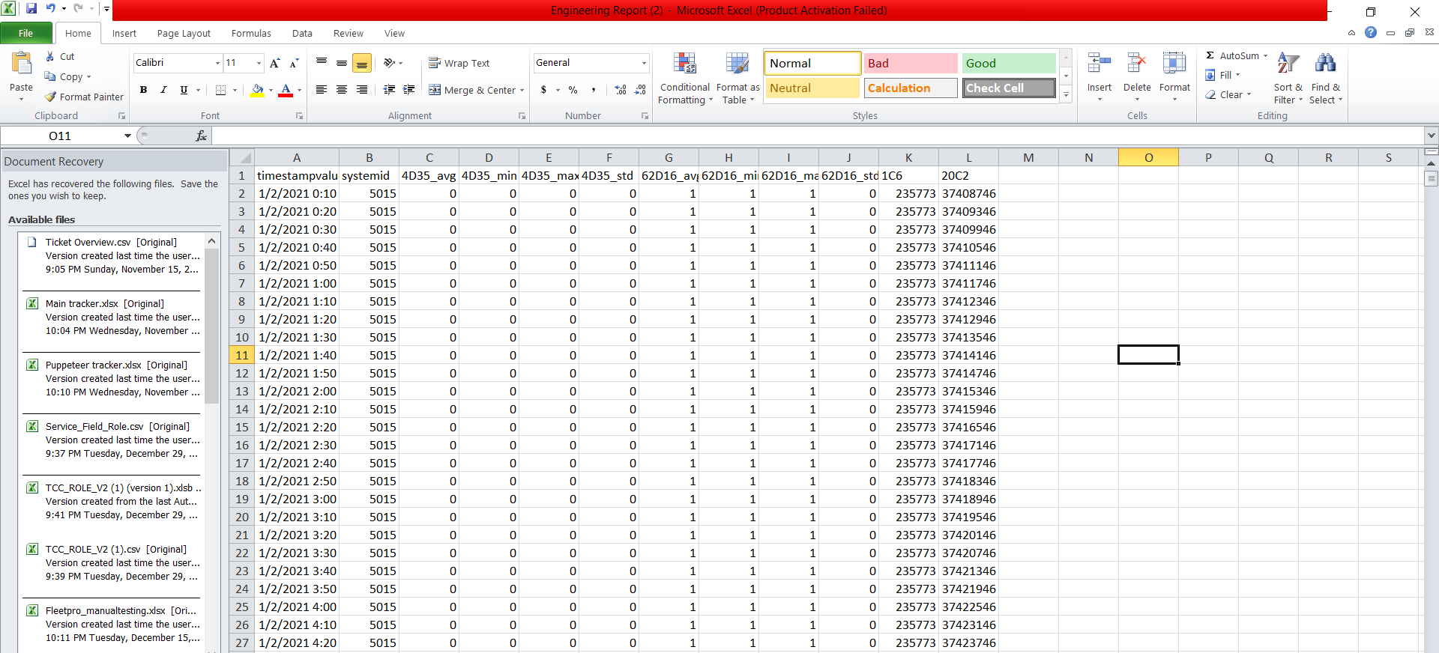

## Status Report

Entire status messages displayed over the selected period of time is listed in this report. It is possible to select a type of status message by clicking the error type like error, warnings or information. Errors are the status messages which come along with a brake procedure warning do not necessarily activate a braking procedure, but they are also a form of error. Information is just for a general statement, declaring current state of the turbine. On click of download the downloaded data’s information history can be seen by the user in the report history.

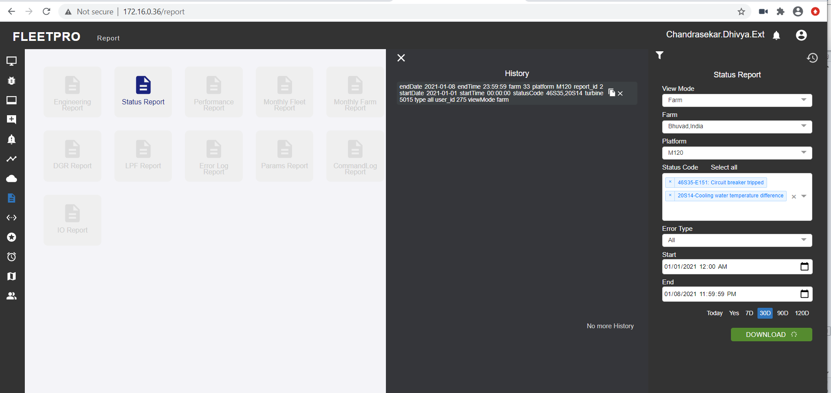

The history displays the selected data by the user. It can be copied to the report settings.

**CSV data:**

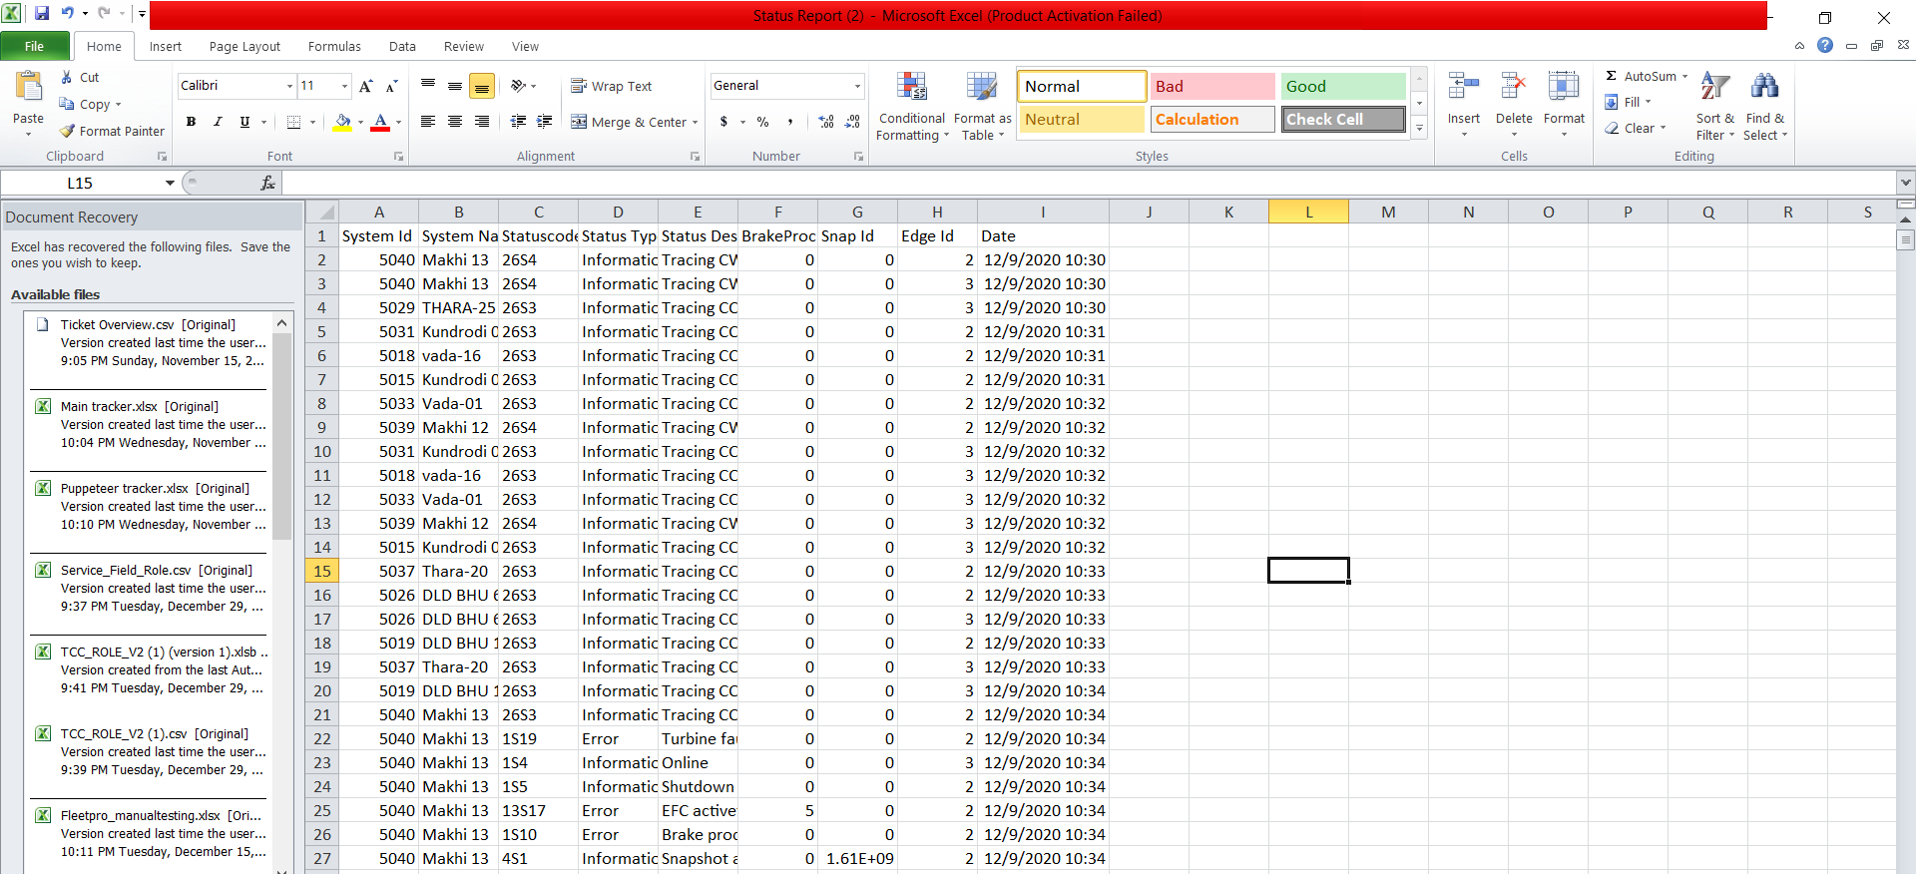

## Performance report:

* The performance report answers the following questions:
* What is the availability of the wind turbine?
* How much energy does the wind turbine produce?
* How is the correlation between average wind speed, availability
* and produced energy? The performance report offers the functionality to enter a start and end date; source (SCADA, Field, All)

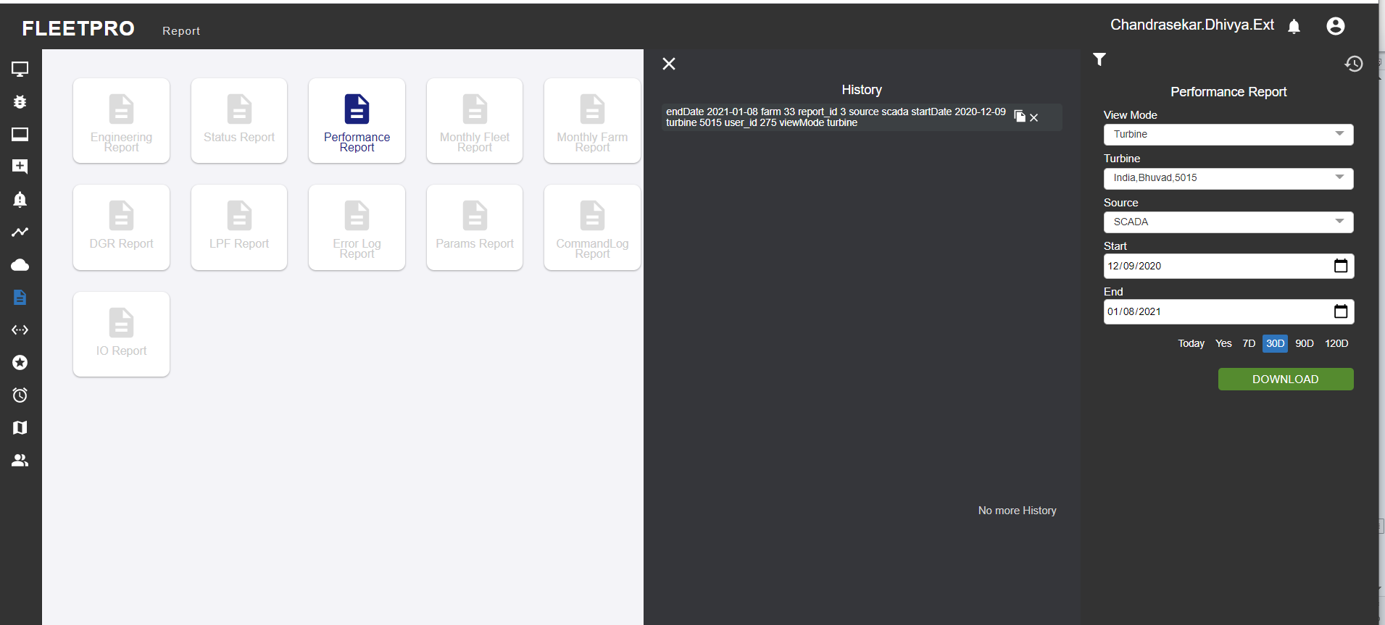

**CSV data:**

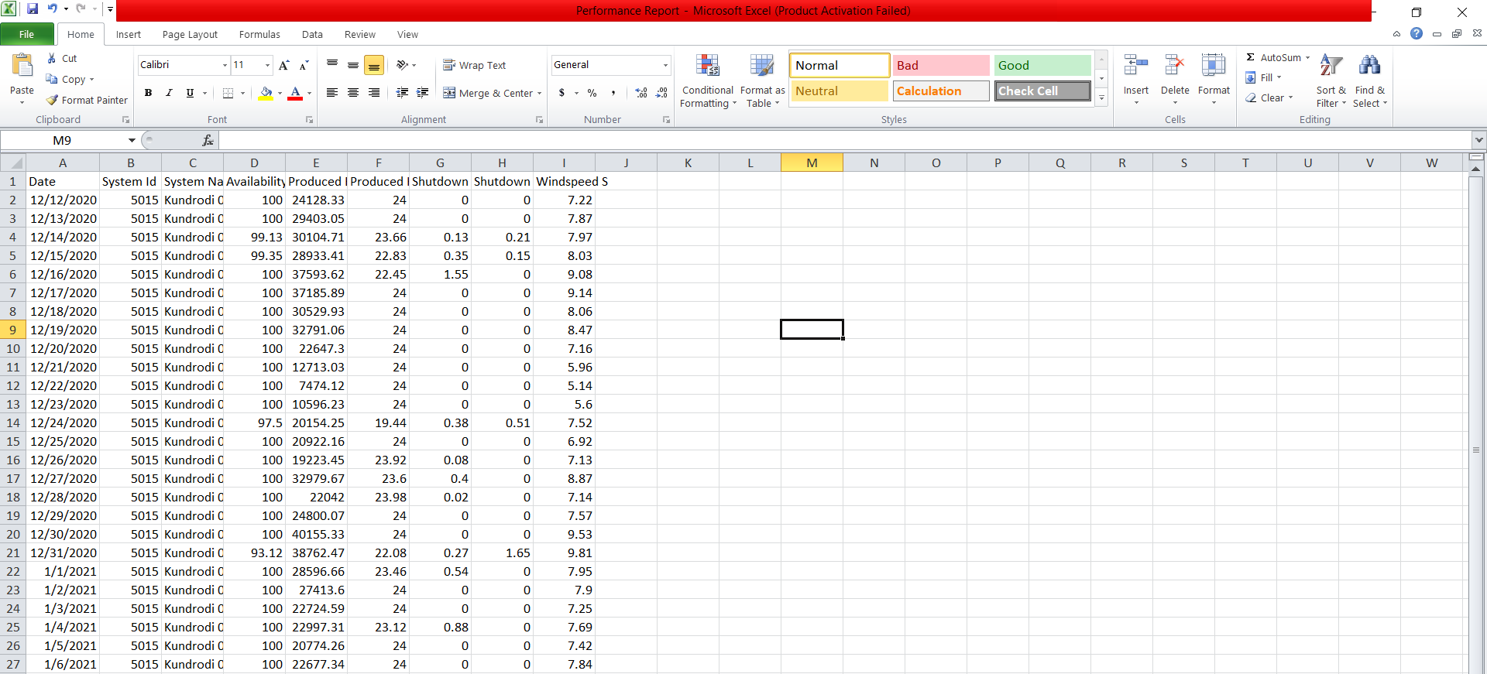

## Monthly Fleet report:

This provides the zip file for the monthly generated fleet data including all the required KPIs like availability, lpf, pba etc.

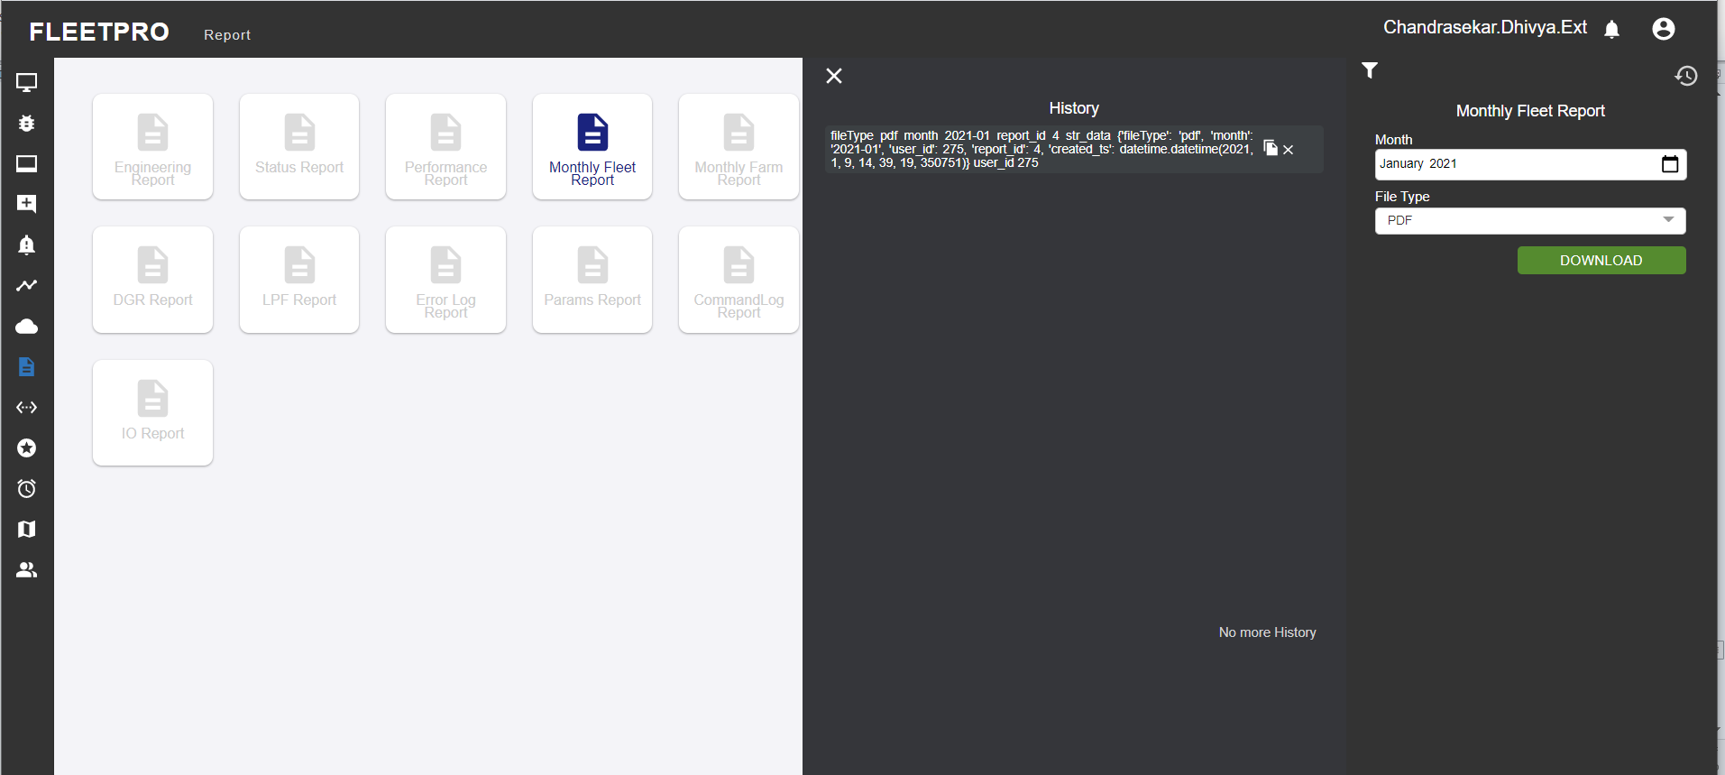

## Monthly Farm report:

This provides the zip file for the monthly generated farm data including all the required KPIs like availability, lpf, pba etc.

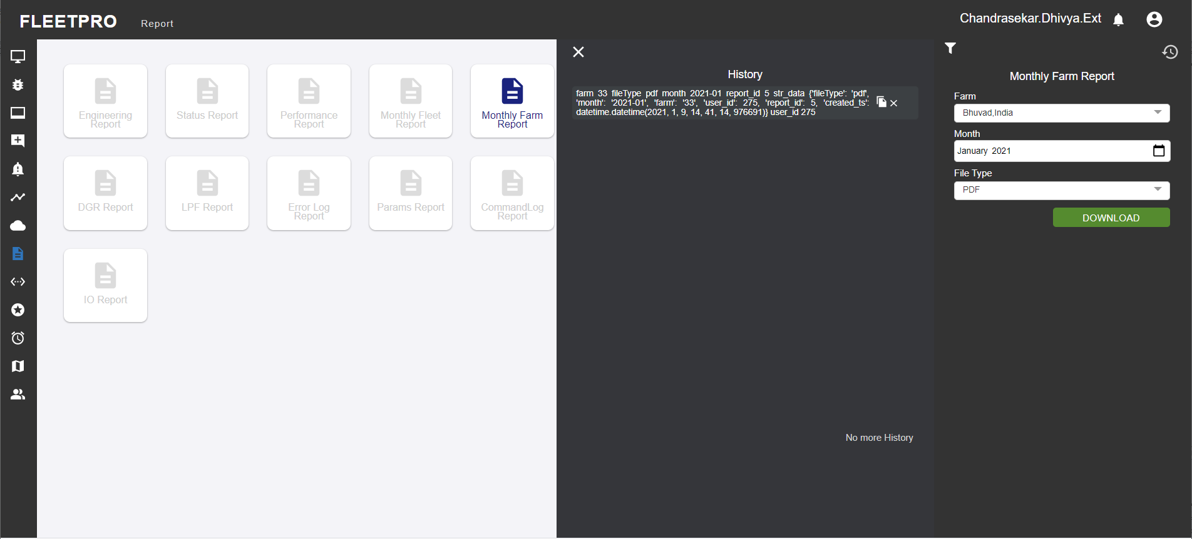

## Root Fault Downtime report

Downtime report summarizes the errors over the fleet. There is option to select the platform and status code. The status code filter helps us understand the occurrence of the particular error over the selected platform for given period.

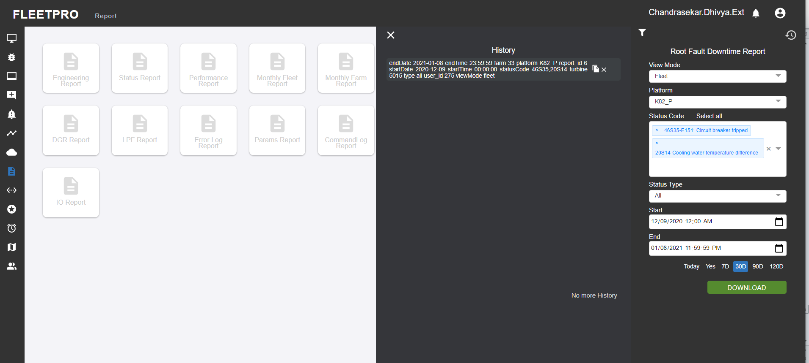

**CSV data:**

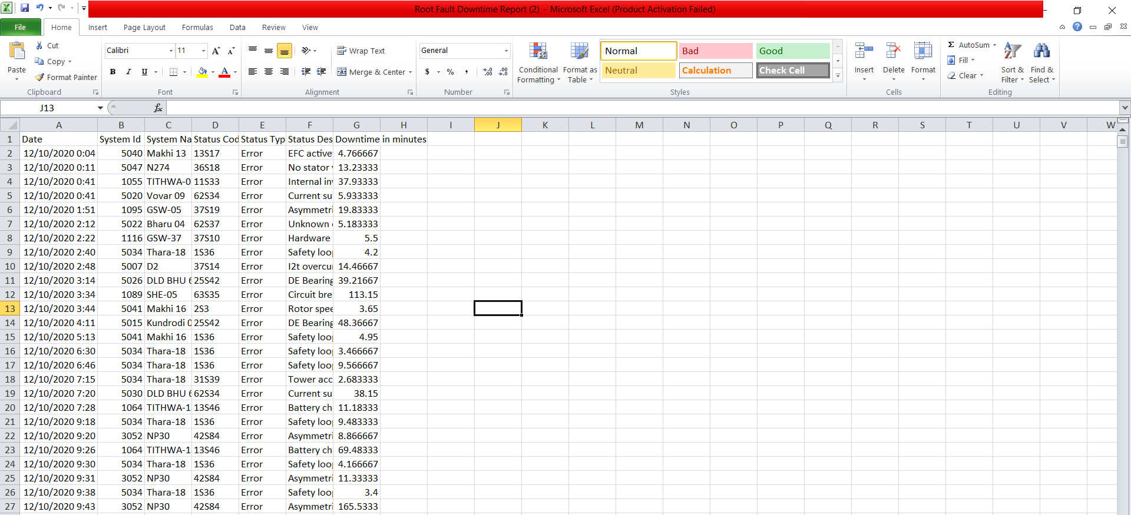

## Daily Error Summary Report

This report provides the total count of generated errors. The status code filter helps us understand the occurrence of the particular error over the selected platform for given period. Status type denotes the type of the ticket which includes Approved or Submitted tickets

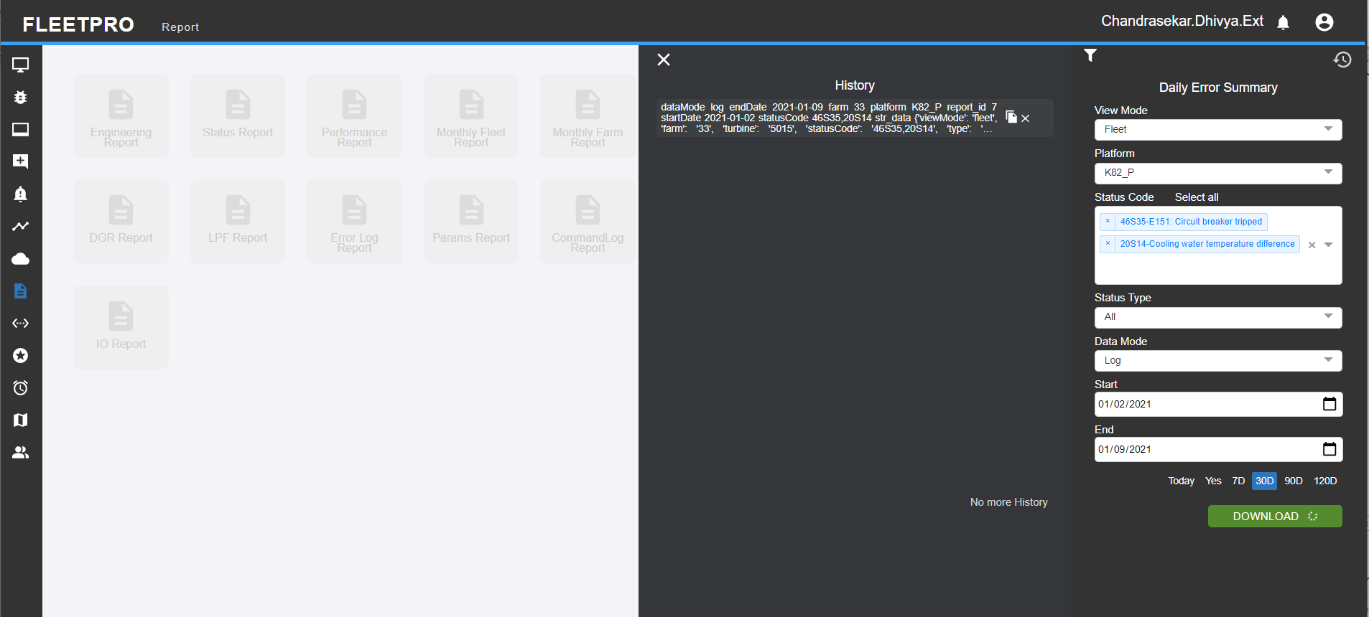

**CSV data:**

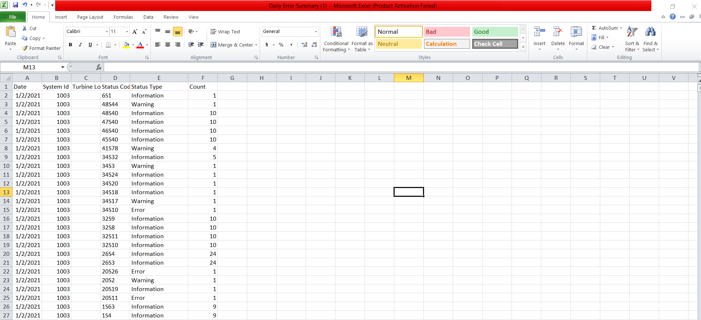

## DTR Report

* It provides the details of all the issues raised, what were the steps taken and the assignee and approver details.
* Ticket type here denotes the error type of the ticket.Status type denotes the status of the ticket which includes two forms Approved and Submitted.Mode indicates either the issue or the ticket type.

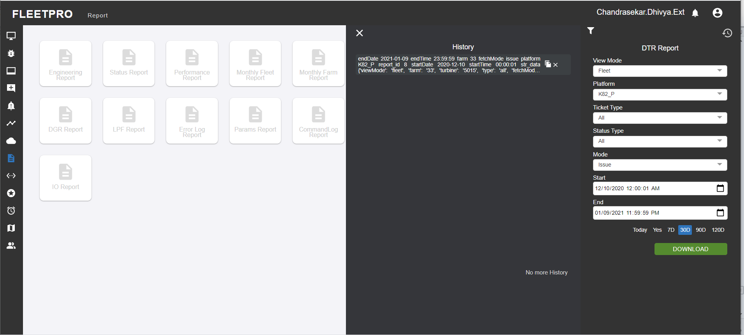

**CSV data:**

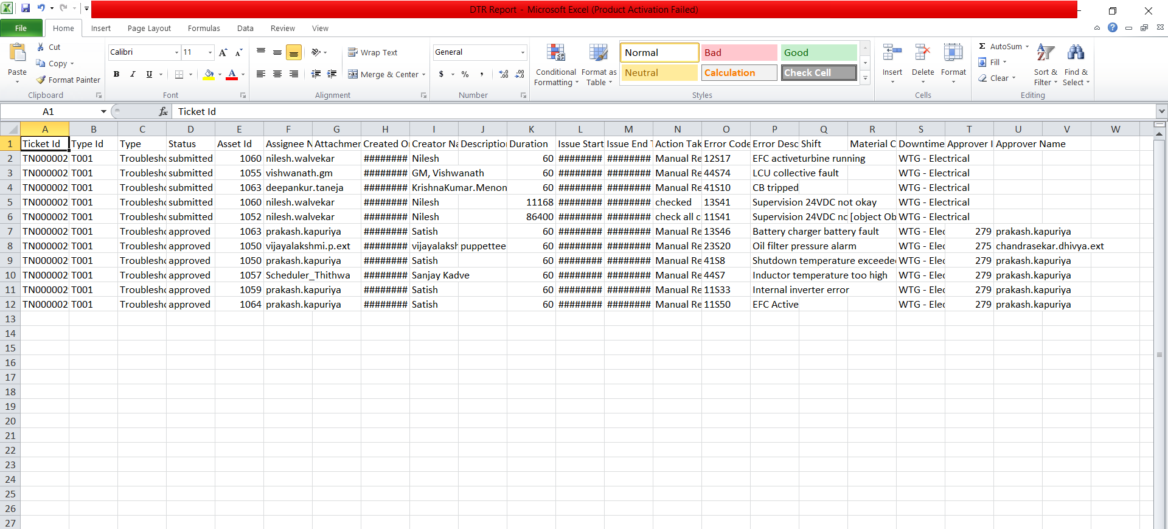

## DGR Report

DGR is Daily Generation report. DGR is used as a reporting format usually shared with the customer/client on daily basis. This is used to share performance of turbine with customer. User can get the downloaded report by selecting the View mode with the start and end dates.

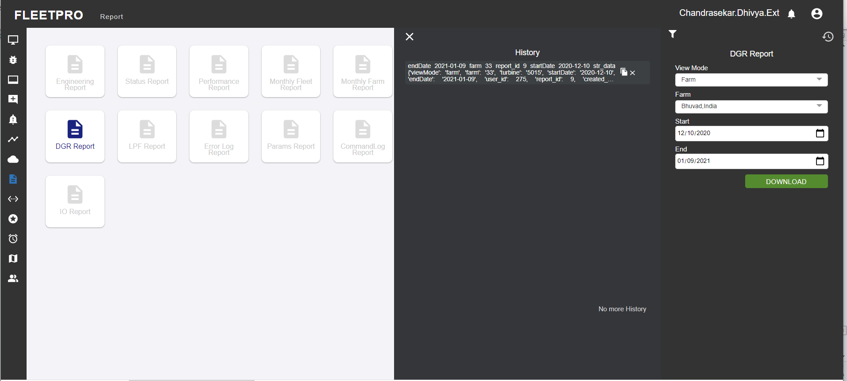

**CSV data:**

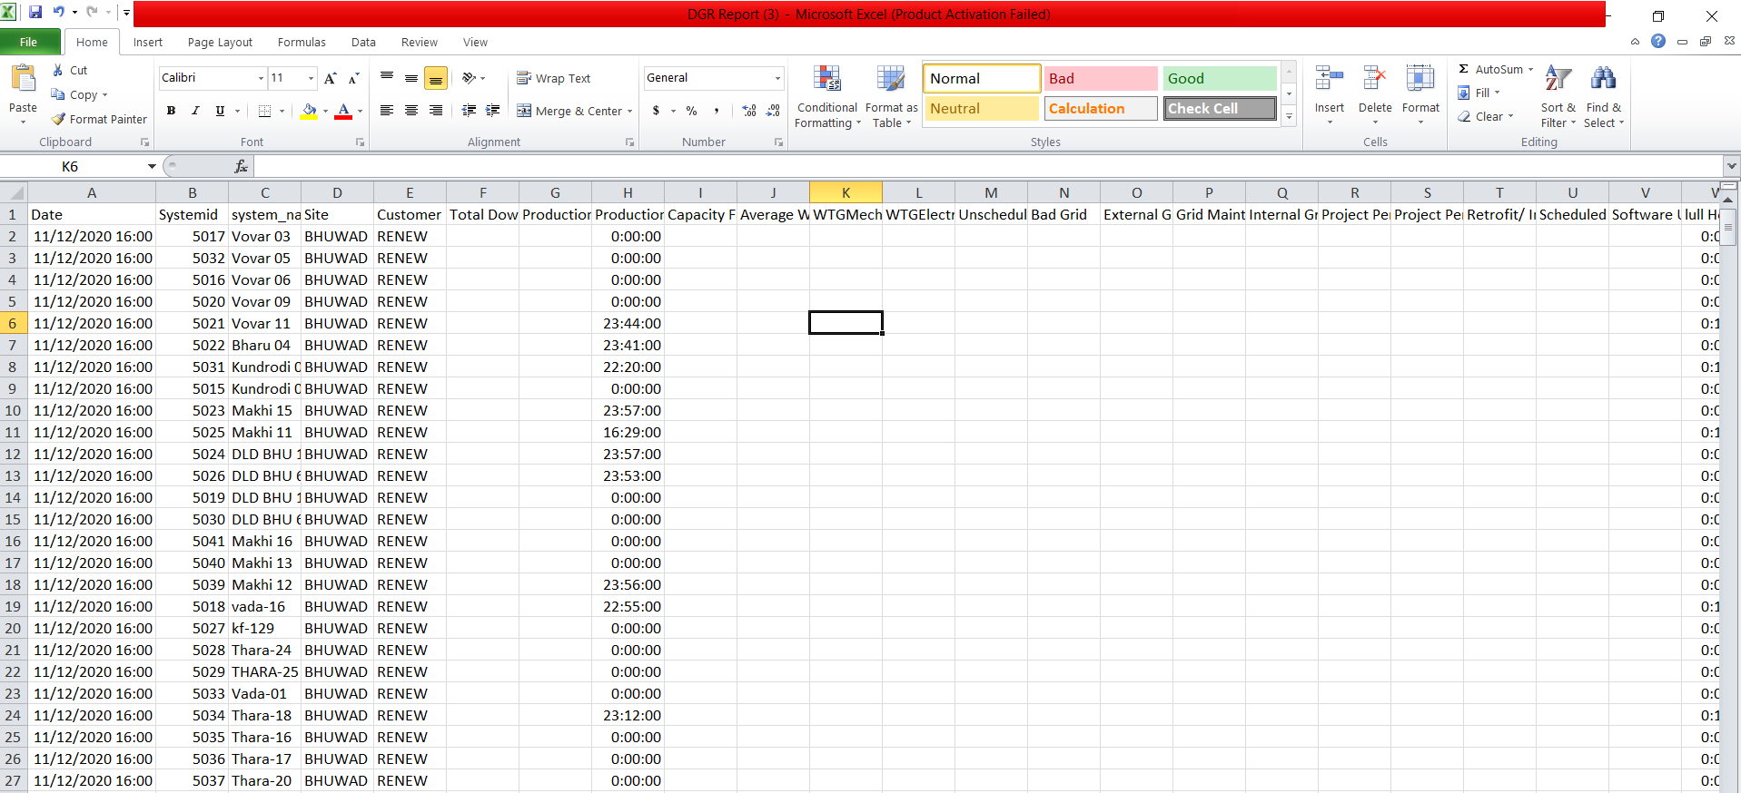

## LPF Report

Loss production factor report can be generated for Farm, fleet, or turbine. There is option for selecting commercial or technical LPF. Mode indicates the daily or the ten minute daily level data and the value type provides the user the option to get either the technical or the commercial lpf report.

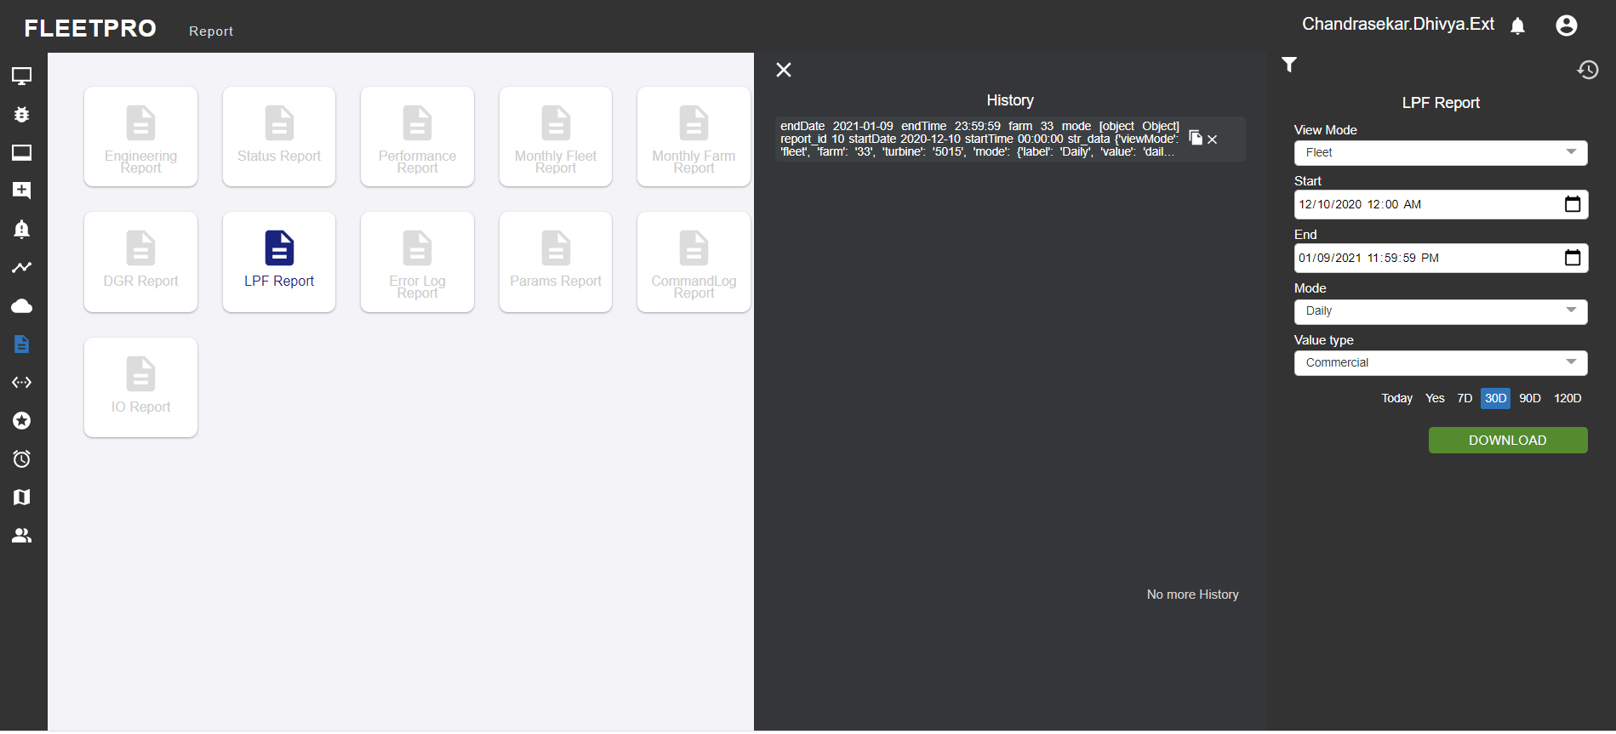

**CSV data:**

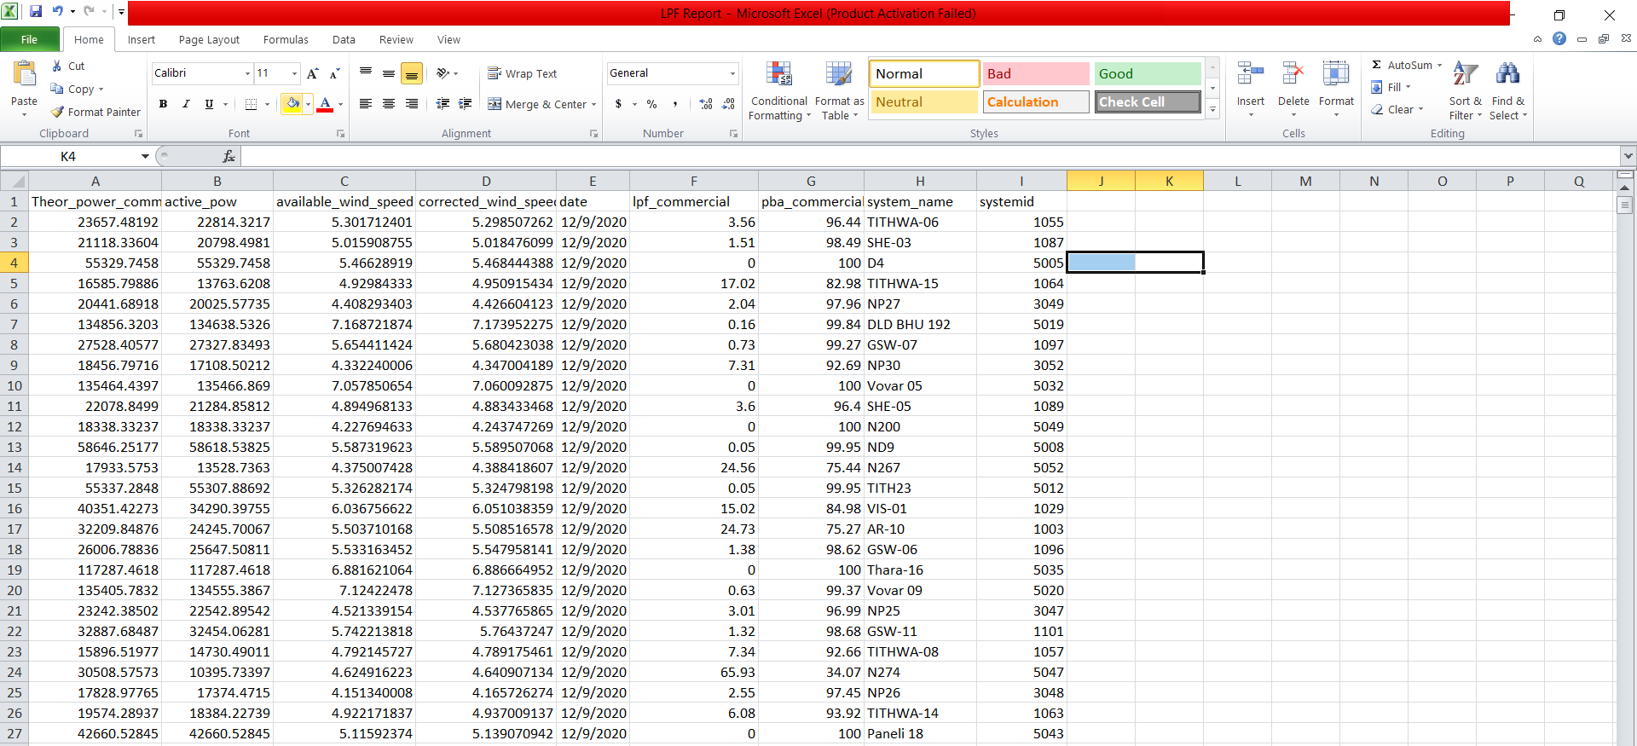

## Error Log Report

* This report generates all the active errors which has been raised.
* Error type denotes the type of the error
* Major Error type indicates the major errors that are reported.
* The user can get the detailed report of the error log by clicking on download.

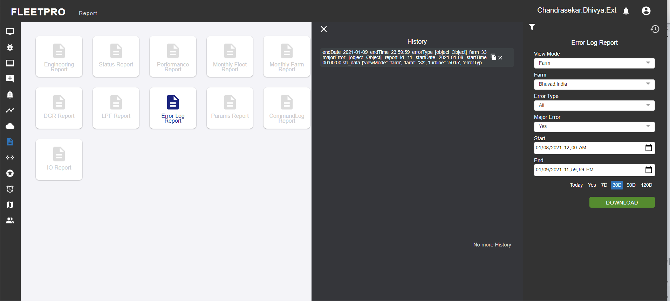

**CSV data:**

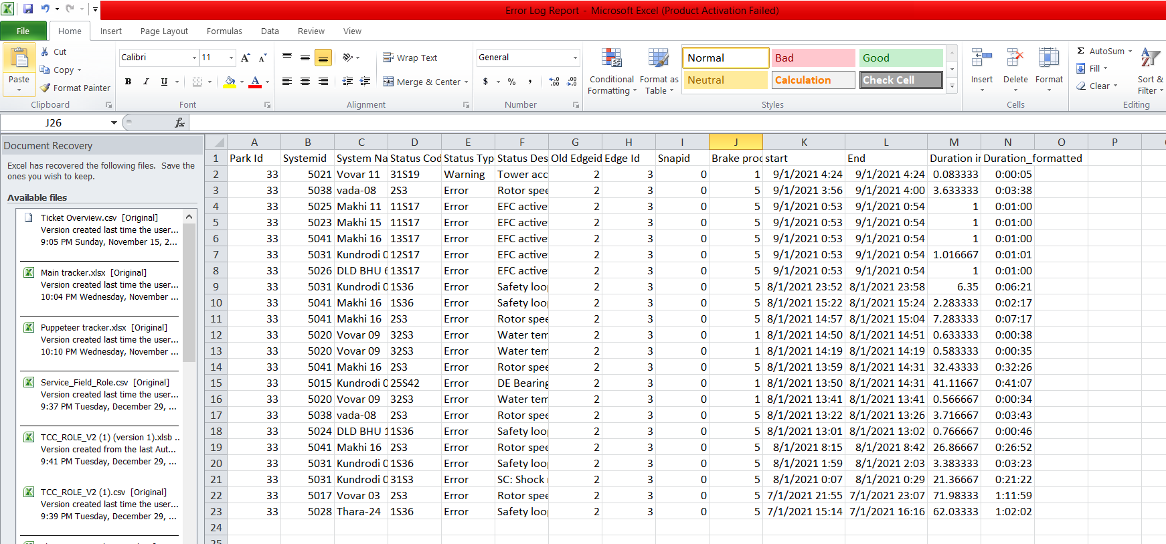

## Params Report

* This report provides the latest value of params
* User can select the view mode and the type. For the selected period of type (Start date and end date) the report can be downloaded.

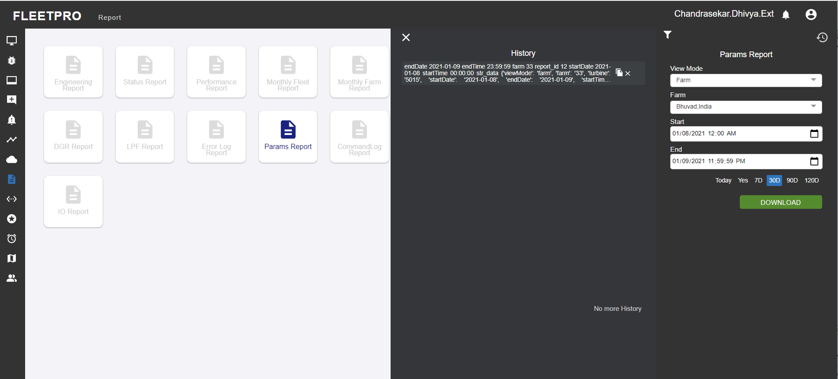

**CSV data:**

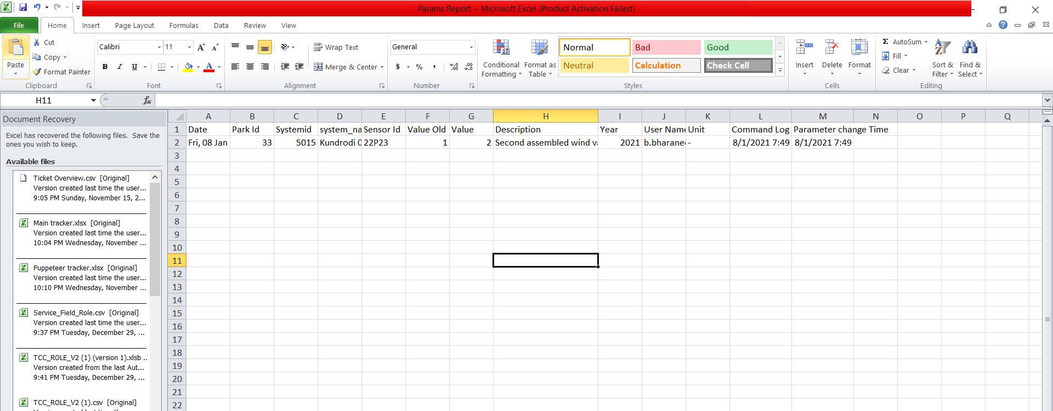

## Command Log Report

* Command log report shows which user has set or reset the prevailing turbine status in the selected period. This report is used to keep record or to trace whoever has set, reset, or changed the existing states, parameters, counters or data of the turbine.
* Type denotes the different data points which indicates the categories of sensor data.

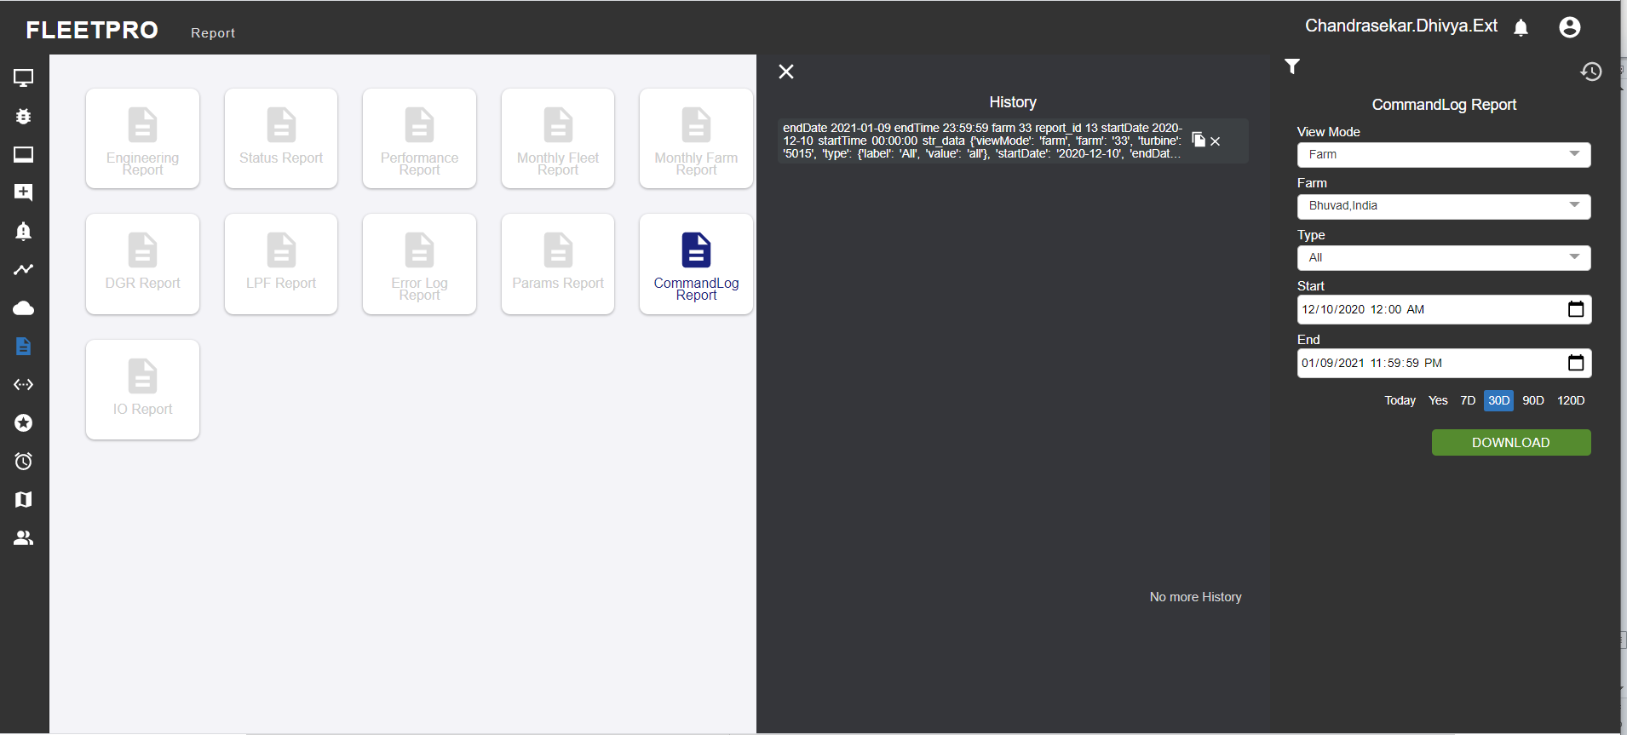

**CSV data:**

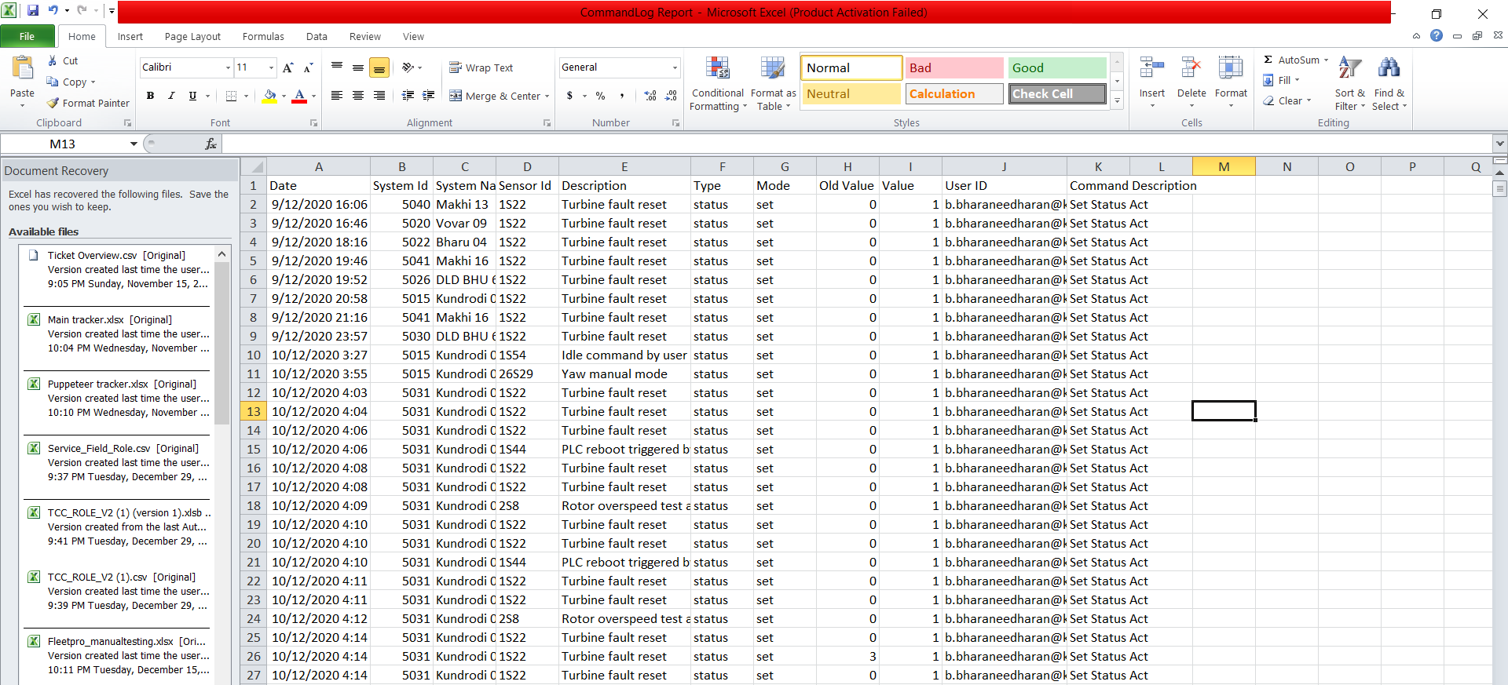

## Counter report:

This report gives the counter data for the selected counters and along with that it also generates the aggregated result for the counters.Custom option provides the user the option to choose any sensor. Curtailment helps the user in choosing the list of curtailment sensors. Similarly the error chooses the list of error sensors.

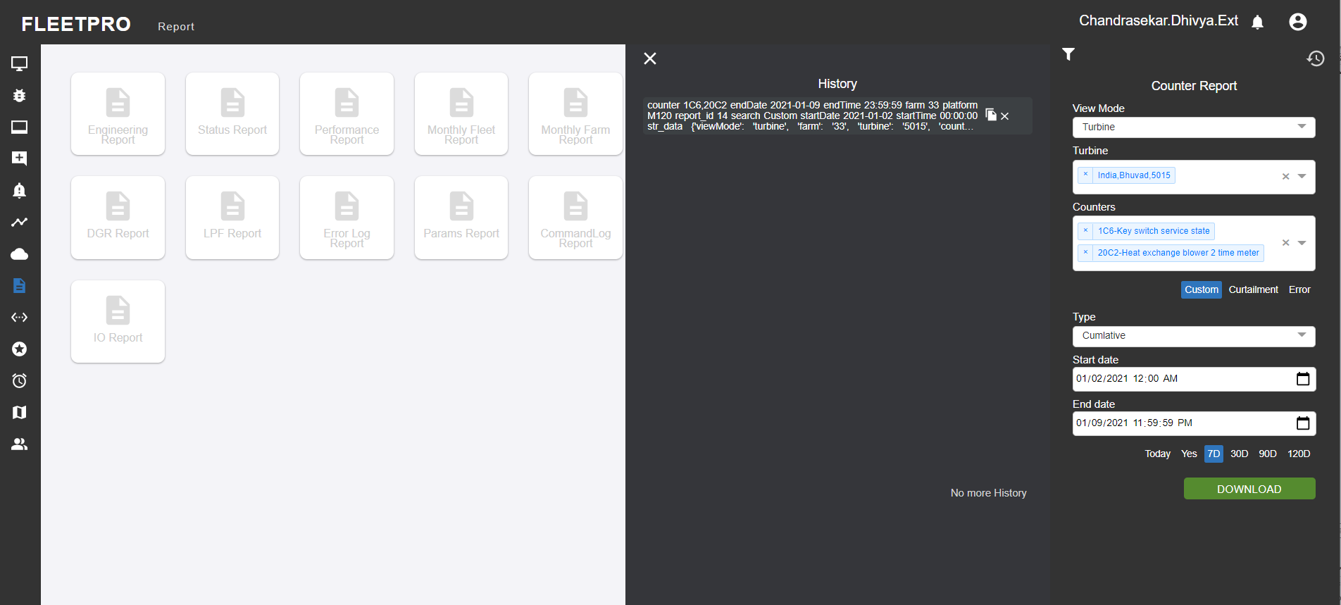

**CSV data:**

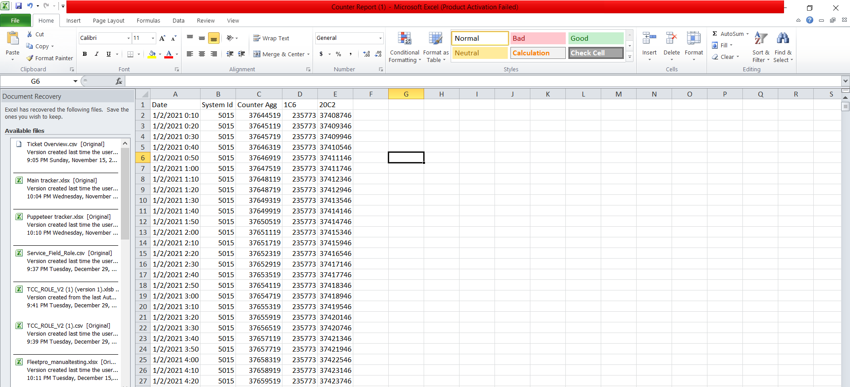

## Component Anomaly report

* This report provides the information regarding ny anomaly which has been encountered for a particular farm or specific turbine.
* Sensor selection here allows the user to select the set of sensors in the particular location.

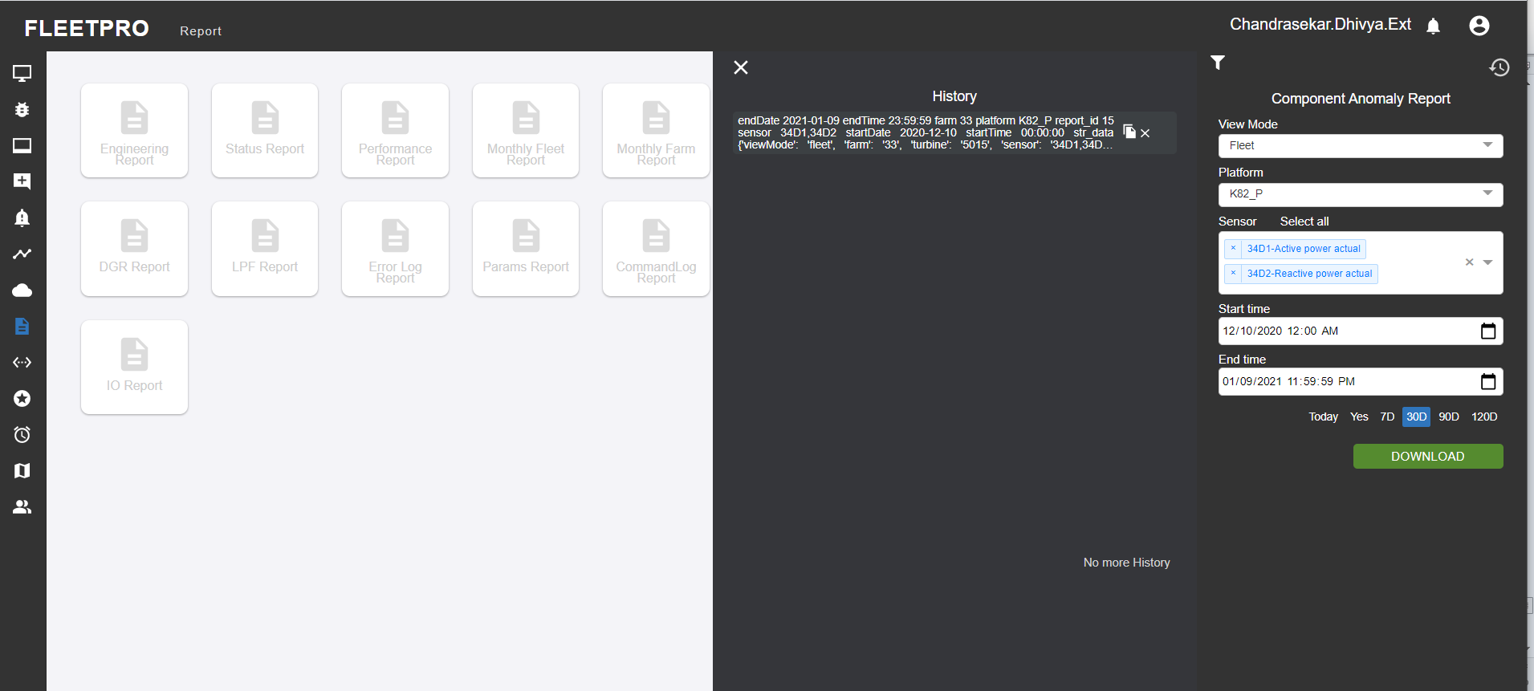

**CSV data:**

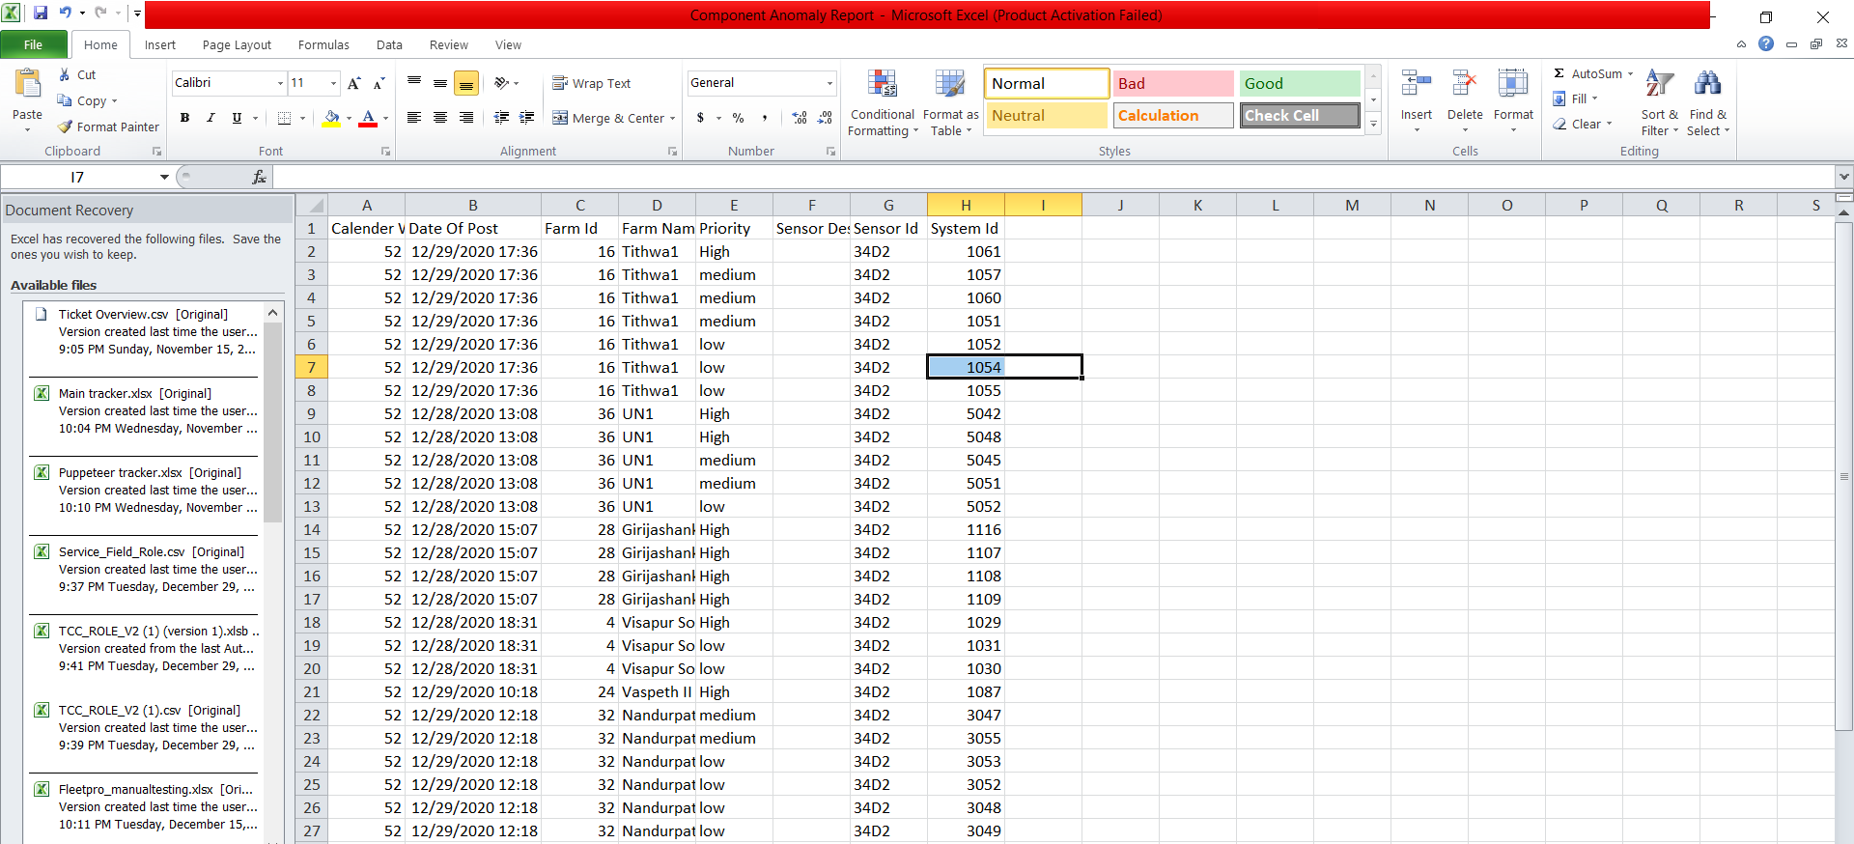

## Power Curve Performance Report

* This report provides the data in regard to the performance of the turbine or how much generation happened on comparison with what should have actually generated.
* NTF helps the user in calculating the correlation between the wind speed.
* Data in filter dropdown denotes: Filteration condition to meet the desired output under optimal conditions.

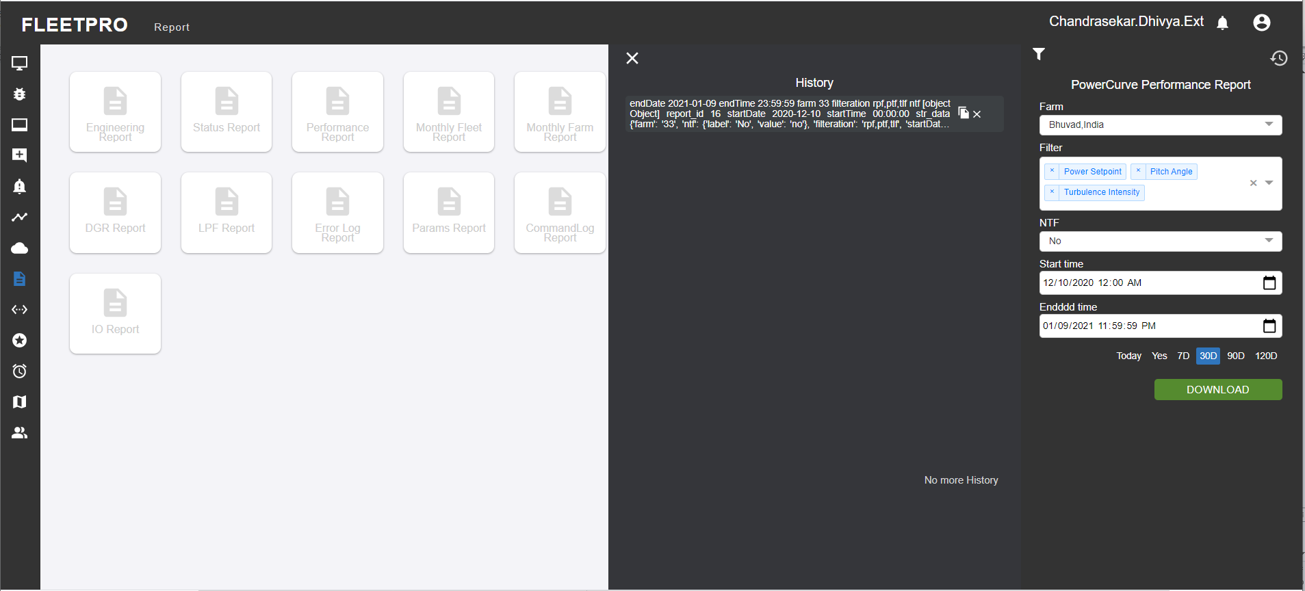

**CSV data:**

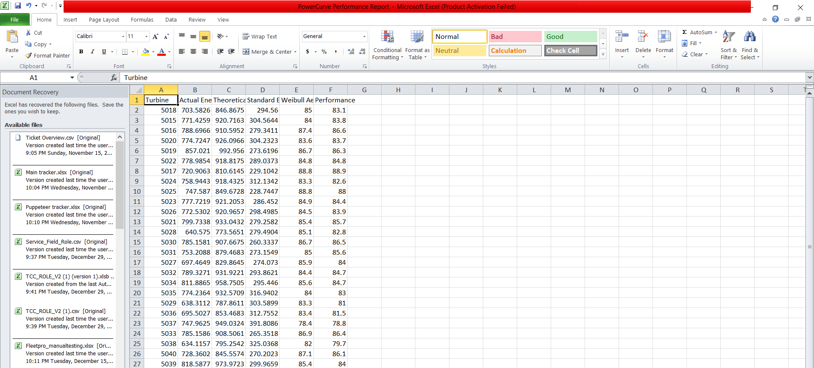

## IO Report

This report provides current input and output values in turbine. Input values are the binary with possible values 0 and 1 (abbr. “I”) Output values are the binary with possible values 0 and 1 (abbr. “O”)

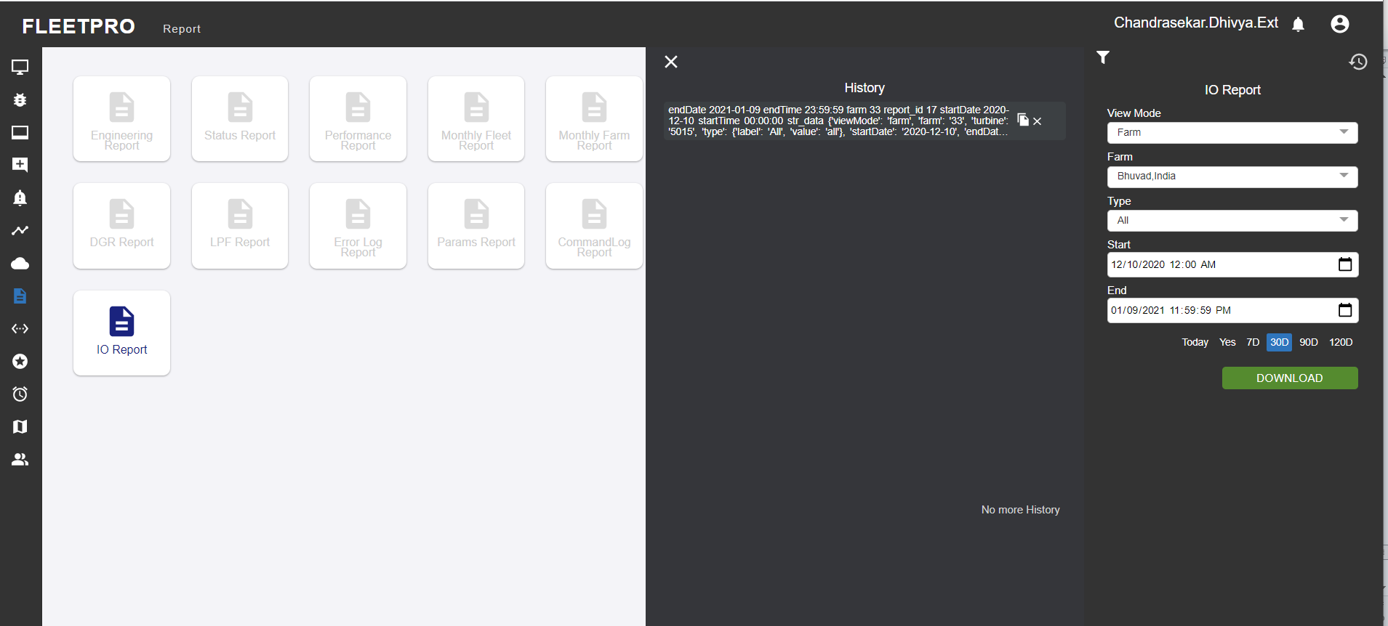

**CSV data:**

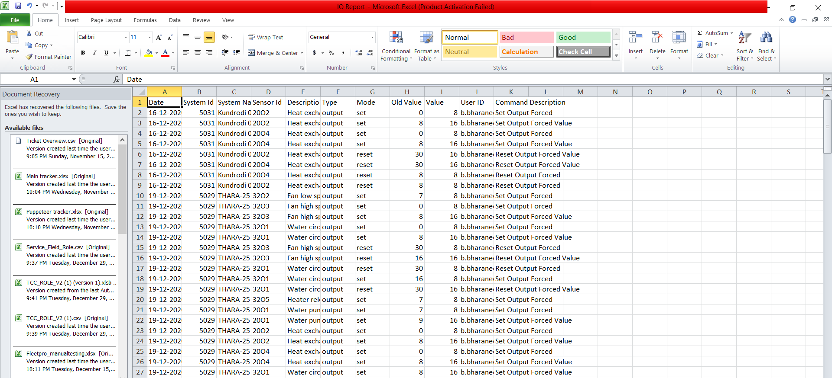

## Weekly Anomaly Report

This provides the zip file for the weekly generated farm data including all the required KPIs like availability, lpf, pba etc.

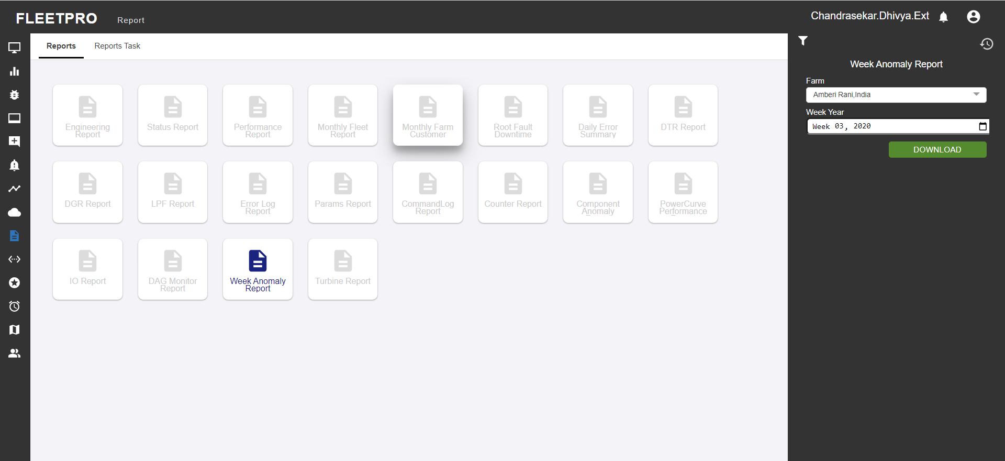

## Turbine Report

In performance report the performance of turbine is been viewed.it is directly send to mail. The performance is form such as last 7 days wind speed, generation power curve, errors will be there. Also we can refer turbine particular turbine with any other turbines.

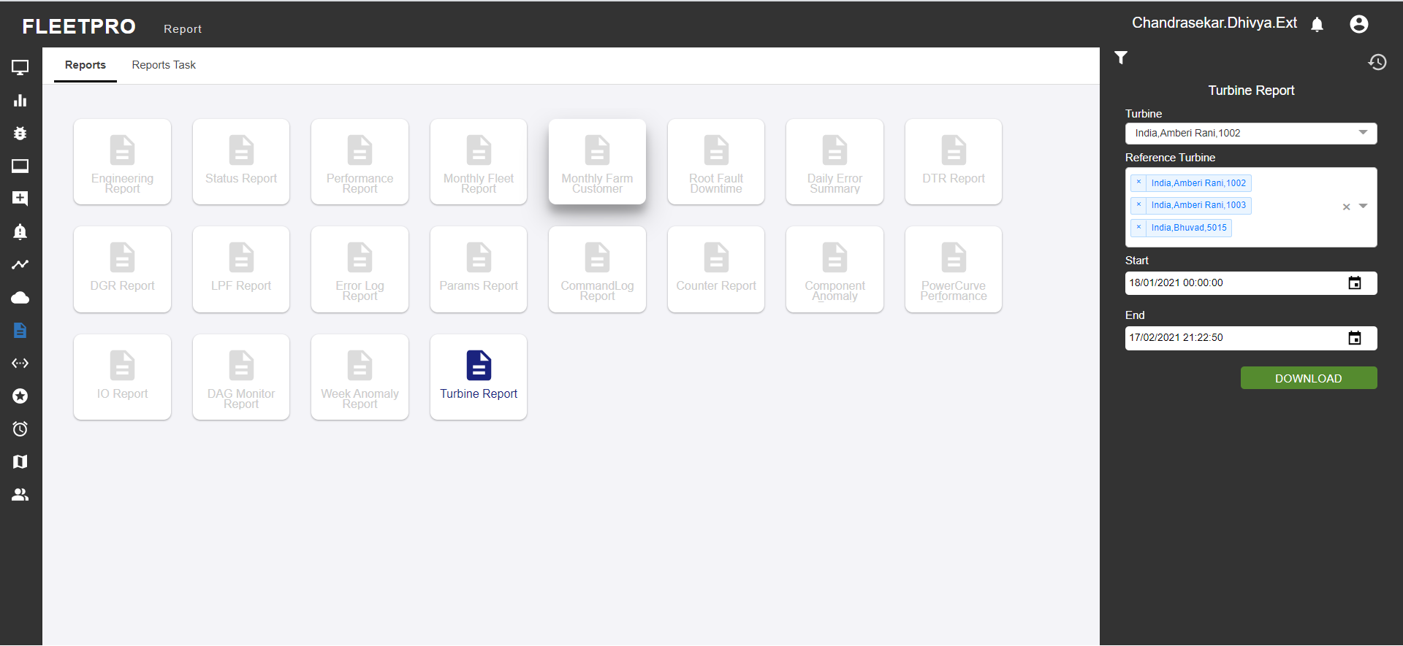

## Production report

In production report the user can choose the view mode of the farm and turbine, for which the desired inputs the production data can be obtained. The user can also choose the data mode and time period listed.

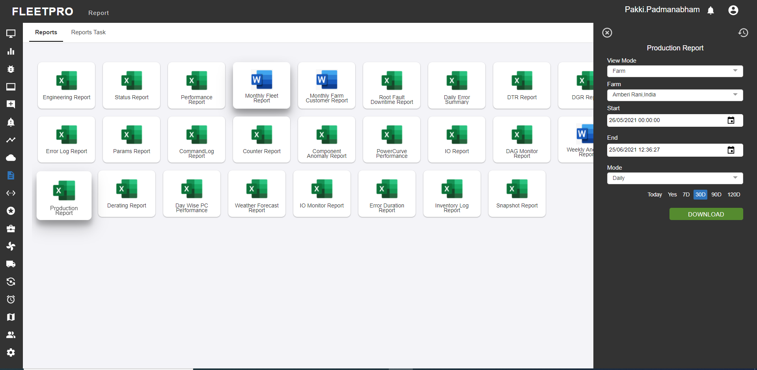

## Derating Report

This report provides deration details such as “Total Derated energy. It also provides the details about ”Loss of energy due to Deration”. And it also provides the details of the counters data of a turbine for the mentioned period.

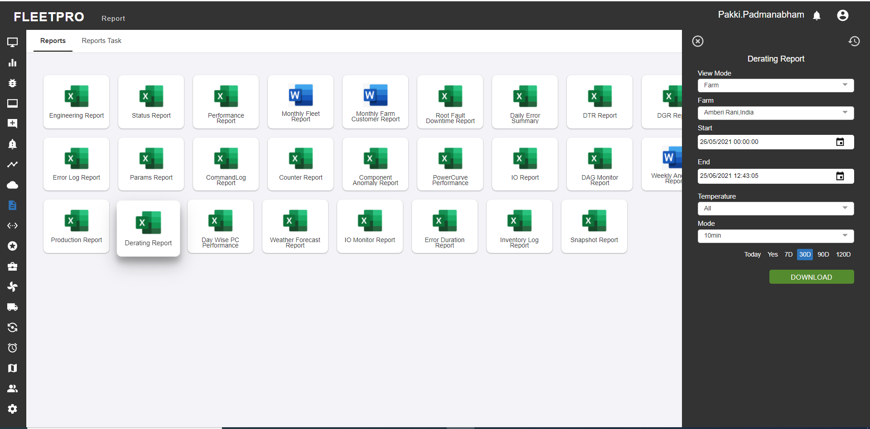

## Day wise PC Performance report:

This report provides day level aggregations of Performance Ratio of selected turbines for the mentioned dates.

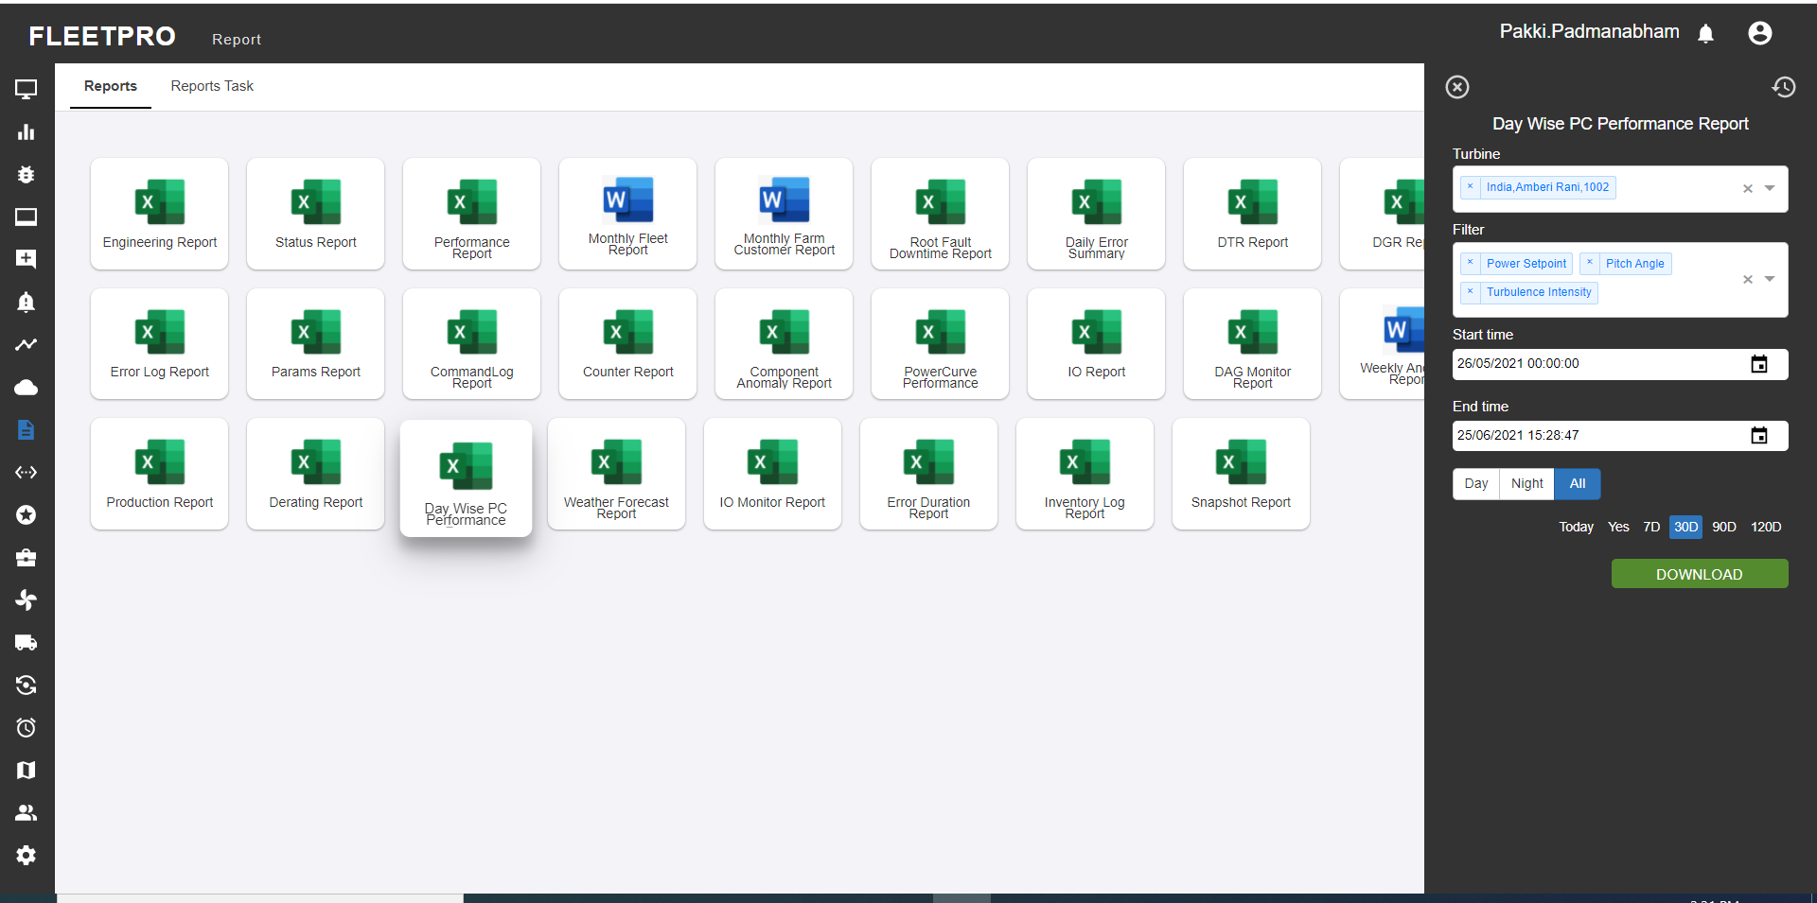

## Weather Forecast report

This report is mainly used in providing the weather forecast functionalities of the farm, with the respective forecast generation date provided.

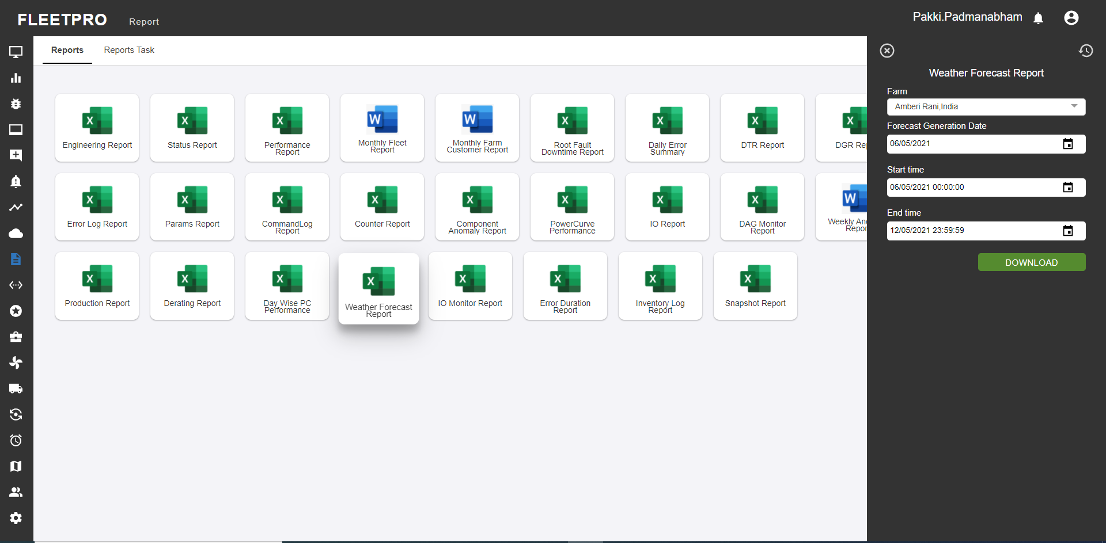

## IO Monitor Report

IO report is report which provides list of changes made in the I/O along with the user details. This will help to track who has made the changes in the values

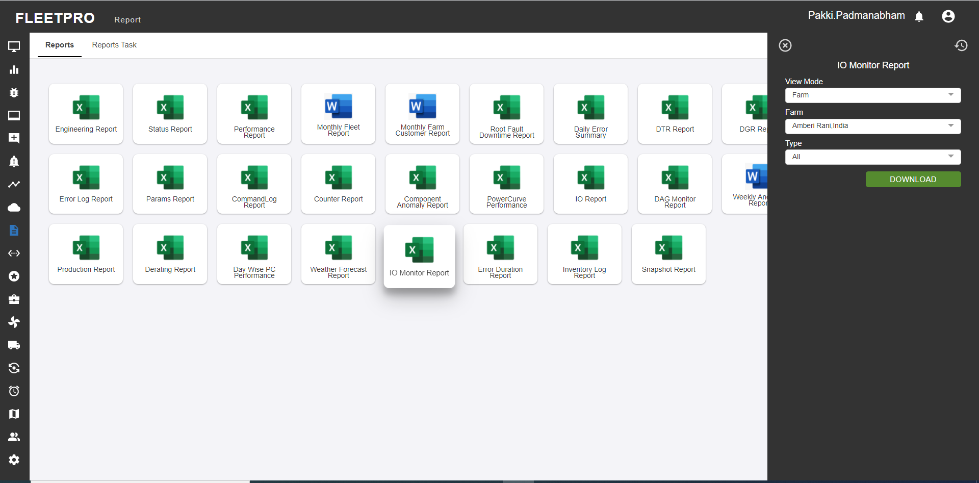

## Error Duration Report

This report provides the duration details of the status codes occurred between the selected dates.

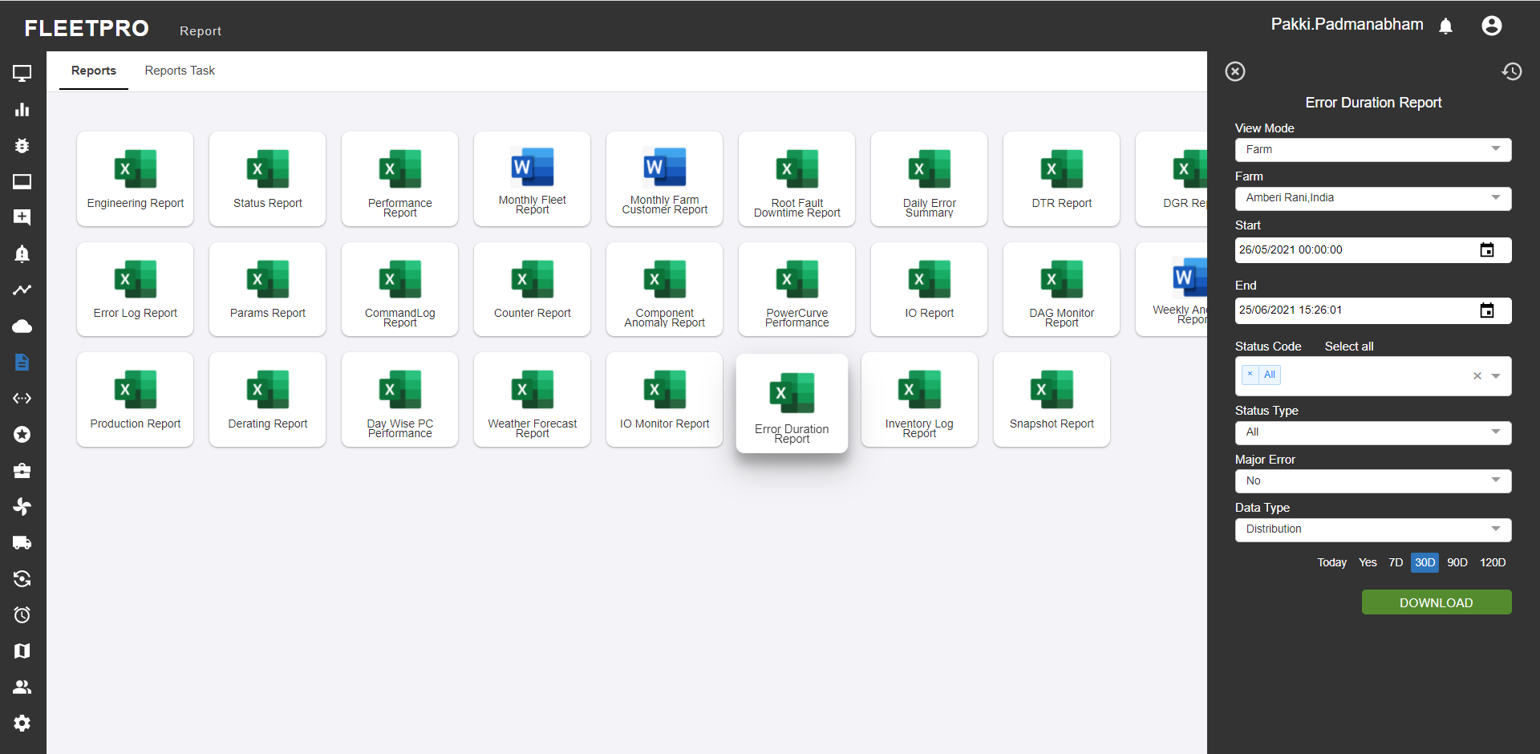

## Snap Shot Report

For the respective view mode and farm or turbine selected by the user, the snapshot table of the respective files will occur, for which the user can view the data for the selected set of dates.

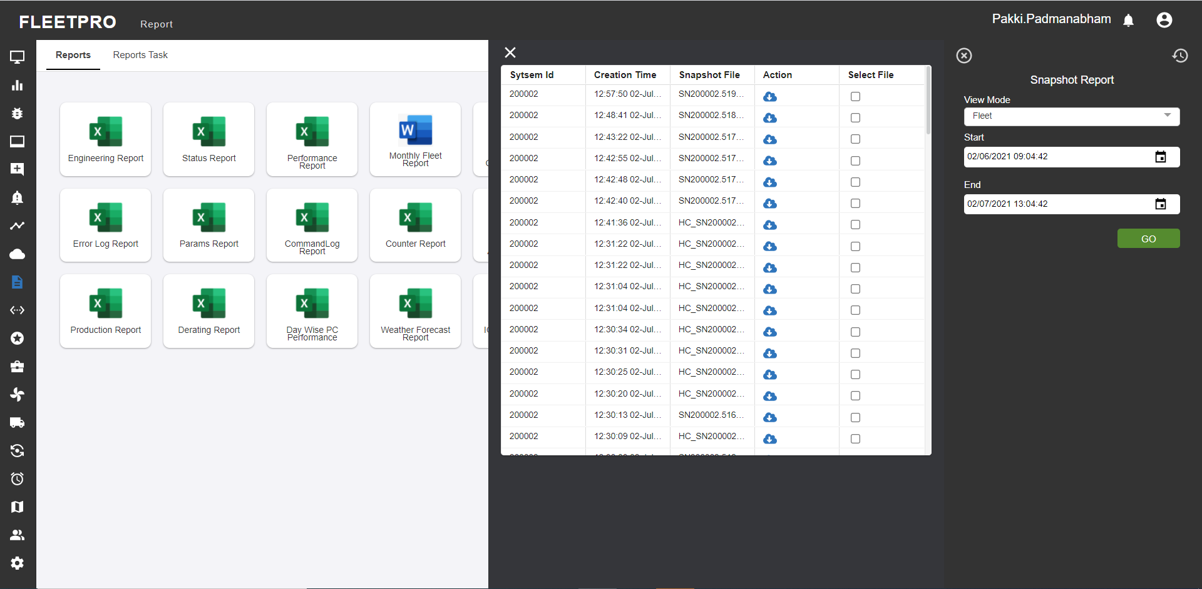

# Weather:

Forecast data including the graphs of wind direction, wind speed and gust data is displayed in form of graph. CSV or PNG data can be downloaded for the respective field selected.

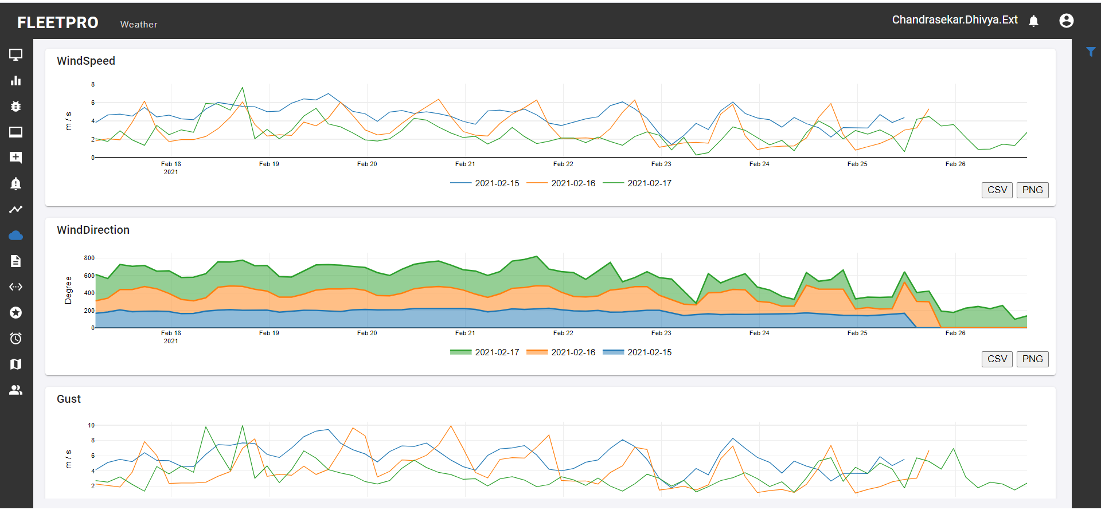

# Financial KPI

Financial KPI results in providing the graphical representation of the farm and turbines for the selected period of time. The user can choose actual or cumulative time period ad get the graph for the chosen time period.

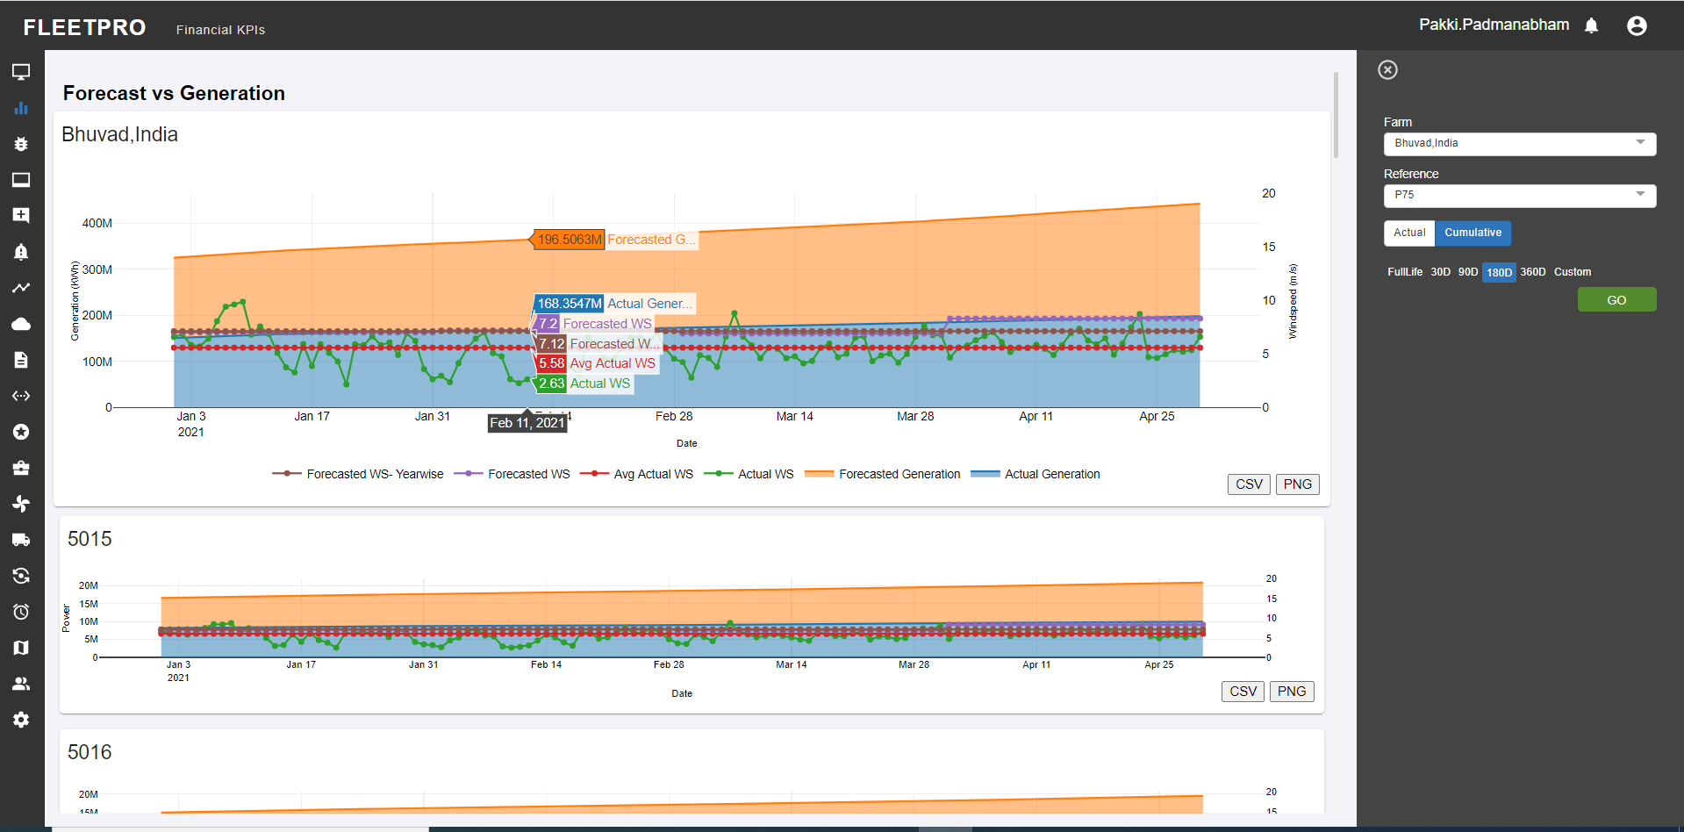

# Tech Center

Tech center provides descriptions of status codes and the action item in the Tech Centre displays the troubleshooting steps for the resolution of error codes. This Acts also a guide for the service team

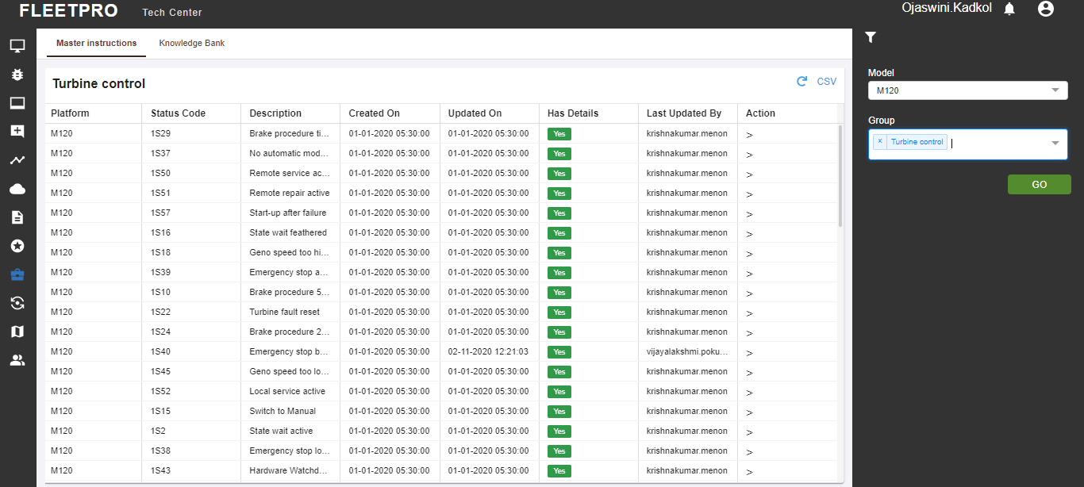

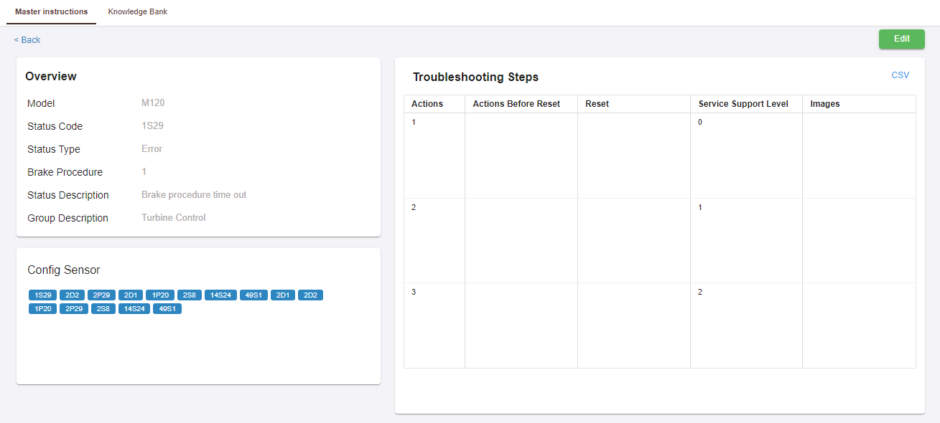

# Map

The Map view of the farm and the turbine data can be seen through this with labels.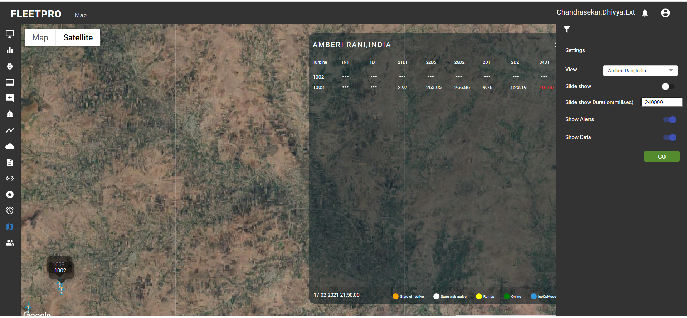

The detailed view of map with labels can also be seen by the user.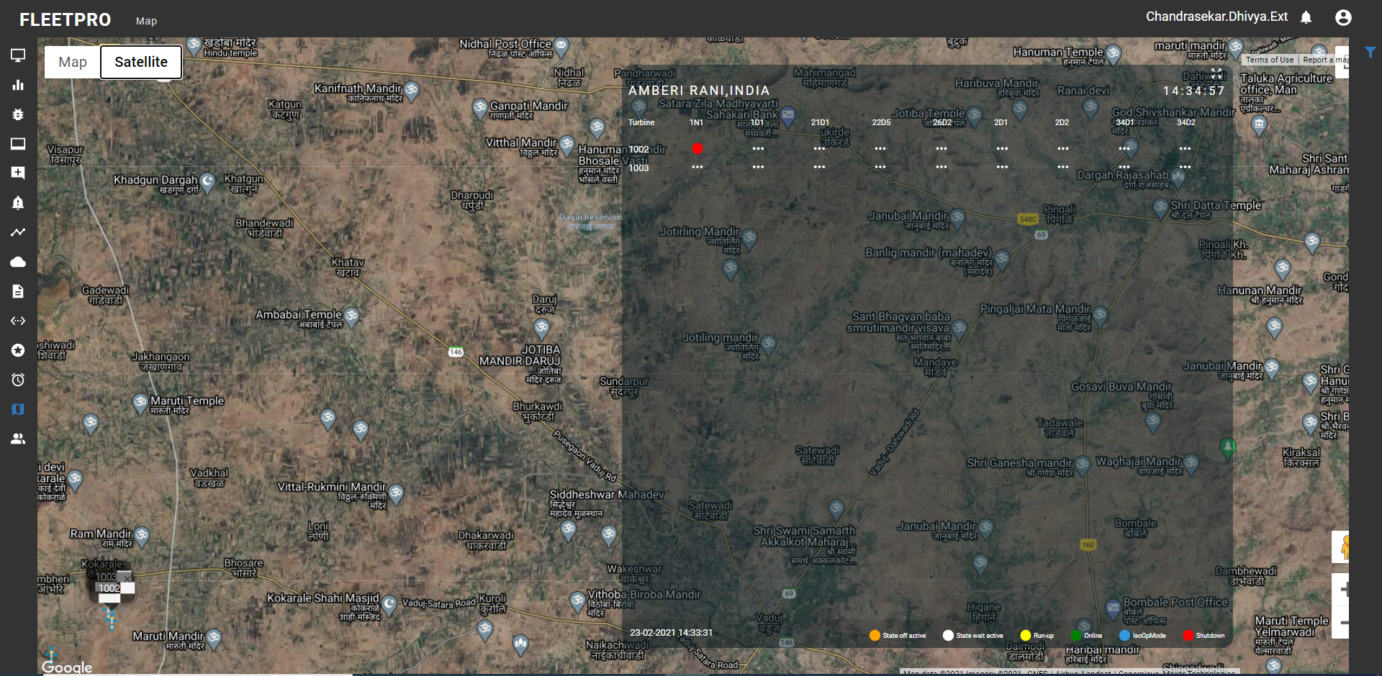

# Email ID Change

The following steps are explained on how to change your email in the FleetPro application

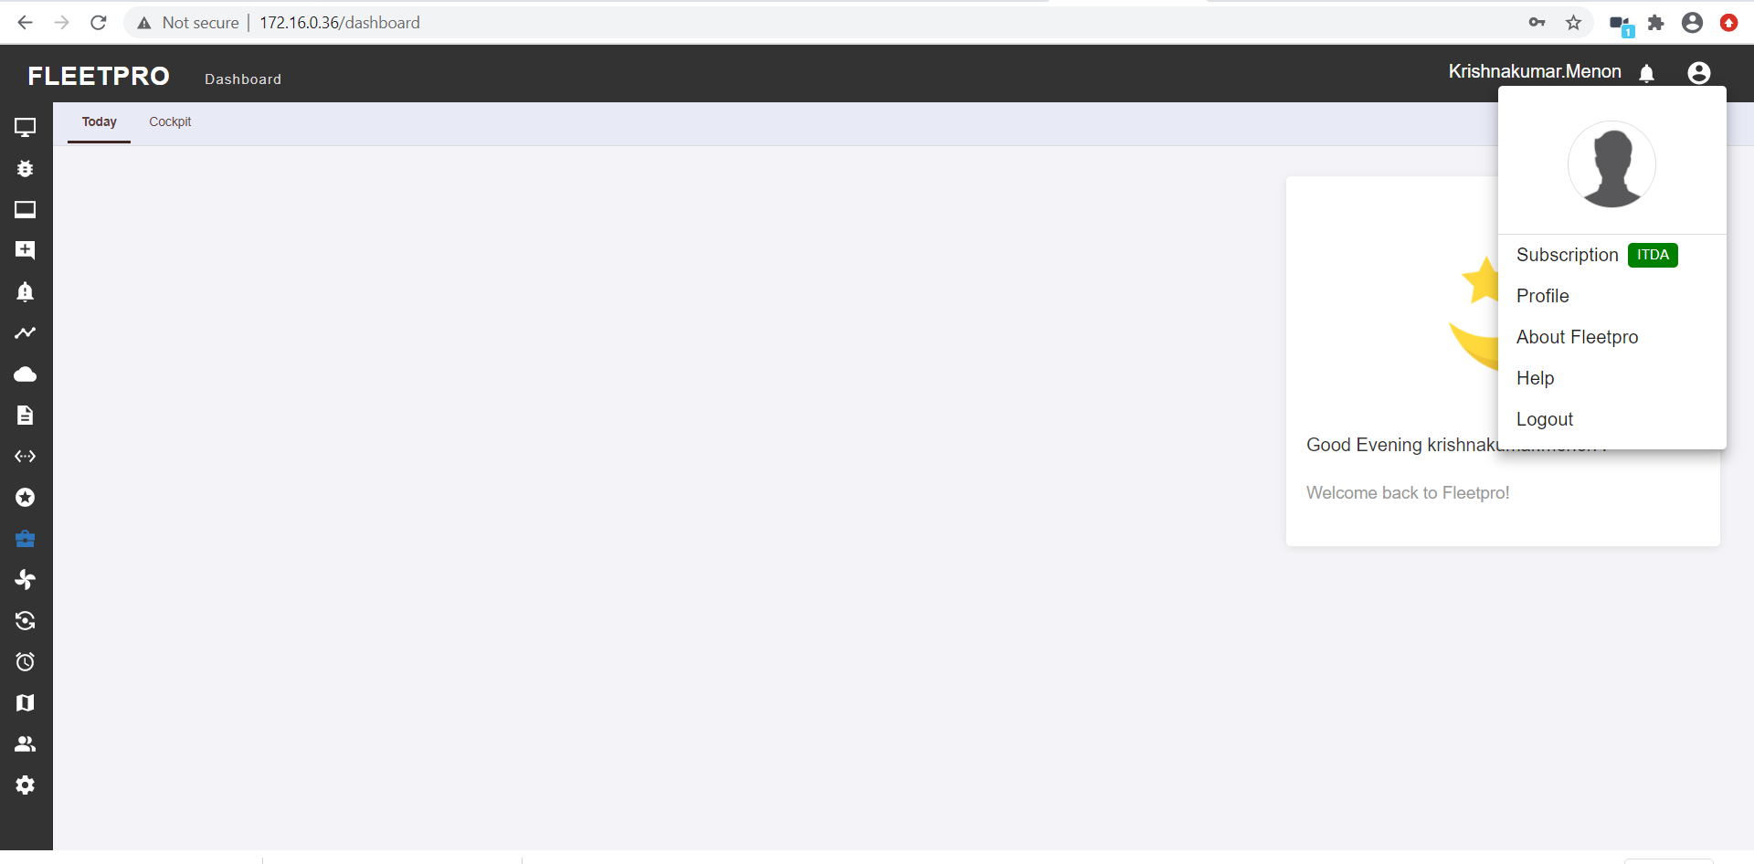

Fig12.1: Click on the account icon at the right top corner of the page. Select the profile from the list.

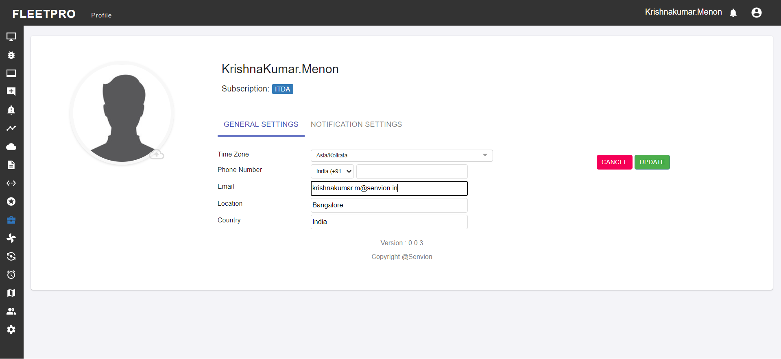

Fig 12.2: Click on the edit profile to make the email changes in the email text box

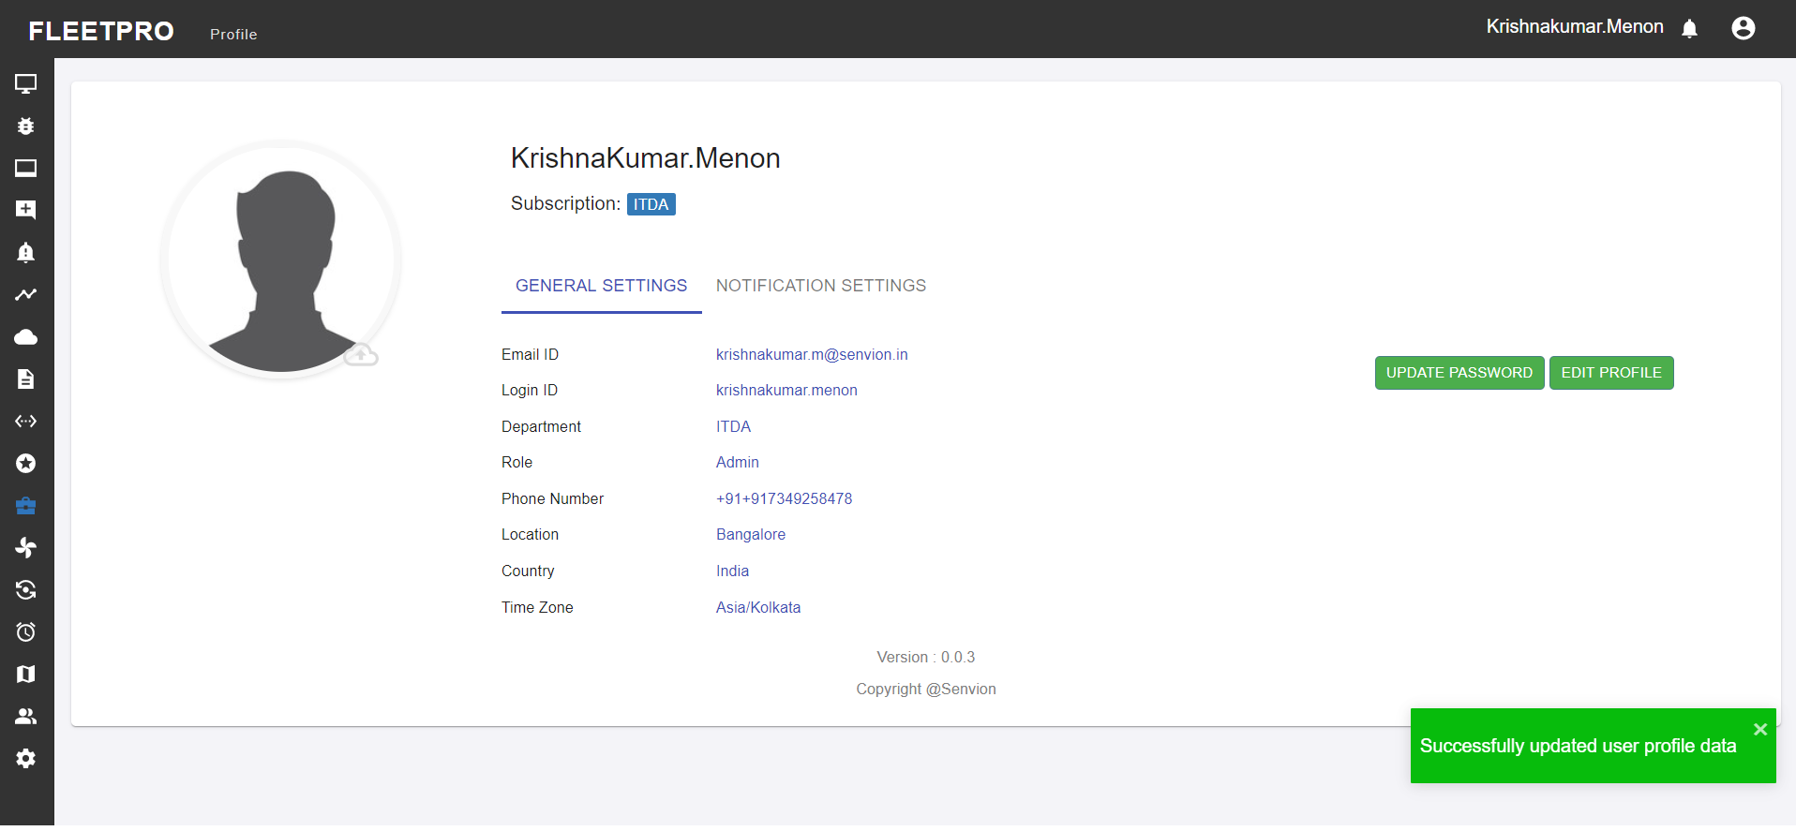

Fig 12.3: Update once the changes are made. A pop-up message will appear saying it is successfully updated.

# Password Reset

The password reset option has been provided where the user can be able to create a password which might include an overall of 8 characters including atleast one Capital letter, one special character and a number.

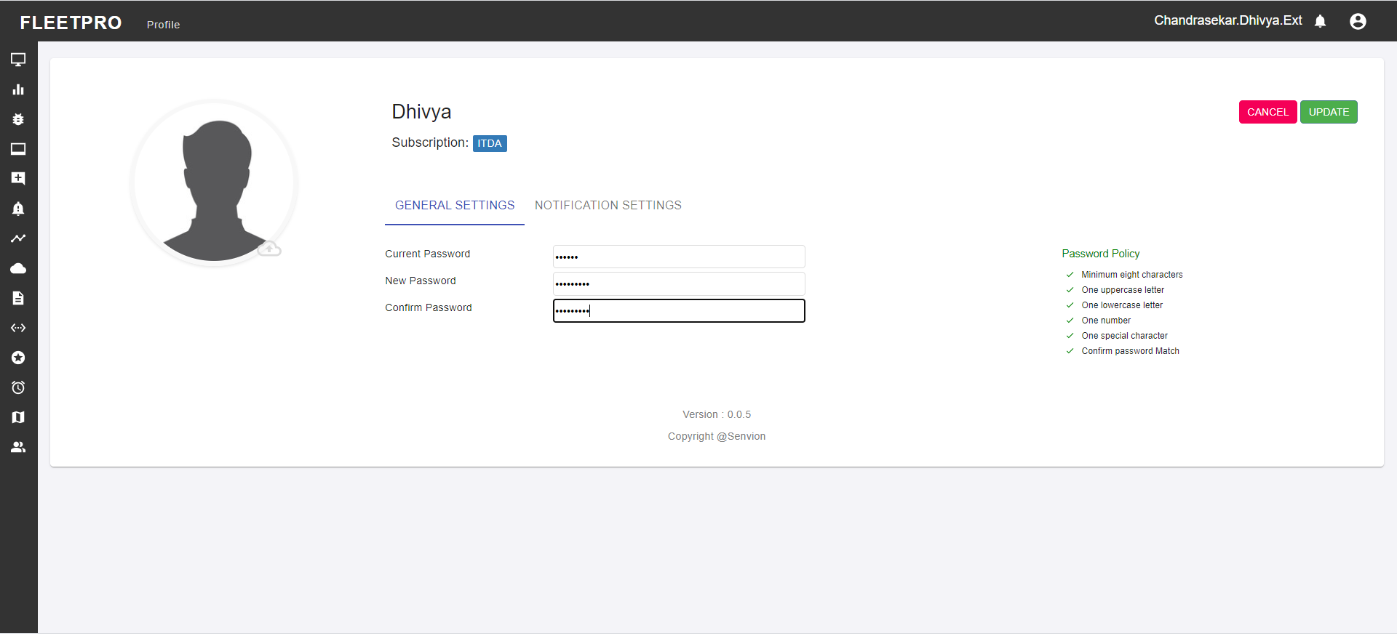

Fig 13.1 When all the conditions are passed, the user can update the password